SOUTH CAROLINA SUPPORT SYSTEM INSTRUCTIONAL PLANNING GUIDE
Content Area: | Second Grade Science
Recommended Days of Instruction: 1 |  |  | (one day equals 45 minutes)

Standard(s) addressed: 2-2
The student will demonstrate an understanding of the needs and characteristics of animals as they interact in their own distinct environments. (Life Science)

Animals
Indicator | Recommended Resources | Suggested Instructional Strategies |  | Assessment Guidelines
2-2.3: Explain how distinct environments throughout the world support the life of different types of animals. | SC Science Standards Support Document Resource List  https://www.ed.sc.gov/apps/cso/standards/supdocs_k8.cfm  SC ETV STREAMLINE  http://etv.streamlineSC.org  Habitats: Homes for Living Things  http://player.discoveryeducation.com/index.cfm?guidAssetId=7BAF8CE8-33F1-43A0-9F0E-1F2A165E4D31&blnFromSearch=1&productcode=US  Peek into the habitats of different kinds of animals to see how they meet their needs. Visit a pond, a desert, a forest, a rainforest, and other habitats to discover how different animals and plants survive and thrive in these unique environments.  Kid Territory at the San Diego Zoo  www.sandiegozoo.org/kids/index.html  This site answers questions about animals and includes information on careers with animals.  Interactive Honeybee Site  www.pbs.org/wnet/nature/alienempire/multimedia/hive.html  Kids learn about pollination, developing larvae, storing honey, and daily life in the hive.  Interactive Animals of the World  www.kidscom.com/games/animal/animal.html  Learn about animals and their habitats by playing games about mammals, insects and arachnids, reptiles and amphibians, birds and fish.  Magic School Bus Animals Tour  http://www.scholastic.com/magicschoolbus/tour/tour.htm?animals  Kids take “guided tours” and learn about animal characteristics and habitats in this interactive site.  Who Lives Here?  www.pbs.org/kratts/crazy/wlh  A Kratts Creatures interactive site where kids can learn about animal habitats and the animals that live there.  National Geographic.com for Kids  http://kids.nationalgeographic.com/kids/animals/creaturefeature/  Get to know some of the most interesting and unusual members of the wild world- from cheetahs to crocodiles and whales to warthogs.  Monterey Bay Aquarium Live Web Cams  www.mbayaq.org/efc/cam_menu.asp  Offers a look at marine life at the aquarium and off the oceanfront decks of the Monterey Bay Aquarium in California. Includes sea birds, otters, sharks, penguins, and more.  Echo the Bat and Amelia the Pigeon Interactive Multimedia Adventures  http://imagers.gsfc.nasa.gov/index.html  This NASA based interactive website tells the stories of these two interesting animals. Provides students with the opportunity to compare bats and birds.  Books  Bugs Are Insects by Anne Rockwell | See Science Module 2-2.3. |  | From the South Carolina Science Support Documents:  The objective of this indicator is to explain how distinct environments allow certain animals to live there; therefore, the primary focus of assessment should be to construct a cause-and-effect model of the various environments and how they support different animals. However, appropriate assessments should also require students to recall the way a distinct environment supports the types of animals that live there; summarize the conditions within an environment that support the life of an animal that lives there; or identify an animal that would live in a distinct environment.

Second Grade

Science Module
2-2.3

Animals

Lesson A

Standard 2-2: The student will demonstrate an understanding of the needs and characteristics of animals as they interact in their own distinct environments. (Life Science)

Indicator 2-2.3: Explain how distinct environments throughout the world support the life of different types of animals.

Other indicators addressed:
Other indicators addressed:
2-1.1: Carry out simple scientific investigations to answer questions about familiar objects and events.
2-1.3: Represent and communicate simple data and explanations through drawings, tables, pictographs, bar graphs, and oral and written language.
2-1.4: Infer explanations regarding scientific observations and experiences.
2-2.1: Recall the basic needs of animals (including air, water, food, and shelter) for energy, growth, and protection.
2-2.2: Classify animals (including mammals, birds, amphibians, reptiles, fish, and insects) according to their physical characteristics.

From the South Carolina Science Support Documents:

Indicator 2.2.3: Explain how distinct environments throughout the world support the life of different types of animals.

Taxonomy level:
Understand Conceptual Knowledge (2.7-B)

Previous/Future knowledge: In 1st grade (1-2.5, 1-2.6) students explained how distinct environments in the world supported different types of plants. In 4th grade (4-2.2) students will explain how distinct environments (including swamps, rivers and streams, tropical rainforests, deserts and polar regions) influence the variety of animals that live there.

It is essential for students to know that animals require air, water, food, and shelter and can only survive in environments where these needs can be met. There are distinct environments in the world (for example salt and freshwater, deserts, grasslands, forests, polar lands) that support the life of different types of animals.

It is not essential for students to study all of the distinct environments (biomes) in the world or all the animals but a study of more than one distinct environment is needed to completely cover the indicator.

Assessment Guidelines:
The objective of this indicator is to explain how distinct environments allow certain animals to live there; therefore, the primary focus of assessment should be to construct a cause-and-effect model of the various environments and how they support different animals. However, appropriate assessments should also require students to recall the way a distinct environment supports the types of animals that live there; summarize the conditions within an environment that support the life of an animal that lives there; or identify an animal that would live in a distinct environment.

Teaching Indicator 2-2.3: Lesson A – “Environments of Animals”

Instructional Considerations:
In this lesson the students will explore the distinct environments of the forest, pond, grassland, ocean, polar land and desert. Through a sorting activity and discussion students will come to understand that animals are supported by their environments which enable them to meet their basic needs (air, food, shelter and water).

This lesson is an example of how a teacher might address the intent of this indicator. The FOSS Insects and the STC Life Cycle of Butterflies kits provide an opportunity for conceptual development of the concepts within the standard.

Lesson Preparation: Duplicate a set of environment sheets which are attached to the end of this lesson. Make enough sets for each group of four students. These pages need to be printed in color. You may wish to laminate them for future use.

Duplicate a set of animal cards (from all environments) which are attached to the end of this lesson. Cut the cards apart and place them in plastic bags. Make enough sets for groups of four students. These pages need to be printed in color. You may wish to duplicate these on cardstock and laminate them for future use.

Prepare an “Animals and their Environment” chart. Glue/tape one of each of the environments (attached at the end of the lesson) to the chart paper. Glue/tape each of the animals around the environment in which it belongs. Keep this chart hidden until the students have completed their sorting activity.

Note: In many of the books, on many of the websites and in many of the videos the word habitat is used for environment. You will need to explain that these two words mean the same thing.

Misconceptions:
Young children have many misconceptions about the animal kingdom. Some common misconceptions include:
- People are not animals.
- Things are living only if they can move, breathe, eat and drink.
- Birds, fish, insects, worms are not animals.
- All animals can move from place to place
- All animals are four-footed or furry.
- All animals are wild.
- Animals are large and are found in zoos, on farms and in homes as pets.
- All animals live on land.
- Insects cannot live in water.
- Spiders are insects
- Fish do not need air, and they sleep with their eyes closed.

Safety Note(s):
None noted for this lesson.

Lesson time:
1 day (1 day equals 45 minutes)

Materials Needed:
- Book: Bugs Are Insects by Anne Rockwell
- Set of environment sheets (attached to end of lesson – 1 per group of 4 students)
- Bag of animal cards (see lesson preparation – 1 per group of 4 students)
- Prepared “Animals and the Environment” chart (see lesson preparation)
- ETV Streamline video: Habitats: Homes for Living Things
- Student science notebooks
- Pencils

Focus Question:
- How do different environments support the animals that live there?

Engage:
- Bring the children to the class gathering area and read the book Bugs Are Insects by Anne Rockwell to them.
- After reading the book, ask questions such as:
  - How can we tell if an animal is an insect?
  - What are some physical characteristics of insects?
  - Where do insects live?
  - How does the environment where an insect lives help it to live and grow?
  - What are some ways insects get their food?
- Tell the children that today they will explore some distinct environments and the animals that live there.

Explore:
- Divide the class into groups of four. Give each group a set of environment cards and a bag of animal cards.
- Ask the groups to place each animal card into its environment. Tell the groups that they must discuss each animal and they must all agree where it goes before placing it with that environment.
- Observe each group and ask questions such as:
  - Why did you place (animal name) in that environment?
  - What do you think the animal eats?
  - Where do you think it gets water?
  - What in that environment helps the animal to live?
- After ample sorting time, show the children the “Animals and their Environment” chart that you prepared and have them check their sorting.
- Allow the children to discuss any animals that were in the incorrect environment.

Explain:
- Show the children the ETV Streamline video: Habitats: Homes for Living Things.
- Discuss the video with the children.
- Explain to the children that every animal has a distinct environment and that environment supports it as it lives and grows.
Extend:
- To review animal classification, divide the children into groups of four and give each group a set of the animal cards. Have them sort the cards into mammals, reptiles, amphibians, birds, insects and fish.
- Discuss with the children the physical characteristics of each group.
- In their science notebooks, have the children draw their favorite animal.
- Have them describe that animal’s environment and how it gets what it needs for the environment
- Allow students to share their notebook entries with the class.

Forest Animals
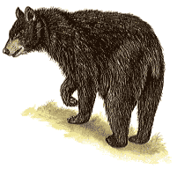  Black Bear | 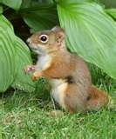  Squirrel
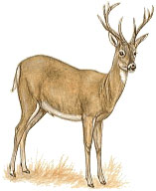  White-Tail Deer | 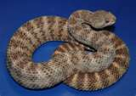  Rattlesnake
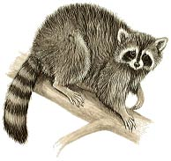  Raccoon | 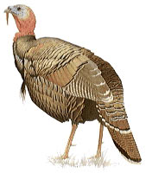  Wild Turkey

Grassland Animals
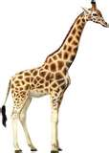  Giraffe | 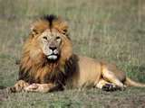  Lion
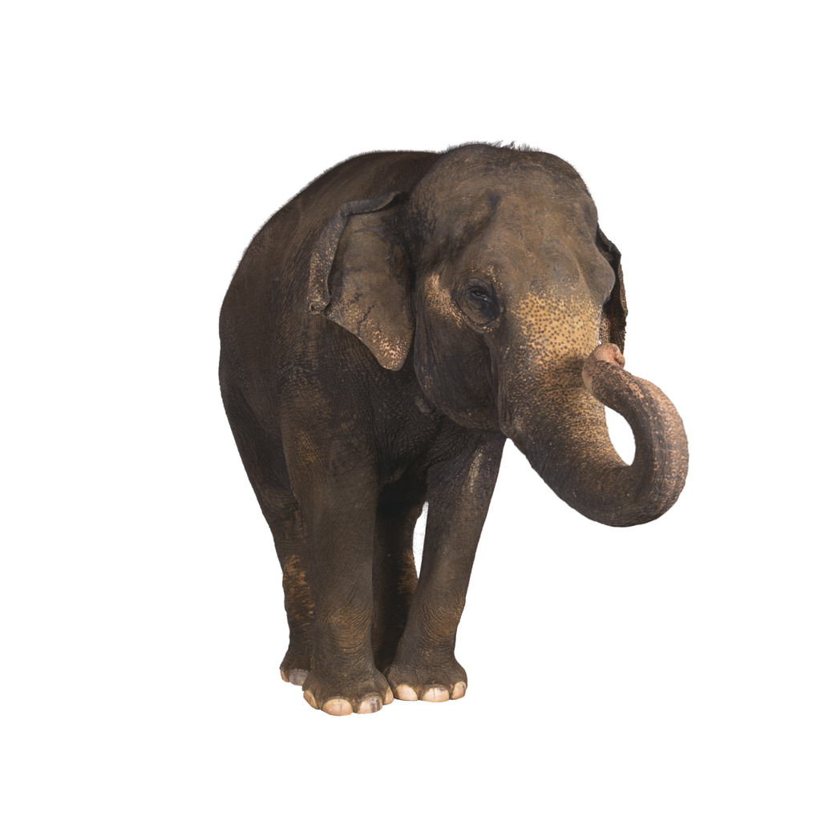  Elephant | 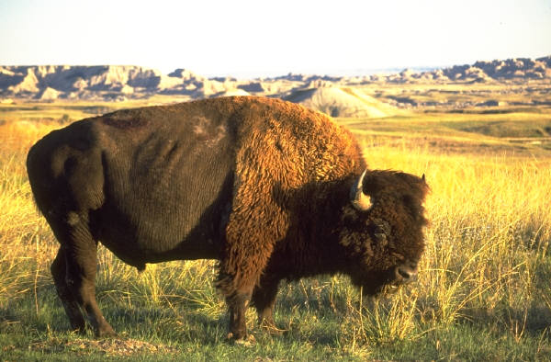  Buffalo
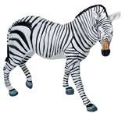  Zebra | 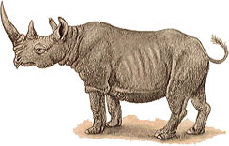  Rhinoceros

Ocean Animals
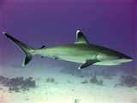  Shark | 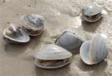  Clams
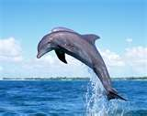  Dolphin | 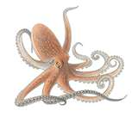  Octopus
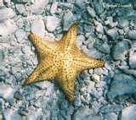  Starfish | 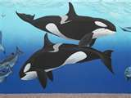  Killer Whales

Desert Animals
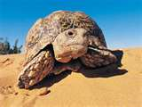  Desert Tortoise | 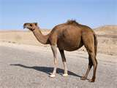  Camel
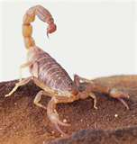  Scorpion | 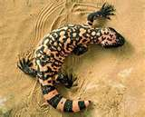  Gila Monster
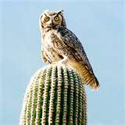  Great Horned Owl | 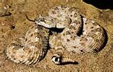  Sidewinder

Pond Animals
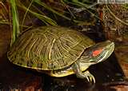  Turtle | 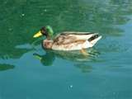  Duck
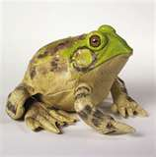  Bullfrog | 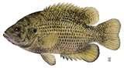  Brown Bass
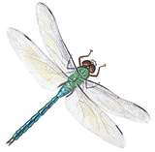  Dragonfly | 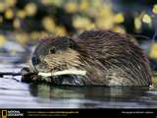  Beaver

Polar Animals
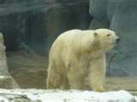  Polar Bear | 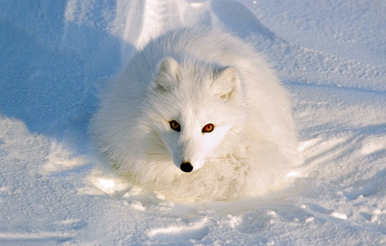  Arctic Fox
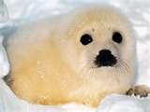  Seal | 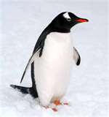  Penguin

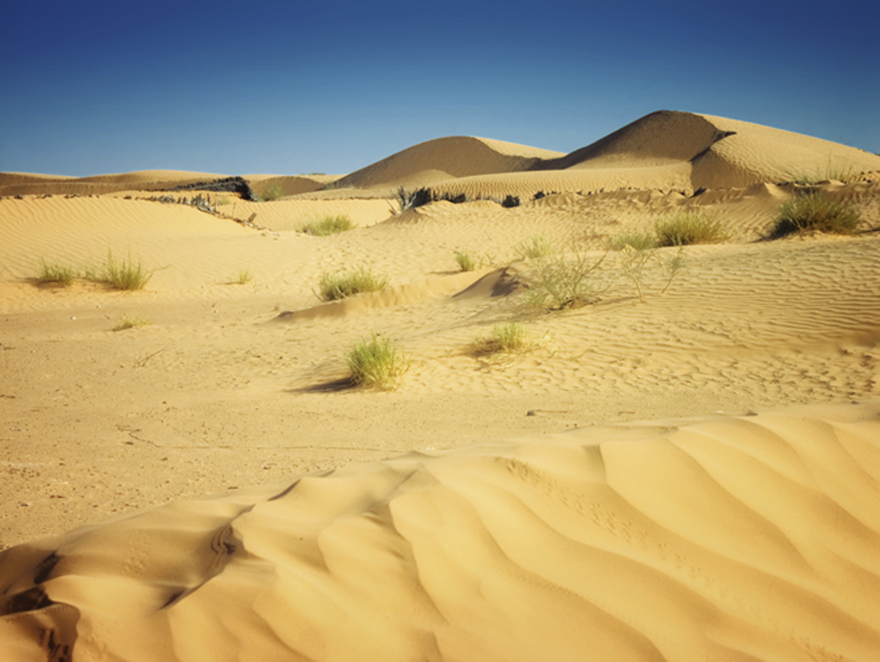
Desert


Ocean

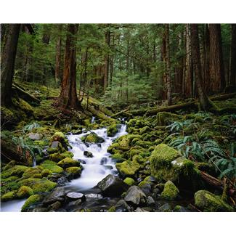
Forest

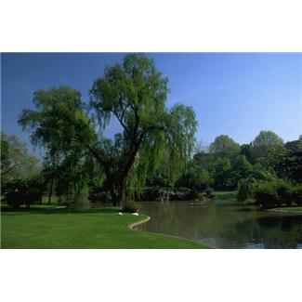
Pond
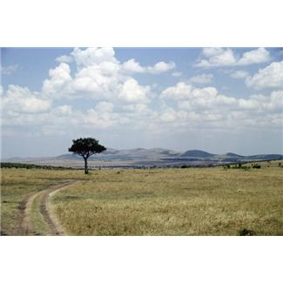
Grassland

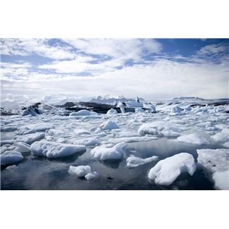
Polar Land

