SOUTH CAROLINA SUPPORT SYSTEM INSTRUCTIONAL PLANNING GUIDE
Content Area: | Sixth Grade Science
Recommended Days of Instruction: 3 |  |  | (one day equals 55 min)

Standard(s) addressed: 6-2
Students will demonstrate an understanding of structures, processes, and responses of plants that allow them to survive and reproduce.

Characteristics of Organisms
Indicator | Recommended Resources | Suggested Instructional Strategies |  | Assessment Guidelines
6-2.6  Differentiate between the processes of sexual and asexual reproduction of flowering plants. | SC Science Standards Support Document  https://www.ed.sc.gov/apps/cso/standards/supdocs_k8.cfm  SC ETV Streamline  Http://etv.streamlinesc.org  Biology: The Science of Life: Making New Life: The Basics of Reproduction Asexual and Sexual Reproduction  http://player.discoveryeducation.com/index.cfm?guidAssetId=FF3875DF-BA7B-4DBE-BE12-45D12345F6F1&blnFromSearch=1&productcode=US  This video segment differentiates between the process of sexual and asexual reproduction 1:14 to 2:35  Plants  http://www.biology4kids.com/files/plants_main.html  This website offers an introduction to plants. Topics include basic structures, xylem-phloem, reproduction, angiosperm and  Gymnosperm  Parts of a Flower  http://www.botany.uwc.ac.za/ecotree/flowers/flowerparts.htm#top  This interactive website will allow students to learn the parts of a flower by playing a game. Upon successful completion, the diagram will be in color. | See Module 6-2.6 |  | From the Science Support Document:  The objective of this indicator is to differentiate between sexual and asexual reproduction in plants; therefore, the primary focus of assessment should be to distinguish between processes and structures that result in asexual reproduction from those that result in sexual reproduction in plants.  However, appropriate assessments should also require student to identify the requirements for sexual reproduction in flowering plants; exemplify asexual reproduction in plants; or identify structures that allow asexual plant reproduction to take place.

Sixth Grade

Science Module
6-2.6

Structures, Processes and Responses of Plants

Lesson A

Standard 6-2: Students will demonstrate an understanding of structures, processes, and responses of plants that allow them to survive and reproduce.

Indicator 6-2.6: Differentiate between the processes of sexual and asexual reproduction of flowering plants.

Other indicators addressed:
    - Differentiate between observation and inference during the analysis and interpretation of data.
    - Use a technological design process to plan and produce a solution to a problem or a product (including identifying a problem, designing a solution or a product, implementing the design, and evaluating the solution or the product).

From the South Carolina Support Documents:

Indicator 6.2.6: Differentiate between the processes of sexual and asexual reproduction of flowering plants.

Taxonomy level:
Analyze Conceptual Knowledge (4.1-B)

Previous/Future knowledge: This is the first time that students have been introduced to the terms sexual and asexual reproduction. They have studied the process of
reproduction in flowering plants in 1st and 3rd grades.

It is essential for students to know the difference between sexual and asexual reproduction in flowering plants.
Sexual reproduction
- A process of reproduction that requires a sperm cell (in pollen) and an egg cell (in the ovule) to combine to produce a new organism.
- All flowering plants undergo sexual reproduction.
Asexual reproduction
- A process of reproduction that involves only one parent plant or plant part and produces offspring identical to the parent plant.
- Many plants can grow new plants asexually from their plant parts.
- If a plant is cut or damaged; it can sprout new growth from the stems, roots, or leaves.
- Plants use a variety of parts to produce new plants such as:
Tubers, bulbs
- These are all types of underground stems.
- The “eyes” or buds of tubers, for example potatoes, grow into roots and shoots to produce a new plant.
- Bulbs, for example onions, are big buds made of a stem and special types of leaves.
Runners
- These are all types of stems that run along the ground.
- New strawberries or some ivy grow from the tips of runners.
- Many lawn grasses grow from runners.
Stem Cuttings
- When a piece of cut stem is planted, roots may form from the cutting, and then a full plant develops.
- Sugar cane and pineapple are examples of plants grown from stem cuttings.
Roots
- Some fruit trees and bushes send up “suckers” or new shoots from the roots.
- Some plants have roots that can produce new plants from root pieces, such as a sweet potato.
Leaves
- Some houseplants produce little plants right on their leaves.
- For example, African violets can produce plants from leaves placed on top of soil.

It is not essential for students to know how reproduction occurs in nonvascular plants, cone bearing plants, or spore-producing plants.

Assessment Guidelines:
The objective of this indicator is to differentiate between sexual and asexual reproduction in plants; therefore, the primary focus of assessment should be to distinguish between processes and structures that result in asexual reproduction from those that result in sexual reproduction in plants. However, appropriate assessments should also require students to identify the requirements for sexual reproduction in flowering plants; exemplify asexual reproduction in plants; or identify structures that allow asexual plant reproduction to take place.

Teaching Indicator 6-2.7: Lesson A- Comparing Sexual and Asexual Reproduction

Instructional considerations:
This lesson is an example of how a teacher might address the intent of this indicator.
Plants have different characteristics and structures, which allow them to reproduce. The structures of flowering plants allow them to reproduce sexually. Other plants have structures that allow them to reproduce asexually.

Preparation for the Lesson:
Obtain the various plant samples needed for student exploration.

Misconceptions: None noted

Safety Notes:
Growing plants in the classroom may expose students to mold and mold spores. Check with students and their parents to ensure that no student has a known mold allergy before beginning the experiments. If students have mold allergies, DO NOT CONDUCT THIS EXPERIMENT.

Lesson time:
3 days – Observations and collecting will be ongoing for several weeks.

Materials Needed:
- Flowering plant such as a lily or tulip with easy to see flower parts
- Potatoes with eyes
- Bulbs
- Coleus plant
- Potting soil
- Sweet potatoes
- Containers for plants

Focus Question:
What are the structures needed for sexual and asexual reproduction?

Engage:
1. Review sexual reproduction by showing a flowering plant and asking students to talk about what they remember about how this plant reproduces. Have them name the reproductive parts of the flower. Tell them that sexual reproduction requires that a sperm cell found in pollen and an egg cell found in the ovule combine to produce a new plant.
2. Ask the students if they have ever grown a plant without starting with a seed. Allow students to elaborate on their experiences. Have them describe how the plant grew. If no responses, ask them if any of them has seen a sweet potato sprout or show them a sprouting sweet potato and ask if they can tell the purpose of the eyes?
3. Introduce asexual reproduction as the process of reproduction that involves only one parent or plant part and produces offspring identical to the parent.
4. Tell the students you will be exploring ways plant reproduce both asexually and sexually.

Explore:

- Hold up a houseplant like a Coleus Plant and ask the students how they might grow another plant like this without any seeds. Take all suggestions.
- Plan to investigate methods suggested. (Inquiry Indicator 6-1.3)
- Be sure that one of the investigations includes Stem cuttings. Stem cuttings produce roots that can produce a new coleus plant. This is an example of plant propagation by stem cuttings.
- Place the cuttings in water until roots begin to grow. Investigate with stems with different quantities of leaves. Does the number of leaves affect asexual reproduction in stem cuttings?
- Have students devise a plan for making observations and collecting data from the stem cutting investigation. Data should include quantitative and qualitative observations.
- Have them set up their notebooks to record this data. A good title might be “Plant Propagation, an example of Asexual Reproduction”
- Have students record data on this investigation and each investigation below making sure they identify the plant and the type of reproduction in each case. Drawings or other illustrations will enhance their data.
- Distribute grasses or ivy samples with runners to student groups. Allow time for them to observe these plants. Many lawn grasses grow from runners. Ask students to illustrate why grasses and ivy are called runners and explain why this is asexual reproduction. Strawberry plants are another example of plants that reproduce with runners.
- Provide bulbs (tulips, spring onions, etc.) for students to observe. Bulbs are big buds made of a stem and special types of leaves. Have students draw and label the parts of a bulb. Plant an example of each bulb and allow student observations over time.
- Show the students potatoes with eyes or buds of tubers. Potatoes are underground stems that swell. Food is stored in the potato and the potato can produce new plants at each “eye” on the potato.
- Select a potato with many eyes and cut the potato in half. Use toothpicks to suspend one half of the potato in a plastic container with the cut side downward. Add enough water to cover most of the potato. Label and date the container with the potato. Do not let the water go below half of the potato. Students may want to investigate to discover the maximum number of plants that can be grown from a single potato. Potatoes are planted in soil as well. Allow them time to observe and record data in their notebooks.
- Record observations weekly.
- Sweet potatoes are “tuberous roots” and can reproduce asexually. Suspend a sweet potato in a container of water using toothpicks. About one-third of the potato should be above the water level in the container. Place in a sunny location and change the water as needed.
- Students should record quantitative and qualitative observations weekly. When the vine gets large enough on the potato it can be planted outside.
- Have students generate graphs related to plant growth investigations and data collected.
- Refer to the Inquiry Indicator 6-1.2: Differentiate between observation and inference during the analysis and interpretation of data. Have students make inferences as well as observations from the graphs and charts they have created during these investigations.

Explain:
1. Have student groups complete a Frayer Model-- a word categorization activity that helps learners to develop their understanding of concepts.
for Asexual Reproduction.
2. Post and share whole class.
3. Display a Frayer Model diagram for students to reproduce. Ask them to draw it in their notebook and complete it individually, then form trios, sharing their individual thoughts and compiling them into one chart for posting.
Characteristics
Definition of Asexual Reproduction RepReproduction
Examples
Nonexamples

a. Students post and share their model whole class.
b. Once posted, allow time for students to view and share their thoughts. Allow for questions from class members.
4. Ask students to describe three ways plants can propagate asexually making sure they give examples.
5. Reproduce a Venn Diagram on the board and ask students to help you complete it to compare asexual and sexual reproduction. (See support document for background information.)
5. Quick Write: What characteristics of a plant indicate whether the plant will reproduce sexually or asexually? As you respond to this question, site examples from the investigations you’ve experienced.

Extend:
1. Have student groups create a concept map for asexual reproduction. Use the support document to assist with detail.
Asexual Reproduction

Tubers
Bulbs
Runners

Cuttings
Roots

2. Parts of a Flower
http://www.botany.uwc.ac.za/ecotree/flowers/flowerparts.htm#top
This interactive website will allow students to learn the parts of a flower by playing the game. On successful completion, the diagram will be in color.
3. Suggested Streamline Video:
Biology: The Science of Life: Making New Life: The Basics of Reproduction
Asexual and Sexual Reproduction
This video segment differentiates between the process of sexual and asexual reproduction. ETV Streamline SC 1:14 to 2:35

Coleus Plant

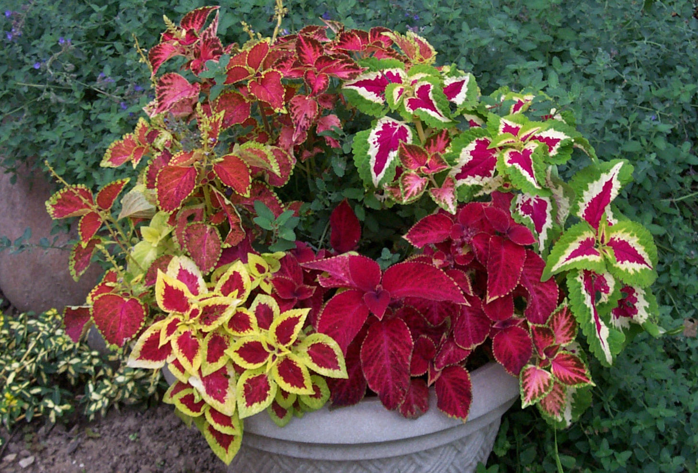

Stem Cutting

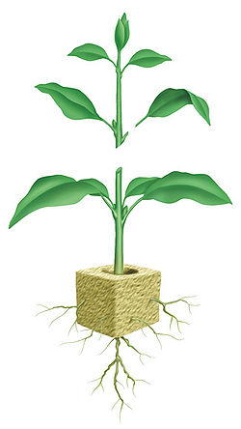

Plants with Runners

Strawberry Plant Runners
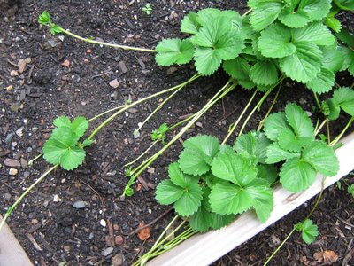

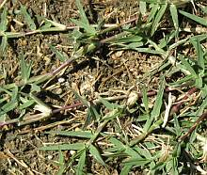
Bermuda Grass with Runners

Ivy Plants with Runners

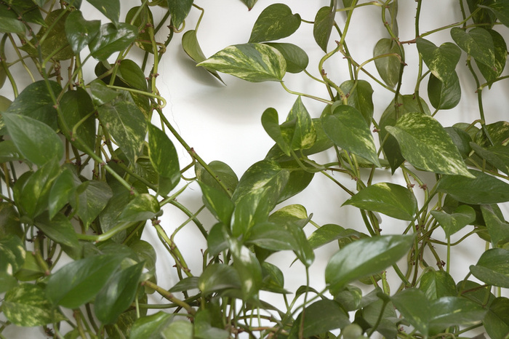

Bulb Plants

Tulips

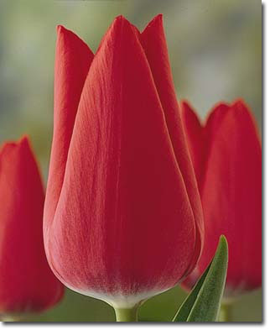

Spring Onions

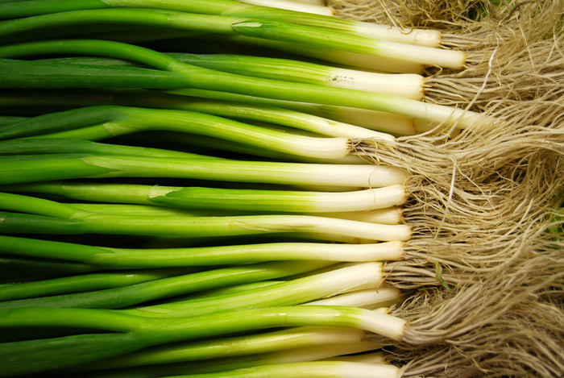

Daffodils

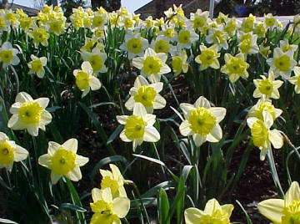

Bulbs
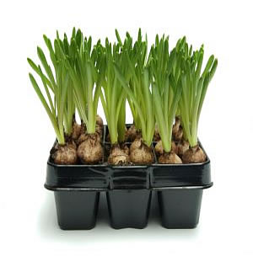

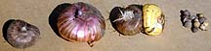

Potatoes with Eyes

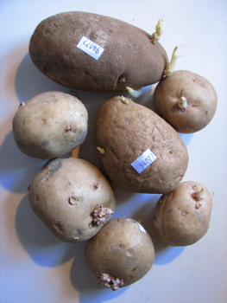

Sweet Potato

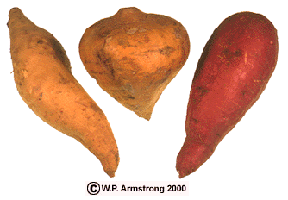

Sweet Potato in Water



