SOUTH CAROLINA SUPPORT SYSTEM INSTRUCTIONAL PLANNING GUIDE
Content Area: | Eighth Grade Science
Recommended Days of Instruction: 2 |  |  | (one day equals 55 min)

Standard(s) addressed: 8-3
The student will demonstrate an understanding of materials that determine the structure of Earth and the processes that have altered this structure. (Earth Science)
Earth’s Structure and Processes
Indicator | Recommended Resources | Suggested Instructional Strategies |  | Assessment Guidelines
8-3.3: Infer an earthquake’s epicenter from seismographic data. | SC Science Standards Support Guide Resource List  https://www.ed.sc.gov/apps/cso/standards/supdocs_k8.cfm  “Shaking and Quaking, Monitoring Earthquakes”  National Park Service’s http://www.nps.gov/brca/forteachers/plateact6.htm  “What Happens During an Earthquake?”  Student Page  http://scearthquakes.cofc.edu/educators/factsheets/SCEEPFactSheets_3.pdf  How a Seismograph Works  http://www.iris.edu/hq/files/publications/brochures_onepagers/doc/OnePager7.pdf  Model locating the epicenter, online simulation http://www.sciencecourseware.org/VirtualEarthquake/VQuakeExecute.html  Computer simulation of calculating the epicenter of an earthquake: http://www.iris.edu/hq/files/programs/education_and_outreach/aotm/interactive/HowAreEQLocated_WalkRunActivity.swf  The IRIS (Incorporated Research Institution for Seismology) Consortium  http://www.iris.edu  USGS Seismic Data page http://earthquake.usgs.gov/  USGS Seismic Information for Children  htt://earthquake.usgs.gov/learn/kids/  The Geologic Society of America http://www.geosociety.org/  Geology and Earth Science http://www.geology.com  National Park Service http://www.nps.gov/brca/forteachers/geodetective.htm  Geology animations and songs from the University of Kentucky http://www.as.uky.edu/academics/departments_programs/EarthEnvironmentalSciences/EarthEnvironmentalSciences/Educational%20Materials/Pages/default.aspx  “How to Locate the Epicenter of an Earthquake”  http://www.iris.edu/hq/files/publications/brochures_onepagers/doc/OnePager6.pdf  Simulation (60 seconds) of how the seismographic data is collected during an earthquake http://www.iris.edu/hq/programs/education_and_outreach/animations/9  “Seismic Sleuths” http://www.scec.org/education/education/internships/00/vanroosendaal/vanroosendallreport.pdf  “Locating an Earthquake Epicenter” http://scearthquakes.cofc.edu/educators/toolkits/LocateEpicenter.pdf  SC ETV Streamline  http://etv.streamlinesc.org  What Causes an Earthquake and How Do Researchers Find the Epicenter?  http://player.discoveryeducation.com/index.cfm?guidAssetId=A823C1F6-9DCE-429A-8F9E-6B7F5188385E&blnFromSearch=1&productcode=US  Earthquake: Our Restless Planet  http://player.discoveryeducation.com/index.cfm?guidAssetId=D629B6EB-6EBE-484C-B9F0-107EB50F04AB&blnFromSearch=1&productcode=US  The destruction created by earthquakes is a reminder that our planet is in a constant state of change. In this program students will see how earthquakes are triggered by movements in the great plates that form a shell around this earth. They will better understand terms such as faults, seismic waves, focus, epicenter, transformation zone, magnitude and seismograph. And while we may soon be able to predict the occurrence of earthquakes, we will never be able to alter the great forces that are at work within our planet.  Earthquake: Our Restless Planet Quiz  http://tools.discoveryeducation.com/quiz/viewQuiz.cfm?guidAssetId=83853FAE-C114-43C7-BDFC-95AB4B3D3066&blnFromSearch=1&productcode=US&blnFromSearch=1&strEditCopy=Copy | See Science Module 8-3.3 |  | From the South Carolina Science Support Documents:  The objective of this indicator is to infer an earthquake’s epicenter; therefore, the primary focus of assessment should be to draw a logical conclusion as to an earthquake’s epicenter given data from seismographs.  However, appropriate assessments should also require students to recognize that a seismogram is used to determine the distance from the earthquake epicenter to the seismograph; or interpret a diagram with seismographic data plotted; or recognize how seismic waves move from the focus of the earthquake.

Eighth Grade

Science Module
8-3.3

Earth’s Structures and Processes
Lessons A-B
(with Alternative and Extra Practice lessons for Lesson B)
Standard 8-3: The student will demonstrate an understanding of materials that determine the structure of Earth and the processes that have altered this structure. (Earth Science)

Indicator 8-3.3: Infer an earthquake’s epicenter from seismographic data.

Other indicators addressed:
Indicator 8-1.3: Construct explanations and conclusions from interpretations of data obtained during a controlled scientific investigation.

Indicator 8-1.7: Use appropriate safety procedures when conducting investigations.

SC Mathematics Indicator 7-5.1: Use ratio and proportion to solve problems involving scale factors and rates.

SC Mathematics Indicator 8-4.2: Use ordered pairs, equations, intercepts, and intersections to locate points and lines in a coordinate plane.
SC Mathematics Indicator 8-5.6: Analyze a variety of measurement situations to determine the necessary level of accuracy and precision.

From the South Carolina Science Support Documents:

Indicator 8-3.3: Infer an earthquake’s epicenter from seismographic data.

Taxonomy level:
Understand Conceptual Knowledge (2.5-B)

Previous/future knowledge: In the 3rd grade (3-3.8), students were introduced to earthquakes as a rapid process that changes Earth’s surface. In 5th grade (5-3.1), earthquakes are explained as a natural process that can have effects on both Earth’s land and oceans. The measuring of earthquake waves involving the interpretation of seismic data is a new concept for this grade. Understanding of the properties of waves as part of 8-6.3 will help students to read and interpret seismographic data.

It is essential for students to know the epicenter is the point on Earth’s surface directly above where the energy is released in an earthquake; energy that reaches the surface is greatest at this point.
- The energy spreads outward in all directions as vibrations called seismic waves. Seismic waves can be measured and recorded by a seismograph.
- The vibration record, called a seismogram, looks like jagged lines on paper.
- Measuring the time between the arrival of the P and S waves determines the distance between the recording seismograph and the earthquake epicenter.
- Triangulation identifies the epicenter of an earthquake. The location of an earthquake’s epicenter is found by plotting circles on a map from the records of three seismograph stations and finding the point where the three circles intersect.

It is not essential for students to determine the magnitude of an earthquake based on seismographic data.

Assessment Guidelines:
The objective of this indicator is to infer an earthquake’s epicenter; therefore, the primary focus of assessment should be to draw a logical conclusion as to an earthquake’s epicenter given data from seismographs. However, appropriate assessments should also require students to recognize that a seismogram is used to determine the distance from the earthquake epicenter to the seismograph; or interpret a diagram with seismographic data plotted; or recognize how seismic waves move from the focus of the earthquake.
Teaching Indicator 8-3.3: Lesson A - “Recording Earthquakes”

Instructional Considerations:
This lesson is an example of how a teacher might address the intent of this indicator. The STC kit Catastrophic Events provides an opportunity for conceptual development of the concepts within the standard. This lesson has been designed to follow Lesson C SC Indicator 8-3.2 “Determining the internal structure of Earth” for the conceptual development of SC Indicator 8-3.

Misconceptions:
Some incorrect beliefs children often hold include but are not limited to:
- Earth is molten except for its crust
- As waves move, matter moves along with them
- Children often have trouble making the connection to real world from simulations or models; be explicit in asking clarifying questions to ensure lifelong misconceptions are not created.

Safety Note(s):
Students should know and practice the procedures for fire, glass and chemical safety. Students should use care when performing this experiment, and be wearing the proper safety equipment including aprons and goggles. Students should know and practice safe disposal of materials in a laboratory setting.

Lesson time:
1 day (1 day equals 55 minutes)

Materials Needed: (per groups of 2)
- Stand or table
- String
- Marker or pencil
- Paper

Focus Question:
How can the earthquakes be recorded?

Engage:
- Have you ever felt an earthquake? Did you know how far away it was?
- Suppose you stomped on the floor –could this be a mini-earthquake? (Answer – Yes, the force of your foot is causing the floor to vibrate.)
- If you wanted to see a picture of the waves created, how might you do so?
- How could we do that on a larger scale, say a real earthquake?
- That is exactly what geologists do – they monitor earthquakes to better understand how the crust is affected by movements and to determine how plates are moving.

Explore:
- Make a stand from which to hang a marker by a string.
- Place a piece of paper below the stand so the tip of the marker is touching the paper.
- Put your new "seismograph" on a table. Then hit the side of the table with a hammer. It would be a good idea to place a piece of wood between the table and the hammer when you hit it.
- Notice the different drawings that result from hitting the table and record your observations in your notebook.
  - What do you notice about push-pull waves?
  - What do you notice about side to side waves? Does this work?
  - How can you tell the difference between the waves?
- How might you identify the P-waves, S-waves and Surface waves?
NOTE: This activity was adapted from the National Park Service’s Lesson “Shaking and Quaking, Monitoring Earthquakes” and can be downloaded in the original format at http://www.nps.gov/brca/forteachers/plateact6.htm
- To download a student one-pager on “What happens during an earthquake?” http://scearthquakes.cofc.edu/educators/factsheets/SCEEPFactSheets_3.pdf

Explain:
- What is an earthquake? (Answer: An earthquake is a series of seismic waves which are energy waves produced when friction along a fault causes vibrations in the crust.)
- How are earthquakes recorded? (Answer: As energy waves pass through the crust they can be monitored by sensitive devices called seismographs. The recording they make is called a seismogram (see below). The seismograph has a base that sets firmly in the ground, and a heavy weight that hangs free. When an earthquake causes the ground to shake, the base of the seismograph shakes too, but the hanging weight does not. Instead the spring or string that it is hanging from absorbs all the movement. The difference in position between the shaking part of the seismograph and the motionless part is what is recorded. When evaluating collected data, various scales are used to describe the magnitude of fault movement, inferred from the intensity of the waves.)
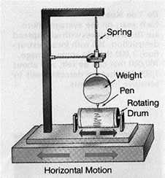

To read more on how a seismograph works, download a one-page informational sheet from iris at http://www.iris.edu/hq/files/publications/brochures_onepagers/doc/OnePager7.pdf
- How do scientists measure the size of earthquakes? (Answer: The size of an earthquake depends on the size of the fault and the amount of slip on the fault, but that’s not something scientists can simply measure with a measuring tape since faults are many kilometers deep beneath the earth’s surface. So how do they measure an earthquake? They use the seismogram recordings made on the seismographs at the surface of the earth to determine how large the earthquake was (see below). A short wiggly line that doesn’t wiggle very much means a small earthquake, and a long wiggly line that wiggles a lot means a large earthquake. The length of the wiggle depends on the size of the fault, and the size of the wiggle depends on the amount of slip.)
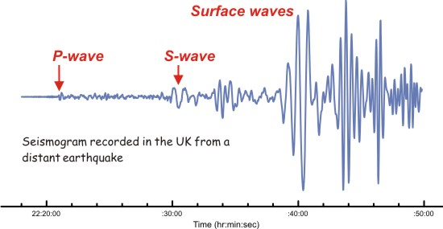
- How do you read a seismogram? Answer: When you look at a seismogram, there will be wiggly lines all across it. These are all the seismic waves that the seismograph has recorded. Most of these waves were so small that nobody felt them. These tiny microseisms can be caused by heavy traffic near the seismograph, waves hitting a beach, the wind, and any number of other ordinary things that cause some shaking of the seismograph. There may also be some little dots or marks evenly spaced along the paper. These are marks for every minute that the drum of the seismograph has been turning. How far apart these minute marks are will depend on what kind of seismograph you have.
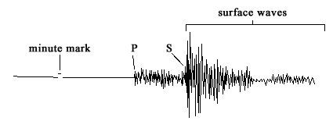
- So which wiggles are the earthquake? Answer: The P wave will be the first wiggle that is bigger than the rest of the little ones (the microseisms). Because P waves are the fastest seismic waves, they will usually be the first ones that your seismograph records. The next set of seismic waves on your seismogram will be the S waves. These are usually bigger than the P waves. If there aren't any S waves marked on your seismogram, it probably means the earthquake happened on the other side of the planet. S waves can't travel through the liquid layers of the earth so these waves never made it to your seismograph.
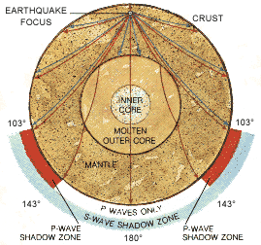
Figure 2 - A cross-section of the earth, with earthquake wave paths defined and their shadow-zones highlighted.
The surface waves (Love and Rayleigh waves) are the other, often larger, waves marked on the seismogram. They have a lower frequency, which means that waves (the lines; the ups-and-downs) are more spread out. Surface waves travel a little slower than S waves (which, in turn, are slower than P waves) so they tend to arrive at the seismograph just after the S waves. For shallow earthquakes (earthquakes with a focus near the surface of the earth), the surface waves may be the largest waves recorded by the seismograph. Often they are the only waves recorded a long distance from medium-sized earthquakes.
- Where are earthquakes recorded? (Answer: Monitoring earthquakes, all over the world, allows scientists to determine where the earthquake originated. In addition to recording ground motion, seismographs also record the date and time the seismograph felt the waves. Using multiple recordings, scientists are able to calculate where the earthquake originated – this process is known as triangulation. The origin of an earthquake is called its hypocenter. This is the point beneath Earth's surface where fault rupture (movement) occurred. The point on the surface that is directly above the hypocenter is called the epicenter.)

Extend:
- Interpret the following seismographs: (Label the P-waves, S-waves and Surface waves): (answers shown here; see attached for student sheet)
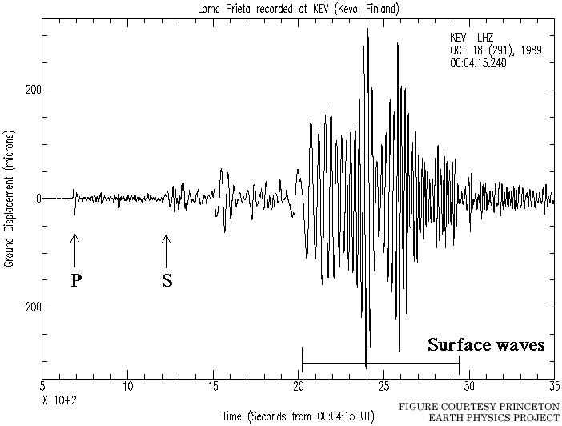
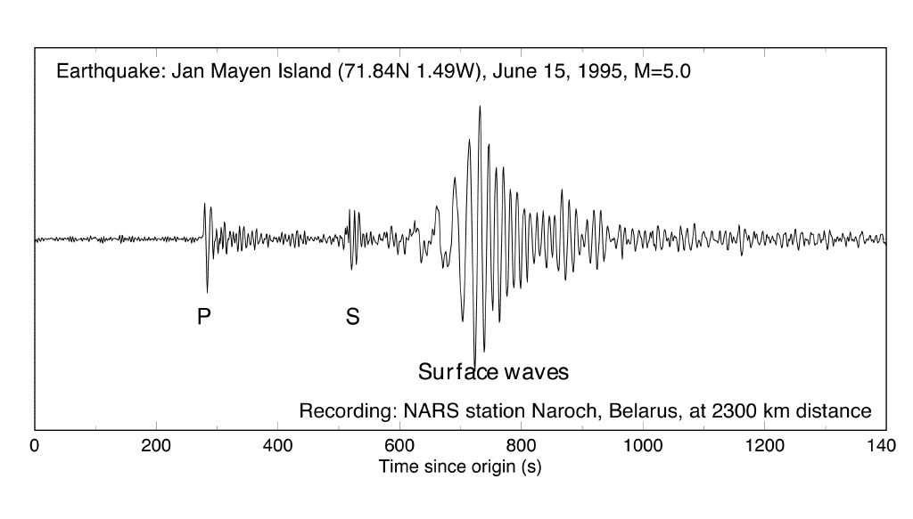
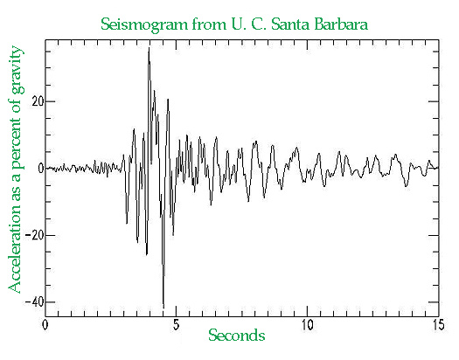
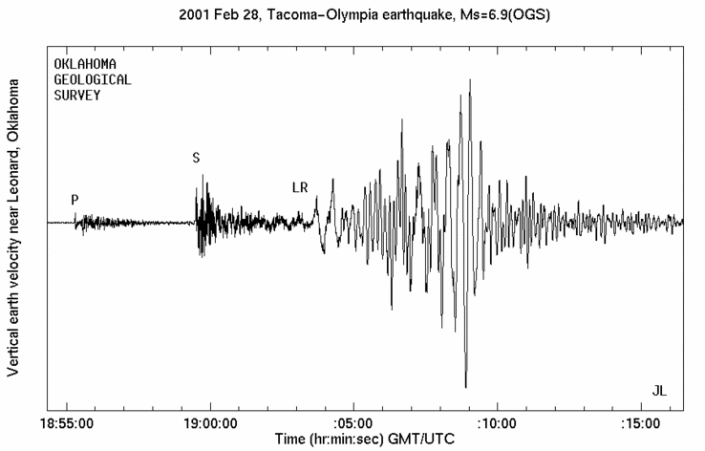
- Have a class discussion around the following questions:
  - How do geologists know earthquakes are happening even if they can not feel them?
  - Why is it important to monitor earthquakes?
  - Can anyone predict earthquakes?
  - How did geologists determine its location, epicenter and hypocenter?
- Teach Lesson B SC Indicator 8-3.3 “Locating Earthquakes”

Additional Resources:
- The IRIS (Incorporated Research Institution for Seismology) Consortium – http://www.iris.edu
- USGS Seismic Data page – http://earthquake.usgs.gov/
- USGS Seismic Information for Children -
http://earthquake.usgs.gov/learn/kids/
- The Geologic Society of America - http://www.geosociety.org/
- Geology and Earth Science – http://www.geology.com
- National Park Service - http://www.nps.gov/brca/forteachers/geodetective.htm
- Geology animations and songs from the University of Kentucky - http://www.as.uky.edu/academics/departments_programs/EarthEnvironmentalSciences/EarthEnvironmentalSciences/Educational%20Materials/Pages/default.aspx

Teaching Indicator 8-3.3: Lesson B - “Locating Earthquakes”

Instructional Considerations:
This lesson is an example of how a teacher might address the intent of this indicator. The STC kit Catastrophic Events provides an opportunity for conceptual development of the concepts within the standard. This lesson has been designed to follow Lesson A SC Indicator 8-3.3 “Recording Earthquakes” for the conceptual development of SC Indicator 8-3. NOTE: A student guide on “How to locate the epicenter of an Earthquake”’ a one pager by IRIS, can be downloaded at:
http://www.iris.edu/hq/files/publications/brochures_onepagers/doc/OnePager6.pdf

Misconceptions:
Some incorrect believes children often hold include but are not limited to:
- Earth is molten except for its crust
- As waves move, matter moves along with them
- Children often have trouble making the connection to real world from simulations or models; be explicit in asking clarifying questions to ensure lifelong misconceptions are not created.

Safety Note(s):
Students should know and practice the procedures for fire, glass and chemical safety. Students should use care when performing this experiment, and be wearing the proper safety equipment including aprons and goggles. Students should know and practice safe disposal of materials in a laboratory setting.

Lesson time:
1 day (1 day equals 55 minutes)

Materials (for each group of two students)
- Student copies “Seismographs” (see attached)
- Student copies “Time/Distance Chart and Reference Table” (see attached)
- Student copies “Map of Station Locations” (see attached)

Focus Question:
How do seismologists use seismograms to locate the epicenter of an earthquake?

Engage:
- Ask students chosen at random to explain the difference between an earthquake’s focus and its epicenter and between a seismograph and a seismogram. Review these distinctions if necessary.
- Watch the quick simulation (60 seconds) of how the seismographic data is collected during an earthquake: http://www.iris.edu/hq/programs/education_and_outreach/animations/9
- Locating an earthquake is usually done by reading the time that P-waves and S-waves arrive at a group (three or more) of seismograph stations by a process known as triangulation. The greater the time between the P-waves and S-waves, the further the earthquake is from the seismograph. A travel time chart, showing how much time it takes for different seismic waves to reach a certain distance, is then used to estimate the distance from the earthquake to each seismograph. With at least three such distances it becomes possible to triangulate the location of the earthquake. The focus is the location on the fault where the actual breaking of the rock occurs, and the epicenter is the location on the surface of the earth directly above the focus.
- To model locating the epicenter, use this online simulation: http://www.sciencecourseware.org/VirtualEarthquake/VQuakeExecute.html
It takes you through the entire process step by step for 4 earthquakes.
- Examine this interactive computer simulation of calculating the epicenter of an earthquake: http://www.iris.edu/hq/files/programs/education_and_outreach/aotm/interactive/HowAreEQLocated_WalkRunActivity.swf

Explore:
- Divide the class into pairs of students. Distribute a set of seismograms, one map, and copies of the Time/Distance Reference Table to each pair. Tell students that all the seismograms are from the same earthquake, a quake that occurred on January 14, 1993, with a magnitude of 3.3, but each was recorded by a different seismograph in the seismograph network.
- Give these directions for finding the epicenter of the earthquake recorded on the five seismograms:
  - On the first seismogram, use the second scale to measure the time-distance from the nearest 10-second mark to the P wave arrival of the earthquake. Record the P wave arrival times in the table to the nearest second.
  - Repeat for the S wave, measuring from the same minute mark.
  - Find the Ts - Tp time by subtracting the arrival time of the P wave from the arrival time of the S wave. Record this time in the table.
  - Use the time/distance table to determine the distance to the epicenter.
  - Repeat this procedure for all of the stations.
  - For each seismogram, draw a circle on the map with the compass, using the distance you calculated as the radius of the circle. Place the point of the compass at zero on the map scale and adjust the compass width to the calculated distance. With the distance set, place the point of the compass on the station and draw a circle.
- Mark the outer edge of each circle with a letter to identify the station.
  - Repeat, setting the compass and drawing circles for all five stations.
- Instruct students to circle the area where all the circles intersect. Ask: What is this area called? (Answer: It is the epicenter of the earthquake.)

Explain
- Build a class discussion around these questions:
  - What information can be obtained from one seismogram? (Answer: The distance from that seismograph in a 3600 circle.)
  - After the arcs for stations TRYN and FGTN were drawn, where was the epicenter of this earthquake? Explain. (Answer: We don’t know yet. It could be at either place where the two arcs cross. They are the common points.)
  - After all the stations were drawn, where was the actual epicenter of this earthquake? Where was its focus? (Answer: In the area where the arcs cross just south of station BHT. Directly under the epicenter.)
  - Why is it necessary to have measurements from at least three different stations to locate the epicenter of an earthquake? (Answers will vary but should relate to the above questions.)
  - Why don’t all of the arcs pass through the same point? (Answers will vary. Accuracy in measurement and drawing should be two most common. Also, an earthquake does not occur at one point but along a fault surface. Have students speculate as to the location and strike of the fault.)
- Which station was closer to the earthquake’s epicenter, BBG or FGTN? Cite two kinds of evidence from the seismograms to support your conclusion. (Answer: BBG. Evidence: amount of lag time and amplitude difference.)
- Would it be possible for an earthquake at this location to be felt where you live? Why or why not? (Answers will vary; will depend on distance from the focus and the magnitude of the quake.)
- P waves travel at an average velocity of 6 km/sec in the Earth’s crust. How long would it take for the P waves from this quake to reach a seismic station in your city, if they continued to travel at a constant speed? (Answers will vary. Multiply 6 km/sec times the distance to your city.)

Extend:
- Challenge students to research these questions:
  - Would a seismograph work on the moon?
  - Have scientists placed seismographs on the moon and other planets?
  - If so, which planets? Have quakes been detected there?
- Interested students may research several types of seismographs and build their own models.
- IF students need additional practice in locating the epicenter of an earthquake, a second lesson has been provided after the attachments. (NOTE: This is ONLY to be done if students are having trouble with the concept)
- Additional practice in locating the epicenter (see attached)
- Teach Lesson A SC Indicator 8-3.4 “Properties of Rocks”

Note: This lesson was extracted from “Seismic Sleuths”: A revision of the Teacher’s Package for Grades 7-12” published by The American Geophysical Union. The entire publication can be downloaded at: http://www.scec.org/education/education/internships/00/vanroosendaal/vanroosendallreport.pdf

Additional Resources:
- The IRIS (Incorporated Research Institution for Seismology) Consortium – http://www.iris.edu
- USGS Seismic Data page – http://earthquake.usgs.gov/
- USGS Seismic Information for Children -
http://earthquake.usgs.gov/learn/kids/
- The Geologic Society of America - http://www.geosociety.org/
- Geology and Earth Science – http://www.geology.com
- National Park Service - http://www.nps.gov/brca/forteachers/geodetective.htm
- Geology animations and songs from the University of Kentucky - http://www.as.uky.edu/academics/departments_programs/EarthEnvironmentalSciences/EarthEnvironmentalSciences/Educational%20Materials/Pages/default.aspx

Identifying the Earthquake Waves on a Seismogram
(Label the P-waves, S-waves and Surface waves)

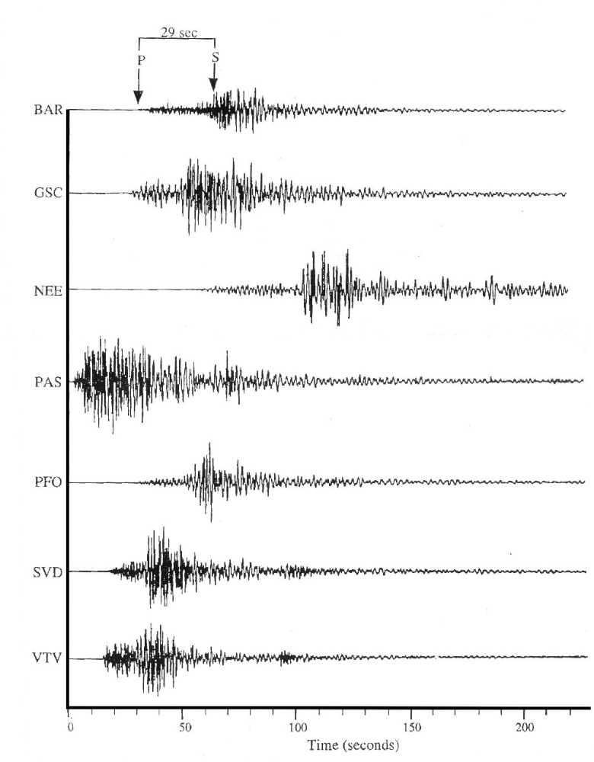
Seismograms
Time/Distance Chart and Reference Table

Data Chart
Station | Arrival Time P-wave | Arrival Time S-wave | Difference in  Time of Arrival | Distance from Station to Epicenter
BAR | 32 seconds | 61 seconds | 29 seconds | 245 km
GSC
NEE
PAS
PFO
SVD
VTV

Time/Distance Graph
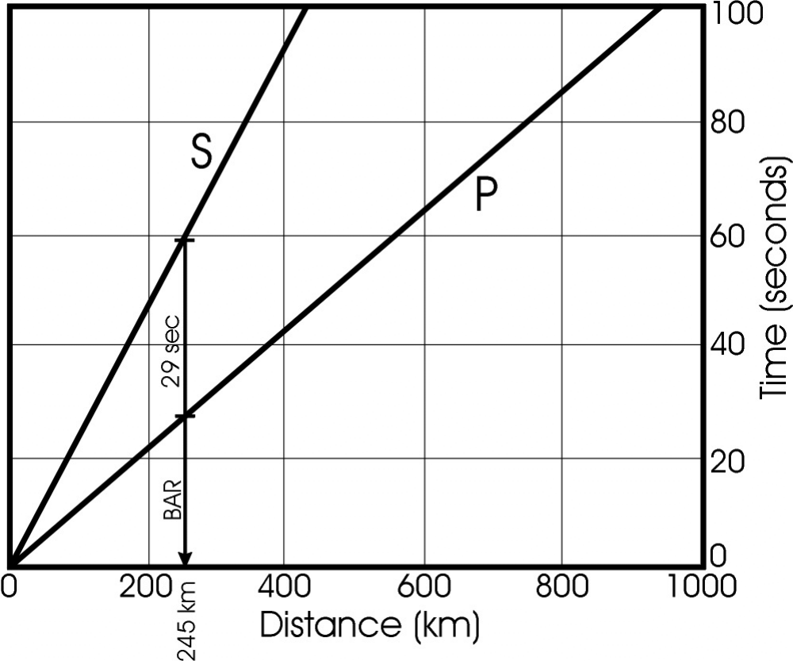
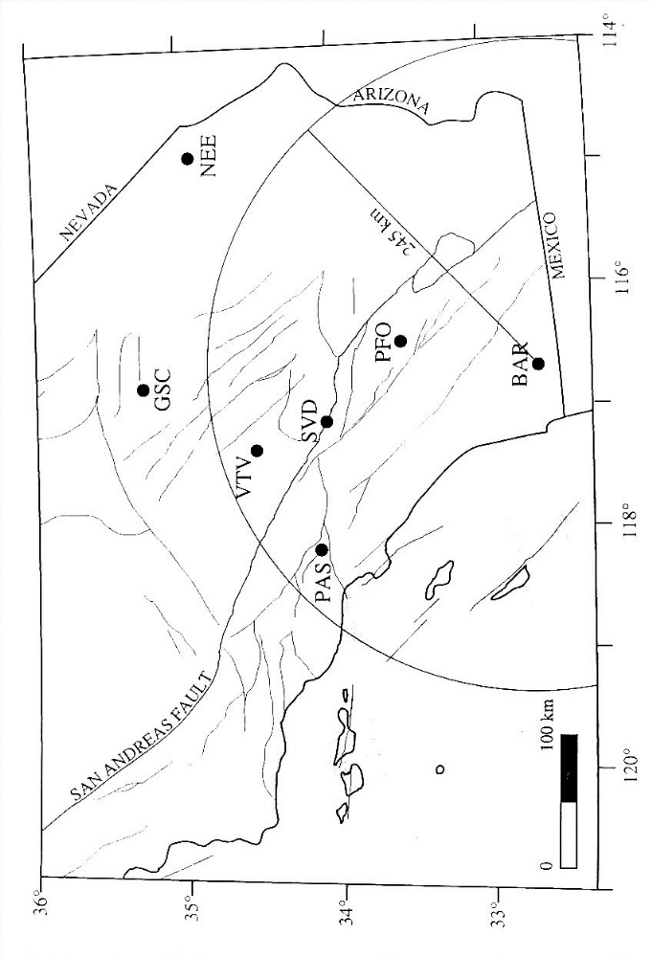
Map of Station Locations
Teaching Indicator 8-3.3: Lesson B (ALTERNATIVE) - “Locating the Epicenter for Earthquake in Charleston, South Carolina”

Instructional Considerations:
This lesson is an example of how a teacher might address the intent of this indicator. The STC kit Catastrophic Events provides an opportunity for conceptual development of the concepts within the standard. This lesson has been designed to be used in addition to or in place of Lesson B “Locating Earthquakes”.

Misconceptions:
Some incorrect believes children often hold include but are not limited to:
- Earth is molten except for its crust
- As waves move, matter moves along with them
- Children often have trouble making the connection to real world from simulations or models; be explicit in asking clarifying questions to ensure lifelong misconceptions are not created.

Safety Note(s):
Students should know and practice the procedures for fire, glass and chemical safety. Students should use care when performing this experiment, and be wearing the proper safety equipment including aprons and goggles. Students should know and practice safe disposal of materials in a laboratory setting.

Lesson time:
1 day (1 day equals 55 minutes)

Materials Needed: (per groups of 2)
- Copies of the three Seismographs from areas around Charleston, SC (see attached)
- Copies of the data tables 1 and 2 (see attached)
- Copy of the map of the Charleston are (see attached)
- Ruler – metric (with millimeters)
- Compass

Focus Question:
How can the epicenter of an earthquake be inferred based on seismographic data?

Engage:
- Review procedures for calculating the epicenter for an Earthquake.

Explore:
- Study the three sections of seismograms shown below.
- Each seismogram indicates the arrival time of the P waves and S waves of the same earthquake, as recorded at three different stations around Charleston, SC (BRNCH, JAMES, TIMBR). Locate the arrival time of the P waves for each seismogram to the nearest second and record in data chart 1.
- Locate the arrival time of the S waves for each seismogram and record in data chart 1.
- Determine the difference, in seconds, between the arrival time of the P and S waves on each seismogram and record in data chart.
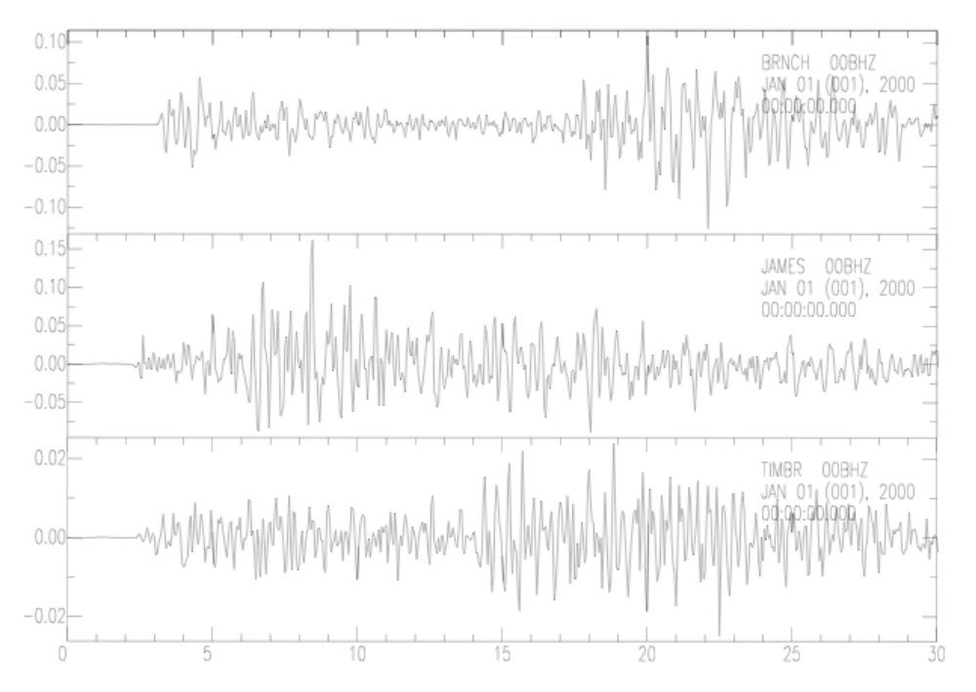
Data Chart
Station | Arrival Time P-wave | Arrival Time S-wave | Difference in  Time of Arrival | Distance of Station from Epicenter
BRNCH | 3 seconds | 18 seconds | 15 seconds | 122 km
JAMES | 2 seconds | 5 seconds | 3 seconds | 26 km
TIMBR | 3 seconds | 14 seconds | 11 seconds | 90 km

- Look at the graph on the following page and answer the following:
  - What amount of time does each increment on the vertical (y) axis represent? (Answer: 5 seconds)
  - How many kilometers does each increment on the horizontal (x) axis represent? (Answer: 25 kilometers)
  - How long does it take a P wave to travel 150 km from an epicenter? (Answer: the P waves arrive first therefore it is the lower line (aqua); about 25 seconds)
  - How long does it take an S wave to travel 150 km from the same epicenter? (Answer: the S waves arrive second therefore it is the upper line (red); about 44 seconds)
  - How much longer does it take an S wave to travel 150 km than a P Wave? (Answer: P wave – S wave: 44 sec – 25 sec = 19 sec)
  - How much longer does it take an S wave to travel 200 km than a P wave? (Answer: P wave – S wave: 57 sec – 34 sec = 23 sec)
  - In general, what happens to the difference in travel times as the distance increases? (Answer: the time difference increases the further the recording station is away from the earthquake)
- Lay the edge of a small piece of paper along the vertical axis so that one end is even with the “0” coordinate. Mark off the “0” point as well as a distance on the edge of the paper that represents 30 seconds.
- Slide the marked paper along the P and S curves of the graph until the upper mark (30sec mark) lies on the S curve, and the lower mark (0s mark) on the P curve. Be sure the edge of the paper lines up with the vertical lines of the graph.
- According to the graph, how far from the epicenter does 30sec represent? (Answer: about 238 kilometers)
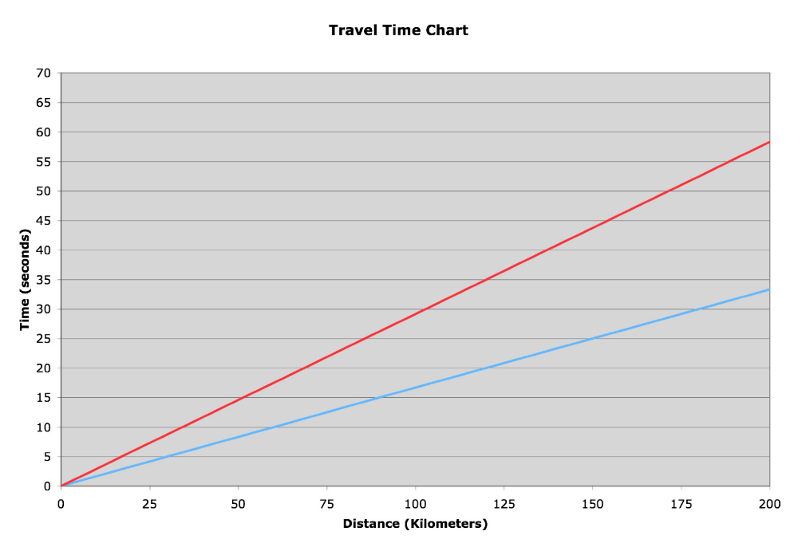
- To find the distance to the epicenter of the earthquake, repeat steps 6-8 for the three stations by using the “Difference in Time of Arrival” for each. Record in data chart.
- Which station is the farthest from the epicenter? (Answer: BRNCH)
- Look at the map for the stations. Determine the scale (hint: how many kilometers is one degree of latitude). (Answer: 1 degree of latitude = 100 km)
- Using the scale, set your compass radius to the distance of the epicenter from the BRNCH station. With this radius and BRNCH station as the center, draw a circle on the map. The epicenter of the earthquake is somewhere on this circle. Why can’t its exact position be determined from this circle? (Answer: you cannot determine the exact position with only one circle; you must have three intersecting circles to determine the exact location)
- Repeat step 12, setting your compass for the radius for the distance of the epicenter from the JAMES station. At how many points do the two circles intersect?
- The epicenter must lie on one of these two points. Why?
- Repeat step 12 for the TIMBR station. At how many points do the three circles intersect? What does the point where they intersect represent? Explain.
- Near what latitude and longitude shown on the map might the earthquake have occurred?
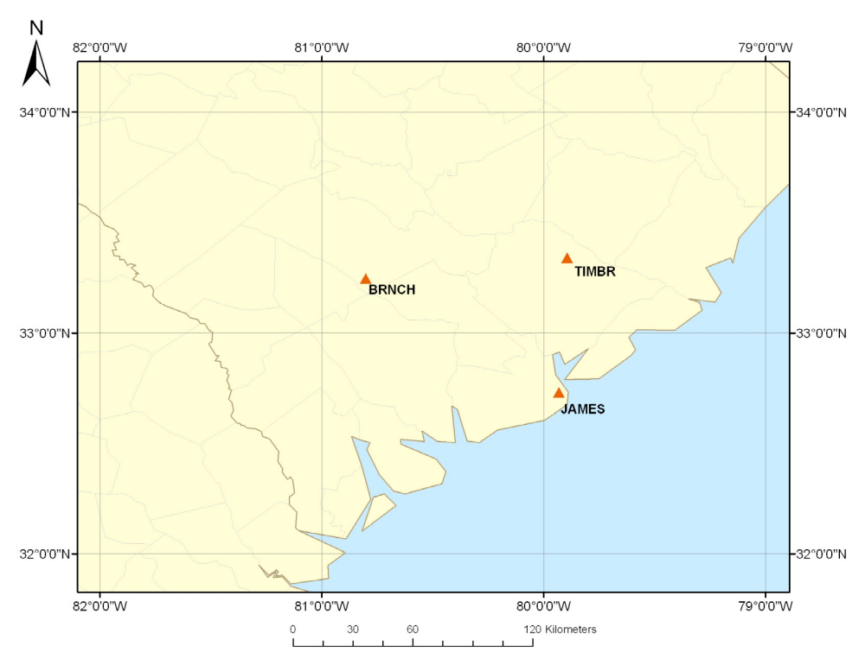

This activity was adapted from the lesson “Locating an Earthquake Epicenter” published by the South Carolina Earthquake Education and Preparedness Program (SCEEP) at the College of Charleston and can be downloaded in its original form at: http://scearthquakes.cofc.edu/educators/toolkits/LocateEpicenter.pdf

Explain:
- (time P-wave) – (time S-wave) = change in time
- Plot change in time on a time-distance graph to determine the distance from the station the earthquake occurred (NOTE: a short cut is to multiply the change in time from the P-wave to the S-wave with eight (8)
- Once you have the distance from station to outer perimeter of the earthquake, use a compass to draw a circle around your location (since all you know is how far it is away, not the direction it happened – it could be anywhere on the circumference of the circle
- Therefore you must know data from at least 3 stations to plot the epicenter – the intersection of the three circles is the epicenter of the Earthquake

Body wave #1: P-waves – first to arrive (longitudinal waves –compress through materials; approximate speed 3.9 miles per second) travel through the earth)
Body wave #2 S-waves – second to arrive (transverse waves therefore deform materials as they travel through the earth slowing them down – approximate speed 2-3 miles per second))
Surface waves – last to arrive (has the highest amplitude) – travel along the surface of ground OR just below it along the planes between rock layers which is why they cause the most damage(approximate speed 2.2 miles per second)
Three Seismographs from areas around Charleston, South Carolina

Data Chart
Station | Arrival Time P-wave | Arrival Time S-wave | Difference in  Time of Arrival | Distance of Station from Epicenter
BRNCH

JAMES

TIMBR

Teaching Indicator 8-3.3: Lesson B (EXTRA PRACTICE) - “Locating the Epicenter”

Materials Needed:
- Metric Ruler
- Compass
- Map of the United States worksheet (see attached)

Procedure:
On February 15, 1999, an earthquake registering 7.2 on the Richter scale occurred somewhere in the U.S. Determine the location of the epicenter using the following data:

- Seismograph information was used to determine the distance of the quake from the following locations:
  - Denver, CO = 740 miles
  - Atlanta, GA = 562 miles
  - Albany, NY = 962 miles

- On the given U.S. map, 1cm = 137 miles. Convert the distance of the earthquake from each city to centimeters.
  - Denver, CO = ________________________
  - Atlanta, GA = ________________________
  - Albany, NY = ________________________

- Using a metric ruler, measure the number of centimeters for Denver on the string. Place your pencil in the loop of the string and hold the other end securely at Denver. Draw an arc across the U.S.

Repeat the procedure for Atlanta and then Albany

- Where is the epicenter of this earthquake located? (Use a map of the U.S. to describe the location.) How do you know?
- Describe how seismographic information is used to calculate the distance to the epicenter.

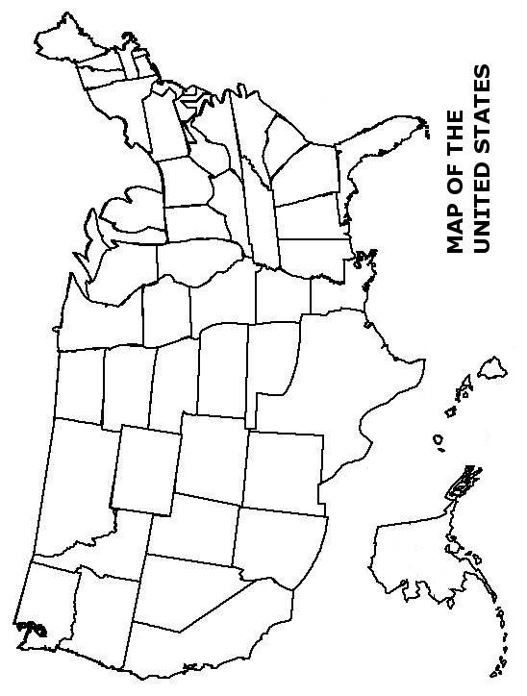

Career Connections

Geologists study the composition, processes, and history of the Earth. They try to find out how rocks were formed and what has happened to them since their formation. They also study the evolution of life by analyzing plant and animal fossils.

Volcanologists study the remains of either dead or dormant volcanoes, or monitor volcanoes that are dormant, but may become active or "reawaken.” A significant portion of a volcanologist’s work is also done in the laboratory and office, analyzing rock samples, reading and writing scientific papers, performing computer modeling of various aspects of eruptions, and interpreting the data that they have collected from the field. Basically, the goals of volcanology are to understand how and why volcanoes erupt, how to predict eruptions, their impacts on the history of the Earth and how they may affect humans and their environment. It is also important for volcanologists to be able to interpret and publish/present their findings in such a way that it is easy for the general public to understand.

Seismologists are scientists who study earthquakes and seismic waves. They study the earth movements - like mini earthquakes - that may precede a major volcanic eruption. The Seismologist may also set up monitoring equipment near to the volcano. The seismologist is an important scientific member of the team in helping scientists predict eruptions. They may be helped in their task in predicting an eruption by the geo-chemist and others who will measure the gases from the Volcano.

