SOUTH CAROLINA SUPPORT SYSTEM INSTRUCTIONAL GUIDE
Content Area |  | High School Biology
Recommended Days of Instruction: CP Biology-13 days/Applied II-28 days
Standard(s) addressed: Standard B-4 The student will demonstrate an understanding of the molecular basis of heredity.
Indicator: B-4.5 Summarize the characteristics of the phases of Meiosis I and II.

Unit VII – Heredity Module B-4.5
Focus  Indicators | Recommended Resources |  | Suggested Instructional Strategies/Activities | Assessment Guidelines
B-4.5  Summarize the characteristics of the phases of Meiosis I and II. | Meiosis  http://www.cellsalive.com/Meiosis.html  Meiosis  http://www.johnkyrk.com/Meiosis.html  Stages of Meiosis I and II  http://www.biology.arizona.edu/CELL_BIO/tutorials/Meiosis/page3.html |  | This site includes an interactive video of the stages of Meiosis. Teachers can use this as an introductory lesson.  Participants can view each stage of Meiosis including a detailed view of crossing over. This video could be used at any point during the lesson.  View each stage of Meiosis I and II in this site. There are animations that show the chromosomal action for both Meiosis I and Meiosis II. The review also describes meiotic errors. The Meiosis tutorial has questions about situations involving Meiosis. | The objective of this indicator is to summarize the characteristics of the phases of Meiosis I and Meiosis II; therefore, the primary focus of assessment should be to describe the major events in the phases of Meiosis I and II.

Unit VII – Heredity Module B-4.5
Focus  Indicators | Recommended Resources |  | Suggested Instructional Strategies/Activities | Assessment Guidelines
B-4.5  Summarize the characteristics of the phases of Meiosis I and II. | www.scilinks.org, Topic Meiosis (Code: cbn-4114)  Turkeys in the Cell – The Meiosis Square Dance  www.accessexcellence.org/AE/AEPC/WWC/1991/Meiosis_dance.php  Meiosis web quest  http://www.biologycorner.com/worksheets/Meiosis_internet.html |  | This site is used by most major publishers. You will need to pre-register. The site describes basic meiotic division, as well as its relationship to independent assortment. It can be used throughout the lesson.  This is an activity to identify the events of Meiosis, as well as the differences between Meiosis and Mitosis. Students will role play as chromosomes. This activity can be used as reinforcement of the indicator.  Activity B-4.5a: This is a web quest of Meiosis. The first link is broken, but others are functional. The students visit various web sites to answer questions, view clips of Meiosis, and develop sketches of the process. It could be used as independent study of the indicator. Answers are attached on Activity B-4.5a.
Unit VII – Heredity Module B-4.5
Focus  Indicators | Recommended Resources |  | Suggested Instructional Strategies/Activities | Assessment Guidelines
B-4.5  Summarize the characteristics of the phases of Meiosis I and II. | Meiosis Diagrams  http://www.biologycorner.com/worksheets/Meiosis_ws.html |  | .  Activity B-4.5b: Meiosis Concentration Game  Students match pictures of meiotic phase to the appropriate titles as a review activity.  Activity B-4.5c: This activity allows students to name the phases of Meiosis based on written descriptions and diagrams. This is available as a reinforcement activity. Answer Sheet is attached as Activity B-4.5c.  Activity B-4.5d: Meiosis Sketches  This exercise examines Meiosis by making drawings of the phases and describing the major characteristics of each phase. This is a reinforcement exercise. Answers are attached as Activity B-4.5d.

Indicator: B-4.6 Predict inherited traits by using the principles of Mendelian genetics (including segregation, independent assortment, and dominance).
Unit VII – Heredity Module B-4.6
Focus  Indicators | Recommended Resources | Suggested Instructional Strategies/Activities | Assessment Guidelines
B-4.6  Predict inherited traits by using the principles of Mendelian genetics (including segregation, independent assortment, and dominance). | Mendelian Genetics  http://www.biology-online.org/2/5_mendelian_genetics.html  Bikini Bottom Genetics I  http://sciencespot.net/Media/gen_spbobgenetics.pdf  Bikini Bottom Genetics II  http://sciencespot.net/Media/gen_spbobgenetics2.pdf  Genetic Practice  http://sciencespot.net/Media/gen_spbobgenetics.pdf  Genetic Review  http://sciencespot.net/Media/gen_spbobgeneticsqz.pdf | This is a tutorial of Mendel’s laws and Mendelian genetics. Students can reinforce their concept of Mendelian genetics.  This web site uses Sponge Bob characters as examples in problems using simple Mendelian genetics. This is a practice activity. A key is included at the site.  This provides more practice on genetic problems using Sponge Bob. A key is provided at the site.  This activity may be used as a practice sheet for simple Mendelian genetics. Includes a key at the site.  This is an assessment of simple Mendelian genetics using Sponge Bob. A key is provided at the site. | The objective of this indicator is predict inherited traits by using the principles of Mendelian genetics, therefore, the primary focus of assessment should be to determine inherited traits of offspring using the principles of segregation, independent assortment, and dominance.

Unit VII – Heredity Module B-4.6
Focus  Indicators | Recommended Resources | Suggested Instructional Strategies/Activities | Assessment Guidelines
B-4.6  Predict inherited traits by using the principles of Mendelian genetics (including segregation, independent assortment, and dominance). | Making a Face  http://www.woodrow.org/teachers/biology/institutes/1997/makeface/stuhnout3.html  Create a Species  http://www.biologycorner.com/worksheets/designspecies.html  Bikini Bottom Dihybrid  http://sciencespot.net/Media/gen_spbobdihybird.pdf | Students use genotypes and phenotypes from simulations of gametogenesis, fertilization, and embryogenesis in this web site to form new faces or babies. This can be a culminating activity.  Using genes for simple dominance, codominance, multiple alleles, and sex-linkage, design creature genotypes in this site. It also includes Punnett Squares and pedigree. This activity needs to be used after students have an understanding of the above terminology.  Activity B-4.6a: Mendel and Meiosis. In this activity students will simulate the law od segregation and determine the genotypes and phenotypes of the offspring. This prides a practical application of this indicator.  Activity B-4.6b:This Sponge Bob activity gives practice problems with dihybrid crosses. A key is attached as Activity B-4.6b.

Unit VII – Heredity Module B-4.6
Focus  Indicators | Recommended Resources | Suggested Instructional Strategies/Activities | Assessment Guidelines
B-4.6  Predict inherited traits by using the principles of Mendelian genetics (including segregation, independent assortment, and dominance). | Genetic Word Search  http://www.biologycorner.com/worksheets/heredity_wordsearch.pdf  Genetic Review Puzzle  http://sciencespot.net/Media/gen_reviewpuzzle.pdf  Dominant and Recessive  http://www.biology.arizona.edu/mendelian_genetics/mendelian_genetics.html | Activity B-4.6c:Here is a word search requiring students to supply the words given the definitions. Key attached as Assessment B-4.6c.  This is a fill-in-the-blank reviewing basic terms. Students can check themselves because their answers must spell out a message. A key is provided at the site.  This is a site that tests student knowledge of crosses involving dominant/recessive traits, sex-linkage, blood type; includes a tutorial and essential vocabulary. This can be used as a formative assessment after students have mastered monohybrid, dihybrid, and sex-linkage crosses.

Unit VII – Heredity Module B-4.6
Focus  Indicators | Recommended Resources | Suggested Instructional Strategies/Activities | Assessment Guidelines
B-4.6  Predict inherited traits by using the principles of Mendelian genetics (including segregation, independent assortment, and dominance). | Basic Genetic Review  http://www.biologycorner.com/worksheets/basicgenetics.html  Chromosomal Traits http://www.biologycorner.com/worksheets/pipecleaner.html | Activity B-4.6d: This is a formative assessment because it tests knowledge of vocabulary such as homozygous/ heterozygous and genotype/phenotype and requires students to predict simple dominant/recessive crosses using Punnett Squares. Key attached as Activity B-4.6d.  Activity B-4.6e: This activity allows students to design chromosomal traits, including sex-linked traits. This could serve as a reinforcement activity. Answers attached as Activity B-4.6e. This can be used in B-4.7 also.

Unit VII – Heredity Module B-4.7
Focus  Indicators | Recommended Resources | Suggested Instructional Strategies/Activities | Assessment Guidelines
B-4.7  Summarize the chromosome theory of inheritance and relate that theory to Gregor Mendel’s principles of genetics. | Article  http://www.genetics.org/cgi/content/full/160/1/1  Article  http://www.nature.com/scitable/topicpage/Developing-the-Chromosome-Theory-164  Polygenics Traits with Pennies  http://www.learnnc.org/lp/pages/3070  Bikini Genetics-Incomplete Dominance  http://sciencespot.net/Media/gen_spbobincdom.pdf | This is an article on Walter Sutton and the Chromosome Theory of Inheritance. This literary component can be used at the beginning of the lesson.  This is an article on developing the Chromosome Theory. It can be used as supplemental reading material.  This is a teacher generated activity demonstrating polygenic traits. Students will model the inheritance of polygenic traits. This can be used after the topic of polygenics is introduced. The handouts and answer sheets are provided at the website.  This activity provides practice on incomplete dominance crosses in the world of Sponge Bob. The activity is a form of practice on the concept. A key is provided at the site.

Unit VII – Heredity Module B-4.7
Focus  Indicators | Recommended Resources | Suggested Instructional Strategies/Activities | Assessment Guidelines
B-4.7  Summarize the chromosome theory of inheritance and relate that theory to Gregor Mendel’s principles of genetics. | Blood Types and Heredity  http://t4.jordan.k12.ut.us/teacher_resources/Science/modelclassroomroot/biologycalendars/0402.html  (Click on blood types and heredity)  X Linked Genes  http://www.biologycorner.com/worksheets/genetics_xlinked.pdf | This activity provides a demonstration on which blood types cannot mix. It includes Punnett Squares and a pedigree. This is useful as a review of the terminology. A key is provided with the activity.  Activity B4.7a: A practice sheet on sex-linked traits is provided for this site. Answers are attached as Activity B-4.7a.  Activity B-4.7d Pedigree  Students are given phenotypic descriptions of family members and must create a pedigree. They also have to determine the genotypes of the members. This is to be used after the introduction of the terms of genetics.

Unit VII – Heredity Module B-4.7
Focus  Indicators | Recommended Resources | Suggested Instructional Strategies/Activities | Assessment Guidelines
B-4.7  Summarize the chromosome theory of inheritance and relate that theory to Gregor Mendel’s principles of genetics. | Attack on the “Mend- Aliens”  http://www.jcseagles.com/cmorris/mendaliengeneticsproblems.html  Genetics: Multiple Allele Traits  http://www.biologycorner.com/worksheets/genetics_multiplealleles.pdf  Sex-Linked Inheritance Problem Set  http://www.biology.arizona.edu/mendelian_genetics/problem_sets/sex_linked_inheritance/sex_linked_inheritance.html | Activity B-4.7c: A teacher generated this interactive web site performing genetic crosses; one question asks the student to propose a chromosome map. This activity should be used as a review of the indicator. Answers attached as Activity B-4.7c.  Activity B-4.7d: This is a review sheet on multiple alleles. Answers are attached as Activity B-4.7d.  Students follow tutorials on sex-linkage in the fruit fly and in humans and then assess their knowledge. It is recommended to use this after the students understand the principle of inheritance of sex chromosomes.  Answers are given with the site.

Indicator: B-4.8 Compare the consequences of mutations in body cells with those in gametes.
Unit VII – Heredity Module B-4.8
Focus  Indicators | Recommended Resources | Suggested Instructional Strategies/Activities | Assessment Guidelines
B-4.8  Compare the consequences of mutations in body cells with those in gametes.  (This is where you teach chromosomal mutations; gene mutations are in Unit VI). | Genetic mutation  http://www.concord.org/~btinker/molo/molo_concept_maps/Mutations.pdf  Mutation Resource  www.accessexcellence.org/RC/VL/GG/mutation2.php  Chromosomal mutations  www.biology-online.org/2/8_mutations.html  Mutation and Genetic Disorders  http://highered.mcgraw-hill.com/sites/0070960526/student_view0/chapter18/animation_quiz_1.html  Review Article  http://learn.genetics.utah.edu/archive/proteinrole/ | This web site shows a concept map of mutations. This can be used as an introduction handout page.  This is a diagram showing basic types of chromosomal mutations. This is a sheet that students can use as a reference.  This is a quick reference guide on types of chromosomal mutations.  A tutorial on chromosomal mutations with a multiple choice quiz is provided at this site. Students will receive a visual reinforcement of the concepts of this indicator.  “How Do Mutations Cause Genetic Disorders?” is the title of this document that students can use to review the terminology of mutations. | The objective of this indicator is to compare the consequences of mutations in body cells with those in gametes, therefore, the primary focus of assessment should be to detect similarities and differences between the mutations that occur in sex cells to those in somatic cells.

Unit VII – Heredity Module B-4.8
Focus  Indicators | Recommended Resources | Suggested Instructional Strategies/Activities | Assessment Guidelines
B-4.8  Compare the consequences of mutations in body cells with those in gametes.  (This is where you teach chromosomal mutations; gene mutations are in Unit VI). | Slides of Mutations  www.cancer.gov/cancertopics/understandingcancer/genetesting | Use slides 8 to 16 to show the consequences of mutations of body cells and the gametes. This site provides students with reinforcement of the terminology of types of mutations, including a review of gene mutations.

Unit VII – Heredity Module B-4.8
Focus  Indicators | Recommended Resources | Suggested Instructional Strategies/Activities | Assessment Guidelines
B-4.8  Compare the consequences of mutations in body cells with those in gametes.  (This is where you teach chromosomal mutations; gene mutations are in Unit VI). | Bioethics  http://www.ncsu.edu/kenanfellows/2002/pligon/biotech/lessons/unit4.html  Chromosome Study  http://www.biologycorner.com/worksheets/Chromosomestudy.html | This is a complete lesson with two web quests on bioethics and biotechnology. Students can search for up to date information about bioethics and biotechnology in relationship to mutations.  Activity B-4.8a: Making Karyotypes  This activity uses models of chromosomes to make karyotypes of normal and abnormal human conditions. The answer key is attached. It should be used after the lesson has been taught.  Activity B-4.8b: Chromosomal Mutations  This review sheet allows students to use the terminology and concepts of the indicator. It should be used as a form of assessment.  Activity B-4.8c: In this activity, students prepare karyotypes of a normal person and a person with a disorder. A teacher preparation sheet is included at this site. This activity provides a review of the terminology for mutations. The answer sheet is attached as Activity B-4.8c.

Indicator: B-4.9 Exemplify ways that introduce new genetic characteristics into an organism or a population by applying the principles of modern genetics.
Unit VII – Heredity Module B-4.9
Focus  Indicators | Recommended Resources | Suggested Instructional Strategies/Activities | Assessment Guidelines
B-4.9  Exemplify ways that introduce new genetic characteristics into an organism or a population by applying the principles of modern genetics. | Plasmid Cloning  http://www.sumanasinc.com/webcontent/animations/content/plasmidcloning.html  Selective Breeding  http://t4.jordan.k12.ut.us/teacher_resources/Science/modelclassroomroot/biologycalendars/0402.html  What Traits Have Been Engineered  http://www.geo-pie.cornell.edu/traits/traits.html  Inserting a DNA Sample into a Plasmid  www.accessexcellence.org/RC/VL/GG/inserting.php | This tutorial shows plasmid cloning. It is a way students can review the process of plasmid cloning through an animation video.  Information with questions on selective breeding and hybridization is presented to students in this activity. This could be used as an introductory lesson (Performance Test-Rabbit Breeding and Selective Breeding).  This web site has a list of products that have been genetically engineered. Students will use this as a reference sheet only. This is used by the teacher for a literacy component to the indicator.  This article shows a DNA sample being inserted into a plasmid. This links to a page showing cloning into a plasmid. It may be used as a reference sheet.

Unit VII – Heredity Module B-4.9
Focus  Indicators | Recommended Resources | Suggested Instructional Strategies/Activities | Assessment Guidelines
B-4.9  Exemplify ways that introduce new genetic characteristics into an organism or a population by applying the principles of modern genetics. | Gene and Inheritance  http://www.abpischools.org.uk/page/modules/genome/dna3.cfm?coSiteNavigation_allTopic=  Click and Clone  http://learn.genetics.utah.edu/content/tech/cloning/clickandclone  Welcome to the Clone Age  www.videos.howstuffworks.com/hsw/6339-the-new-frontier-welcome-to-the-clone-age-video.htm  Genetically Modified Organism  http://www.learner.org/courses/biology/units/gmo/images.html | Click on Cloning. This is a tutorial website on cloning with questions for students. Students could use this as an introductory lesson.  The basics of cloning are introduced in this interactive program. It may be used as an introductory lesson by the students.  Several videos on cloning, including Dolly, endangered species, and the ethics issues involved are explored at this site and its direct links. This could be used as a discussion guide after the students have an understanding of the cloning concept.  Short animations of creation of a transgenic animal and recombinant DNA are shown. This also includes an image of selective breeding of corn. Suggested activities and questions are included. This could be used after the introduction of the lesson.

Unit VII – Heredity Module B-4.9
Focus  Indicators | Recommended Resources | Suggested Instructional Strategies/Activities | Assessment Guidelines
B-4.9  Exemplify ways that introduce new genetic characteristics into an organism or a population by applying the principles of modern genetics. | The Human Genome Project  http://www.teachersdomain.org/resource/tdc02.sci.life.gen.lp_hgpwhat/  Bioengineered Food  http://www.teachersdomain.org/resource/tdc02.sci.life.gen.lp_bioengfood/ | This is another teacher’s domain activity on the human genome project. Several quick videos are available for the students. Questions are presented also. There is a jeopardy type activity listed for use. Students must demonstrate an  understanding of the terminology to succeed at the lessons and questions.  Lessons showing transgenic manipulation and selective breeding are provided at this site. It includes factual and ethical situations. Students must demonstrate an understanding of the terminology to succeed at the lessons and questions.  (Registration with the teacher’s domain is required, but it is free.)

Unit VII – Heredity Module B-4.9
Focus  Indicators | Recommended Resources | Suggested Instructional Strategies/Activities | Assessment Guidelines
B-4.9  Exemplify ways that introduce new genetic characteristics into an organism or a population by applying the principles of modern genetics. | Decisions, Decisions  http://www.accessexcellence.org/AE/ATG/data/released/0350-SharonNelson/index.php  Issues in Biotechnology  www.actionbioscience.org/biotech/ | This is an activity requiring students to make ethical decisions on inherited diseases; it has rubrics so that it can be used as an assessment. Doing research is required to do this activity. Students should do this activity after an introduction to the indicator.  This site provides several links to various topics dealing with the issues of biotechnology. The titles alone can lead to class discussions on biotechnology in modern genetics. Many articles are provided for research projects in biotechnology. This site is useful if the teacher pursues further study of biotechnology.  Activity B-4.9a: Stem Cell Research Flier  Students are asked to do some basic research on stem cell research and create a flier on the information. A rubric suggestion is included. This may be used at any time during the lesson.

Unit VII – Heredity Module B-4.9
Focus  Indicators | Recommended Resources | Suggested Instructional Strategies/Activities | Assessment Guidelines
B-4.9  Exemplify ways that introduce new genetic characteristics into an organism or a population by applying the principles of modern genetics. | Genetic Engineering  http://www.biologycorner.com/worksheets/Genetic%20Engineering%20Concept%20Map.pdf | Activity B-4.9b: A concept map on genetic engineering  is given at this site. This is a way students can review genetic engineering. Answer key is attached as Activity B-4.9b.

High School Biology

Unit VII
Heredity

Activities for Indicators
B-4.5, B-4.6, B-4.7, B-4.8, B-4.9

Standard(s) Addressed: Standard B-4 The student will demonstrate an understanding of the molecular basis of heredity.

Indicators:
B-4.5: Summarize the characteristics of the phases of meiosis I and II.

B-4.6: Predict inherited traits by using the principles of Mendelian genetics (including segregation, independent assortment, and dominance).

B-4.7: Summarize the chromosome theory of inheritance and relate that theory to Gregor Mendel’s principles of genetics.

B-4.8: Compare the consequences of mutations in body cells with those in gametes.

B- 4.9: Exemplify ways that introduce new genetic characteristics into an organism or a population by applying the principles of modern genetics.

Activity B-4.5a Meiosis Concentration
Activity B-4.5a.- Meiosis Concentration

ACTIVITY B-4.5a -Meiosis Web Quest Answer Sheet*

*Teacher’s Note: Due to page constraints, only the answer sheet is provided in this document. The worksheet and instructions may be found at Meiosis web quest
http://www.biologycorner.com/worksheets/Meiosis_internet.html

Site 2
12. Interphase
13. Meiosis I and Meiosis II
14. opposite poles
15. synapsis
16. chiasmata
17. Homologous chromosomes line up along the equatorial plate.
18. Chromosomes from each pair move to opposite poles.
19. Short interphase period following Telophase I.
20. haploid
21. single
22. chromosomes decondense and the nuclear membranes reform
23. unique

Quiz
24. Before Meiosis I only
25. Prophase I
26. Metaphase II
27. Telophase II
Site 3
- Purple with green and pink with dark green
- Purple with dark green and pink with light green
Site 4
Meiosis – Check all
Mitosis – Check 2, 4, 6

Activity B-4.5b - Meiosis Concentration

Laminate then cut out or cut out of card stock the following 16 cards. You will need one set per group of students; put no more than four per group. Shuffle the cell cards then lay upside down in 2 columns of four. Shuffle the stage cards (it would be a good idea to have them a different color) then lay upside down in 2 columns of four beside the cell cards. The student should turn over one cell card and one stage card. If they match, they get a point. If there is no match, the cards are turned over at their location and another student gets a turn. This continues until all cards have been identified correctly. You can print a copy of the original cards for them to check by or you can check their cards.
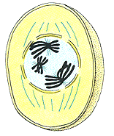

Prophase I

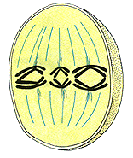

Metaphase I

Activity B-4.5b cont.- Meiosis Concentration

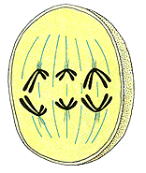

Anaphase I

Activity B-4.5c -Meiosis Diagrams* Answer Sheet

*Teacher’s Note: Due to page constraints, only the answer sheet is provided in this document. The worksheet and instructions may be found at
http://www.biologycorner.com/worksheets/Meiosis_ws.html

- Anaphase II
- Interphase
- Metaphase I
- Telophase II
- Telophase I
- Cytokinesis II
- Metaphase II
- Prophase I
- Prophase II
10. Anaphase I
- 4/10
- Prophase I
- 32
- Metaphase I
- 2/haploid
- Gametes
- Anaphase II
- Anaphase I
- Telophase II
- Cytokinesis II
- Prophase II
- Metaphase I
- Metaphase II
- Prophase I
- Interkinesis (Interphase II)
26.Telophase I

Activity B-4.5d - Meiosis Sketches

Meiosis Sketches: Please draw this as if the diploid number was 6.

- Interphase I – Please draw and label interphase. Explain what occurs during each phase.

A. G1_______________________________

B. S _______________________________

C. G2 _____________________________

Number of Cells: _______________

Number of Chromosomes in Cell: _________

- Prophase I – Please draw prophase and explain what occurs

A.__________________________________

B. _________________________________

C.__________________________________

Number of Cells: _______________

Number of Chromosomes in Cell: _________

- Metaphase I - Please draw metaphase and explain what occurs

A.__________________________________

Number of Cells: _______________
Number of Chromosomes in Cell: _________

Activity B-4.5d cont. - Meiosis Sketches

4.Anaphase I - Please draw anaphase and explain what occurs

A.__________________________________

Number of Cells: _______________

Number of Chromosomes in Cell: _________

- Telophase I - Please draw telophase and explain what occurs

A. _________________________________

B. _________________________________

Number of Cells: _______________

Number of Chromosomes in Cell: _________

- Explain the purpose of Meiosis I.

____________________________________________________________

- Why is it important that you know about Meiosis I?

Activity B-4.5d cont. - Meiosis Sketches

- Interphase II (Interkinesis) – Please draw and label interphase. Explain what occurs in each part.

A. G1 ___________________________

B. S _____________________________

C. G2 _____________________________

Number of Cells: _______________

Number of Chromosomes in Cell: _________

- Prophase II – Please draw prophase and explain what occurs

A. _________________________________

B. _________________________________

C. _________________________________

Number of Cells: _______________

Number of Chromosomes in Cell: ________

- Metaphase II - Please draw metaphase and explain what occurs

A. _________________________________

Number of Cells: _______________

Number of Chromosomes in Cell: ________

Activity B-4.5d cont. - Meiosis Sketches

- Anaphase II - Please draw anaphase and explain what occurs

A. _________________________________

Number of Cells: _______________

Number of Chromosomes in Cell: _________

- Telophase II - Please draw telophase and explain what occurs

A. _________________________________

B. ________________________________

Number of Cells: _______________

Number of Chromosomes in Cell: _________

- Explain the purpose of Meiosis II.

____________________________________________________________

- Why is it important that you know about Meiosis II?

Activity B-4.5d cont. - Meiosis Sketches Answer Sheet

1. Interphase I
A. Growth
B. DNA replication (synthesis)
C. Organelles replicate
Number of cells: 1
Number of Chromosomes in Cell: 12 (6 chromatids)
Drawing should show 6 replicated chromosomes, nuclear membrane breaking
apart, and nucleolus breaking apart.

2. Prophase I
A,B,C: Nuclear membrane is gone, nucleolus is gone, spindle fibers are
beginning to form from centriole (animal cell), chromatids visible and
join as a tetrad. Crossing over may occur.
Number of cells: 1
Number of Chromosomes in Cell: same as Interphase
Drawing should show what is listed in A,B,C and have 3 tetrads.

3. Metaphase I
A. All the tetrads are lined up at the equator on the spindle fibers.
Number of cells: 1
Number of Chromosomes in Cell: 3 tetrads
Drawing should show all 3 tetrads at the equator on the spindle fibers and
the centrioles.

4. Anaphase I
A. Chromatids separate from tetrads and pull toward poles.
Number of cells: 1
Number of Chromosomes in Cell: 3 chromatids (haploid chromatids)
Drawings should show 3 chromatids that have moved toward the centrioles
and spindle fibers beginning to break apart.

5. Telophase I
A, B: two nuclei form, cytoplasm begins to divide, spindles break apart
Number of cells: 1(will become two after cytokinesis)
Number of Chromosomes in Cell: 3 chromatids in each of two nuclei
Drawings should show two nuclear areas in the cell with 3 chromatids in
each.

6. To copy the chromosomes as chromatids and then divide the pairs of
chromatids.

7. It shows how the pairs of chromosomes get separated to get ready for
Meiosis II.

Activity B-4.5d cont. - Meiosis Sketches Answer Sheet

8. Interphase II (Interkinesis) (some cells lack this)
A. growth
B. DOES NOT OCCUR
C. organelles replicate
Number of cells: 2
Number of Chromosomes in Cell: 3 Chromatids
Drawings should show a nucleus in each cell with 3 chromatids and the
nuclear membrane breaking up.

9. Prophase II
A,B,C: Centrioles migrate, spindle fibers form, nuclear membrane breaks:
apart, chromatids attach to spindle fibers
Number of cells: 2
Number of Chromosomes in Cell: 3 Chromatids
Drawings should show each cell with 3 chromatids moving toward spindle
fibers that are radiating from centrioles. There is not nuclear
membrane.

10. Metaphase II
A. Chromatids line up at the equator.
Number of cells: 2
Number of Chromosomes in Cell: 3 Chromatids
Drawings should show each cell with spindle fibers attached to centrioles and
3 chromatids lined up at the equator.

11. Anaphase II
A. Chromatids split and chromosomes move toward the poles.
Number of cells: 2
Number of chromosomes: 3

12. Telophase II
A,B: New nuclei form, nucleolus forms, spindles break apart, cytoplasm
begins to divide.
Number of cells:2 (will become four after cytokinesis)
Number of Chromosomes in Cell: 3

13. To divide the chromatids into chromosomes.

14. This is how haploid cells, gametes, are formed.

Activity B-4.5c -Meiosis Diagrams* Answer Sheet

*Teacher’s Note: Due to page constraints, only the answer sheet is provided in this document. The worksheet and instructions may be found at
http://www.biologycorner.com/worksheets/Meiosis_ws.html

- Anaphase II
- Interphase
- Metaphase I
- Telophase II
- Telophase I
- Cytokinesis II
- Metaphase II
- Prophase I
- Prophase II
10. Anaphase I
- 4/10
- Prophase I
- 32
- Metaphase I
- 2/haploid
- Gametes
- Anaphase II
- Anaphase I
- Telophase II
- Cytokinesis II
- Prophase II
- Metaphase I
- Metaphase II
- Prophase I
- Interkinesis (Interphase II)
26.Telophase I

CHECK THESES ANSWERS

Activity B-4.5d - Meiosis Sketches

Meiosis Sketches: Please draw this as if the diploid number was 6.

- Interphase I – Please draw and label interphase. Explain what occurs during each phase.

A. G1_______________________________

B. S _______________________________

C. G2 _____________________________

Number of Cells: _______________

Number of Chromosomes in Cell: _________

- Prophase I – Please draw prophase and explain what occurs

A.__________________________________

B. _________________________________

C.__________________________________

Number of Cells: _______________

Number of Chromosomes in Cell: _________

- Metaphase I - Please draw metaphase and explain what occurs

A.__________________________________

Number of Cells: _______________
Number of Chromosomes in Cell: _________

Activity B-4.5d cont. - Meiosis Sketches

4.Anaphase I - Please draw anaphase and explain what occurs

A.__________________________________

Number of Cells: _______________

Number of Chromosomes in Cell: _________

- Telophase I - Please draw telophase and explain what occurs

A. _________________________________

B. _________________________________

Number of Cells: _______________

Number of Chromosomes in Cell: _________

- Explain the purpose of Meiosis I.

____________________________________________________________

- Why is it important that you know about Meiosis I?

Activity B-4.5d cont. - Meiosis Sketches

- Interphase II (Interkinesis) – Please draw and label interphase. Explain what occurs in each part.

A. G1 ___________________________

B. S _____________________________

C. G2 _____________________________

Number of Cells: _______________

Number of Chromosomes in Cell: _________

- Prophase II – Please draw prophase and explain what occurs

A. _________________________________

B. _________________________________

C. _________________________________

Number of Cells: _______________

Number of Chromosomes in Cell: ________

- Metaphase II - Please draw metaphase and explain what occurs

A. _________________________________

Number of Cells: _______________

Number of Chromosomes in Cell: ________

Activity B-4.5d cont. - Meiosis Sketches

- Anaphase II - Please draw anaphase and explain what occurs

A. _________________________________

Number of Cells: _______________

Number of Chromosomes in Cell: _________

- Telophase II - Please draw telophase and explain what occurs

A. _________________________________

B. ________________________________

Number of Cells: _______________

Number of Chromosomes in Cell: _________

- Explain the purpose of Meiosis II.

____________________________________________________________

- Why is it important that you know about Meiosis II?

Activity B-4.5d cont. - Meiosis Sketches Answer Sheet

1. Interphase I
A. Growth
B. DNA replication (synthesis)
C. Organelles replicate
Number of cells: 1
Number of Chromosomes in Cell: 12 (6 chromatids)
Drawing should show 6 replicated chromosomes, nuclear membrane breaking
apart, and nucleolus breaking apart.

2. Prophase I
A,B,C: Nuclear membrane is gone, nucleolus is gone, spindle fibers are
beginning to form from centriole (animal cell), chromatids visible and
join as a tetrad. Crossing over may occur.
Number of cells: 1
Number of Chromosomes in Cell: same as Interphase
Drawing should show what is listed in A,B,C and have 3 tetrads.

3. Metaphase I
A. All the tetrads are lined up at the equator on the spindle fibers.
Number of cells: 1
Number of Chromosomes in Cell: 3 tetrads
Drawing should show all 3 tetrads at the equator on the spindle fibers and
the centrioles.

4. Anaphase I
A. Chromatids separate from tetrads and pull toward poles.
Number of cells: 1
Number of Chromosomes in Cell: 3 chromatids (haploid chromatids)
Drawings should show 3 chromatids that have moved toward the centrioles
and spindle fibers beginning to break apart.

5. Telophase I
A, B: two nuclei form, cytoplasm begins to divide, spindles break apart
Number of cells: 1(will become two after cytokinesis)
Number of Chromosomes in Cell: 3 chromatids in each of two nuclei
Drawings should show two nuclear areas in the cell with 3 chromatids in
each.

6. To copy the chromosomes as chromatids and then divide the pairs of
chromatids.

7. It shows how the pairs of chromosomes get separated to get ready for
Meiosis II.

Activity B-4.5d cont. - Meiosis Sketches Answer Sheet

8. Interphase II (Interkinesis) (some cells lack this)
A. growth
B. DOES NOT OCCUR
C. organelles replicate
Number of cells: 2
Number of Chromosomes in Cell: 3 Chromatids
Drawings should show a nucleus in each cell with 3 chromatids and the
nuclear membrane breaking up.

9. Prophase II
A,B,C: Centrioles migrate, spindle fibers form, nuclear membrane breaks:
apart, chromatids attach to spindle fibers
Number of cells: 2
Number of Chromosomes in Cell: 3 Chromatids
Drawings should show each cell with 3 chromatids moving toward spindle
fibers that are radiating from centrioles. There is not nuclear
membrane.

10. Metaphase II
A. Chromatids line up at the equator.
Number of cells: 2
Number of Chromosomes in Cell: 3 Chromatids
Drawings should show each cell with spindle fibers attached to centrioles and
3 chromatids lined up at the equator.

11. Anaphase II
A. Chromatids split and chromosomes move toward the poles.
Number of cells: 2
Number of chromosomes: 3

12. Telophase II
A,B: New nuclei form, nucleolus forms, spindles break apart, cytoplasm
begins to divide.
Number of cells:2 (will become four after cytokinesis)
Number of Chromosomes in Cell: 3

13. To divide the chromatids into chromosomes.

14. This is how haploid cells, gametes, are formed.

Activity B-4.6e - Chromosomal Traits (Pipe Cleaner Babies)*

*Teacher’s Note: Due to page constraints, only the answer sheet is provided in this document. The worksheet and instructions may be found at
http://www.biologycorner.com/worksheets/pipecleaner.html

- Chromosomes
- Genes
- 23
- Female
- Y
Parents’ traits
Mom has brown eyes; Bb
Dad is brown; Bb
Mom has blond hair; dd
Dad has dark; Dd
Mom’s genotype is X^{H}X^{h}; yes
Dad is X^{H}Y
There isn’t a gene for hemophilia on the Y chromosome

Activity B-4.7a - Genetics: X Linked Genes* Answer Sheet

*Teacher’s Note: Due to page constraints, only the answer sheet is provided in this document. The worksheet and instructions may be found at
http://www.biologycorner.com/worksheets/genetics_xlinked.pdf

- Female, red male, red female, white female, red male, white

- X^{r}Y X^{R}X^{r} X^{r}X^{r} X^{R}Y

X^{r} X^{r}
- X^{R}
X^{R}X^{r} | X^{R}X^{r}
X^{r}Y | X^{rY}
Y

- X^{R}X^{R} x X^{r}Y
0, 0, 100%, 100%

- X^{R}X^{r} x X^{R}Y
50%, 0, 50%, 100%

Math: 50 males + 200 females = 250 red-eyed flies

- 50% for females; 50% for males

- 0% for females; 50% for males
Male

- 0% for females; 100% for males

- 25%, 0%, 50%

- 50%, black

Activity B-4.7b - Pedigrees

Divide the students into four groups ,and give each student a family member’s name and phenotype. Give each group a large piece of paper. Tell them to draw the pedigree and write the genotypes and family members’ names on the pedigree. They should also tell the pattern of inheritance: autosomal dominant, autosomal recessive, sex-linked dominant, or sex-linked recessive. Each person should also return his original assignment and tell you his or her genotype.
Female Female with trait Male Male with trait

FAMILY I – THE SNOW FAMILY - Albinism
Generation I – Pa Snow – Normal pigmentation _______
Generation I – Ma Snow – Normal pigmentation________
Generation II – Jack Snow – Son and middle child of Ma and Pa Snow – Has Albinism _____________
Generation II – Dot Snow Globe – The oldest daughter of Ma and Pa Snow – Has Albinism ______________
Generation II – Wilma Snow Ville – The youngest daughter of Ma and Pa Snow – Normal pigmentation _____________
Generation II – Melvin Globe – Husband of Dot Snow Globe – Normal pigmentation ______________
Generation II –David Ville – Husband of Wilma Snow Ville – Normal pigmentation_____________
Generation III – Mac Globe – The youngest son of Melvin and Dot Globe – Normal pigmentation ________________
Generation III – Al Globe – Son of Melvin and Dot Globe – Normal pigmentation_______________
Generation III – Jill Ville – Daughter and firstborn of Wilma and David Ville – Has albinism ________
Generation III – Will Ville – Son of Wilma and David Ville – Normal pigmentation ___________

Activity B-4.7b cont. - Pedigrees

FAMILY II – THE APPLE FAMILY
The Apple family has had a few individuals born with Lesch-Nyhan Syndrome. This is a rare disease which causes a build-up of uric acid in all body fluids; it is found more often in males than females. People with the disease have kidney problems, poor muscle control, and moderate mental retardation; death is usually due to kidney failure.
Generation I – Father Apple is normal _________________
Generation I – Mother Apple is normal ________________
Generation II – Cherry Apple Pie is the youngest daughter of Father and Mother Apple and she is normal ________________
Generation II – Candy Apple is the middle daughter of Father and Mother Apple and she is normal __________________
Generation II – Summer Apple is the oldest daughter of Father and Mother Apple and she is normal ______________
Generation II – Grant Pie is the husband of Cherry Apple Pie _______
Generation II – Luke Cake is the husband of Summer Apple
Generation III – Jewel Price is the youngest child of Grant and Cherry Pie and she is normal_____________
Generation III – Bud Pie is the oldest child of Grant and Cherry Price and he is normal___________
Generation III – Sue Cake is the youngest child of Summer and Luke Cake and she is normal ___________________
Generation III – Bill Cake is the oldest child of Summer and Luke Cake and he has just been diagnosed with Lesch-Nyhan syndrome

Activity B-4.7b cont. - Pedigrees

Family III – The Hand Family with Polydactly or an extra digit
Generation I – Mr. Hand has polydactyl ___________
Generation I – Mrs. Hand is normal __________
Generation II – The first child, Fran, is a female with polydactyl_________
Generation II – The second child, a boy named Dan, has polydactyl
_______________
Generation II – The third child, Jan, is a female with polydactyl ____
Generation II – The youngest child, a boy, Van, has polydactyl _____
Generation II – Dan Hand marries Chris Foot, who is normal _______
Generation III – Stan Hand is the first son of Dan and Chris and has polydactly _______________
Generation III – Landon Hand is the second son of Dan and Chris and is normal __________
Generation III – Sarah Hand is the youngest child of Dan and Chris and is a normal female __________________

Activity B-4.7b cont. - Pedigrees

Family IV – The Smith Family and Cystic Fibrosis
Generation I – Mr. Smith is normal
Generation I – Mrs. Smith has cystic fibrosis.
Generation II – The first daughter, Cindy, has cystic fibrosis.
Generation II – The second child, a son, John, has cystic fibrosis.
Generation II – John Smith marries Brooke, who is normal.
Generation II – Cindy Smith Jones marries Steve Jones who is normal.
Generation III – John and Brenda Smith have three girls, Lacy, Mary, and Judy, in that order, all who are normal
Generation III – Cindy and Steve Jones have a boy, Casey Jones, who is normal
Generation III – Cindy and Steve Jones have two more children, 2 girls, Laurie and Beth, in that order, both who are normal

The Snow Family (Albinism) The Apple Family (Lesch-Nyhan)

Aa Aa X^{L}Y X^{L}X^{l}

X^{L}Y X^{L}X^{L} X^{L}X^{l} X^{L}X^{l} X^{L}Y
Aa aa aa Aa Aa

Aa Aa aa Aa X^{L}X^{L} X^{L}Y X^{L}X^{L} X^{l}Y
or
X^{L}X^{l}
Autosomal recessive Sex-linked recessive

Activity B-4.7b cont. - Pedigrees

The Hand Family (Polydactyl) The Smith Family (Cystic fibrosis)

H hh Cc Cc

Hh Hh hh Hh hh Cc cc cc CC

Hh hh hh cc Cc Cc Cc Cc Cc

Autosomal dominant Autosomal recessive

Activity B-4.7c- Mend-Aliens* Answer Sheet

*Teacher’s Note: Due to page constraints, only the answer sheet is provided in this document. The worksheet and instructions may be found at
http://www.jceagles.com/cmorris/mendaliangeneticsproblems.html

- NN x nn
- All Nn; all normal head tops
- 1NN : 2Nn : 1nn; 3 normal : 1 Bart head top
- 1NN : 1Nn; all normal
- 1Nn : 1nn; 1normal : 1 Bart head
One eyed purple people eaters
- Two eyes are dominant over 1 eye; all F₁ have 2 eyes
- Purple color is recessive; all F₁ are green
- They are inherited independently
- T = two eyes; t = one eye; G = green; g = purple
- 1 two-eyes, green : 1 two-eyes purple : 1 one-eye green : 1 one-eye purple
Poindexter
- 100% females no ears(normal)
50% males no ears (normal) and 50% males pointed ears
- 50% females no ears (normal); 50% females pointed ears
50% males no ears; 50% males pointed ears
Head Shape
- The progeny are in an approximately 1 : 2 : 1 phenotypic ratio, which is the characteristic ratio expected for a cross between two heterozygotes if incomplete dominance is involved.
Thus, the simplest explanation is that these head shapes involve incompletely dominant alleles, with one homozygote giving the normal head shape, the other homozygote giving a disk head, and the heterozygote giving a round head.

- Dd x Dd, parents and DD, Dd, dd for offspring
1 normal head : 2 round head : 1 disk head

- 1 round head : 1 disk head (Dd, dd)
Problem X
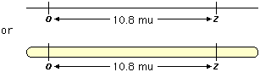

Activity B-4.7d- Genetics – Multiple Alleles* Answer Sheet

*Teacher’s Note: Due to page constraints, only the answer sheet is provided in this document. The worksheet and instructions may be found at
http://www.biologycorner.com/worksheets/genetics_multiplealleles.pdf

1. a) AA and AO b) AB C) OO d) BB and BO
2. 25%; 25%; 0%; 50%
3. B , BO
4. 25%; 25%; 25%; 25%
5. yes, AO
6. Grace
7. A; AB; B; O
8. Star-dot
9. 25%; 50%; 0%; 25%
10. Starry 50% and Dot 50%
11. 25%; 50%; 25%; 0%
12. A; B; AB; O
13. 50%; 50%
14. 25%; 25%; 50%
15. Both are heterozygous

Activity B-4.8a - A Chromosome Study Answer Sheet

For www.biologycorner.com/worksheets/chromosomestudy.html

Normal Human

- 46
- 46
- XX=female; XY=male (depends on the karyotype the teacher chooses to use)
- 46
- 46
- 23

Abnormal Human (answers vary as to the karyotypes the teacher chooses to use)

- Patau – trisomy 13
- Edward – trisomy 18
- Downs – trisomy 21
- Turner’s – monosomy X
- Klinefelter’s – XXY

- all but Turner’s will have 47; Turner’s has 45
- 47 or 45
- See chart a-e
- See chart a-3

Activity B-4.8b - Making Karyotypes

Some of the human disorders that interest students are caused by chromosomes that are missing, or by having an extra chromosome, or even from a damaged chromosome. Scientists investigate these types of disorders by taking cells of people with the known condition and working with their cells. The cells are grown in a special chemical that will cause the cells to stop dividing during the metaphase stage. During metaphase, the replicated chromosomes are large, easier to see, and are attached at their centromeres.

These dividing cells are then stained to show the banding patterns they have. They are then placed on slides and observed under a microscope. A photograph of the cells is made. This is then enlarged. The chromosomes are then counted and abnormalities are noted. The individual photograph of each chromosome is then cut out and matched to its homologous chromosome. The pairs are then arranged by size on a chart. This chart is a karyotype.

In this activity, you will use the attached models of chromosomes to make a karyotype. You will determine if there is an abnormality in the chromosomes.

QUESTION: How do scientists observe chromosomes for abnormalities?

Pre-Lab Questions:

- What can a karyotype show you about genetic disorders?
___________________________________________________________

- Why are photographs of chromosomes used instead of the actual chromosomes?

___________________________________________________________

- Why is staining chromosomes an important step in preparing the karyotype?

___________________________________________________________

- Which pair of chromosomes may contain different shaped chromosomes and still be considered normal? Explain.

________________________________________________________________

________________________________________________________________

Activity B-4.8b cont.- Making Karyotypes

- What are the autosomes? How are they different than the sex chromosomes?

______________________________________________________________________________________________________________________

Materials Needed: Scissors and transparent tape are needed (Be careful using the sharp instruments.

Procedures:

- Use Figure 1 to locate the two sex chromosomes, pair 23. They do not look alike. This karyotype is of a male, with one X and one smaller Y chromosome.

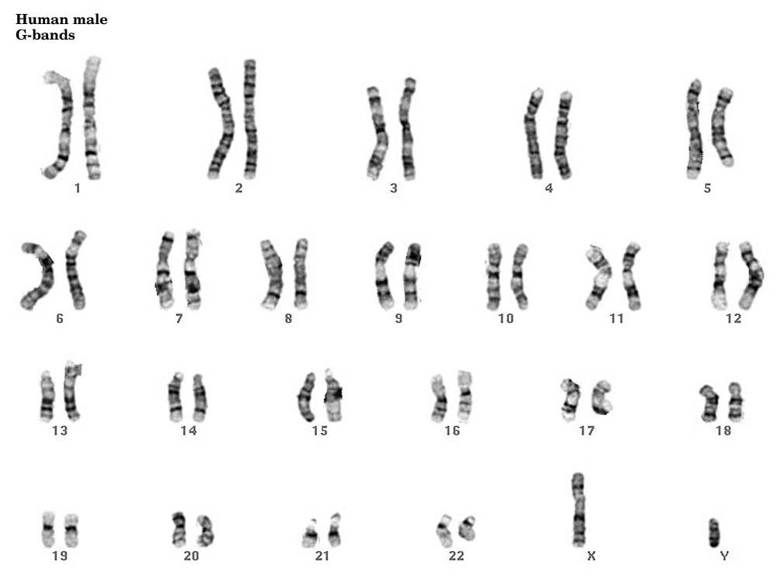

Figure 1

Activity B-4.8b cont. - Making Karyotypes

- Notice the banding patterns on each set of homologous chromosomes.
Making Karyotypes (Continued)

- Look at Figure 2. Notice that the chromosomes are models.

- Cut out all the chromosomes from Figure 2. (Be careful using the scissors.) Align them by size. Keep the pairs together as you place them on Figure 3. Put the longest ones at position 1. The next longest one will be in position 2, etc. Use the line on Figure 3 as a way to keep them matched. Put the centromeres on the line. Note any chromosomal abnormality.

- Use Figure 4 and Figure 5 to observe any chromosomal abnormalities.

Laboratory Questions:

- Of the four karyotypes you looked at, which one was normal? ______

- Which karyotype(s) showed evidence of a missing chromosome? ____

- Which karyotype(s) showed evidence of an extra chromosome? _____

- What abnormal chromosomal trait is in Figure 4? ________________________________________________________

- What abnormal chromosomal trait is in Figure 5?

________________________________________________________

- Are the genetic abnormalities in Figure 4 and 5 associated with the sex chromosomes or the autosomes? Explain your answer.
________________________________________________________________________________________________________________________________________________________________________

- Develop a question that could be answered by making a karyotype of chromosomes of different species of animals.
________________________________________________________________________________________________________________

Activity B-4.8b cont. - Making Karyotypes

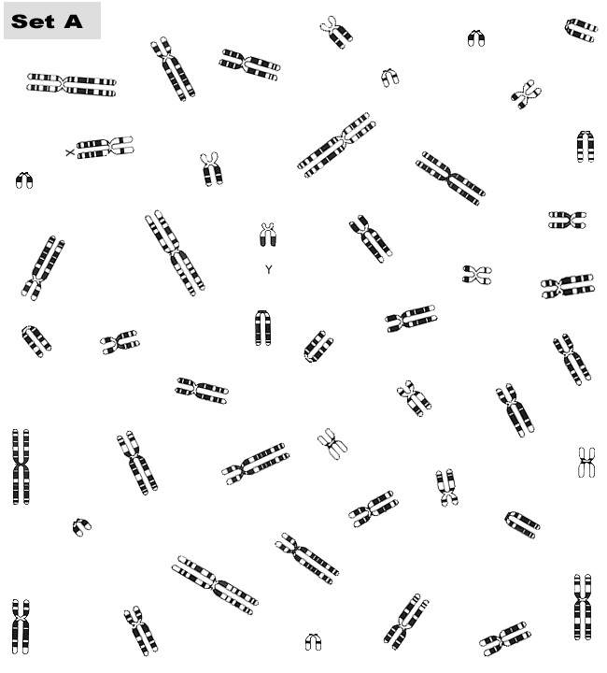
Figure 2 (http://www.biologycorner.com/worksheets/karyotype/A-karyotype-down.gif)
Activity B-4.8b cont.- Making Karyotypes

Figure 3: Line the centromeres of each homologous chromosome pair on the line. Put the pairs in their corresponding numbered position by size.

1 2 3 4 5

6 7 8 9 10 11 12

13 14 15 16 17 18

19 20 21 22 23

Activity B-4.8b cont. - Making Karyotypes

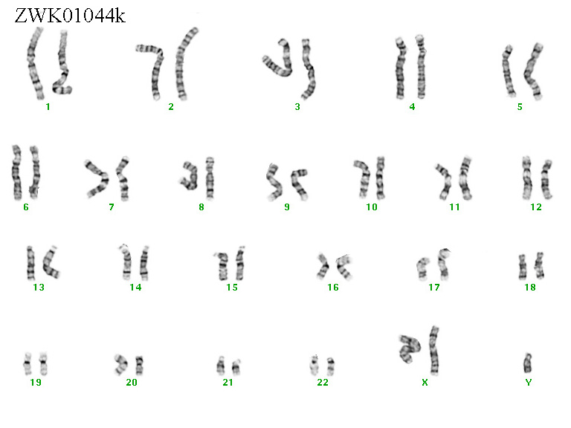
Figure 4

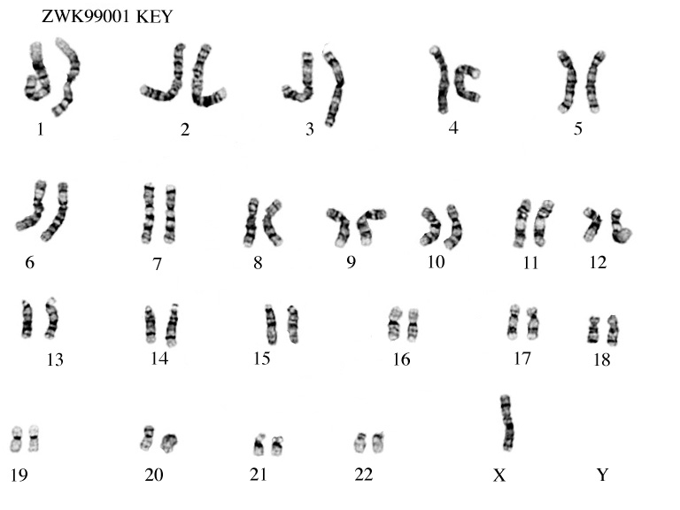

Figure 5.

Activity B-4.8b cont. - Making Karyotypes Answer Sheet

Materials: Teacher will need to copy the labs for each student or pair of students.

Scissors

Transparent Tape

ANSWERS:

Pre-Lab Questions:

1. Karyotypes can show chromosomes that are missing, extra, or damaged.
2. Chromosomes are too small to work with and can get damaged.
Photographs allow us to enlarge the image and have multiple copies.
3. The stained areas help to match the homologs.
4. The sex chromosomes can be different in a male with an X and a Y.
5. Autosomes are all the chromosomes except the sex chromosomes. X and
Y determine sex.

Laboratory Questions:

1. Figure 1
2. Figure 5
3. Figure 3(they may say Figure 2) and Figure 4
4. There is an XX and Y which is Klinefelter’s Syndrome
5. There is only one X which is Turner’s Syndrome or monosomy X
6. Sex chromosomes because they are dealing with the X and Y
chromosomes
7. The student’s questions will probably deal with comparison of chromosome
appearances or chromosome numbers of different animals.

Activity B-4.8b cont. - Making Karyotypes Answer Sheet

Figure 3: Line the centromeres of each homologous chromosome pair on the line. Put the pairs in their corresponding numbered position by size.
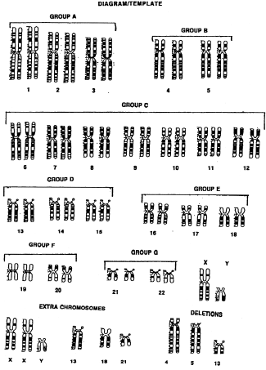

***There will be three at position 21.****

(http://www.accessexcellence.org/AE/AEPC/WWC/1993/karyotype1.gif&imgrefurl)

Activity B-4.8c - Chromosomal Mutations

Each diagram shows a possible mutation of the models of chromosomes. Use the diagram and descriptions to complete the table below. One is done for you.

Original Chromosome Deletion
D E F FDF
A B C CCC
A B C
D F

Original Chromosome Inversion
D E F FDF
A B C CCC
A E D
C B F

Original Chromosome Duplication
D E F FDF
A B C CCC
A B B C
D E F F

Original Chromosome Translocation
D E F FDF
A B C CCC
A B C
I J K L

G H
G H
D E F

I J K L

Mutation | Description
Deletion | Part of chromosome is lost
 | Extra copies of part of a chromosome are made
 | Part of a chromosome breaks off and attaches to another chromosome
 | Sections of a chromosome are reversed

Which two types of mutation can add genes to a chromosome?

_______________________________________________________

Activity B-4.8c cont.- Chromosomal Mutations

Answer the following questions concerning mutations.

1. What are mutations?
___________________________________________________________

2. Chromosomal mutations are caused by changes in a single gene. T or F

3. Mutations that happen at one single nucleotide in the DNA sequence are
__________________ mutations.

4. A mutation where an insertion or deletion of a nucleotide has happened is a(n) __________________________ mutation.

5. Complete the table that compares and contrasts the types of mutations:

Chromosomal Mutations
Type | Description | Examples
 |  | ABC.DEF → ABC.DF
Duplication
 | Part of chromosome gets changed into the reverse direction
Translocation

6. Circle the letter of the statement(s) that are true about gene mutations.

A. Point mutations affect only one nucleotide.
B. The substitution of one nucleotide for another in the gene never changes
the function of the protein.
C. Point mutations that involve the deletion or insertion of a nucleotide
change the reading frame of the genetic message.
D. Frameshift mutations can change every amino acid that follows the point
of that mutation.

7. Mutations that cause dramatic changes in protein structure are --(circle
your choice): often helpful, often harmful, of no effect to the organism

Activity B-4.8c cont.- Chromosomal Mutations

8. Mutations are a source of _____________________ in a species’
evolution.

9. What is polyploidy?
________________________________________________________

Reviewing Key Concepts

1. Genetic information is changed when the DNA sequence is altered.
This is called a _______________________.

2. Changes in the DNA sequence of a single gene are a _________ mutation.

3. The DNA sequence of the entire chromosome is changed in a
___________________________ mutation.

Describe the type of mutation and describe what happens to cause it.

Chromosomal Changes:
4. __________________________
__________________________ 4. ABC.DEF → AC.DEF
__________________________

5. __________________________
__________________________ 5. ABC.DEF → ABBC.DEF
__________________________

6. __________________________
__________________________ 6. ABC.DEF → AED.CBF
__________________________

7. __________________________
__________________________ 7. ABC.DEF → ABC.JKL
__________________________ GH.IJKL → GH.IDEF

8. How are frameshift and substitution mutations alike? Different?

___________________________________________________________

Activity B-4.8c cont.- Chromosomal Mutations

9. How can polyploidy that happens in plants be a benefit for humans?
_________________________________________________________________

10. Compare the original sequence GCA CCG AGA to the mutant sequence of GCA CGA GAT and determine what type of mutation probably happened.
_________________________________________________________________

Activity B-4.8c cont.- Chromosomal Mutations Answer Sheet

Chart: duplication, translocation, inversion

duplication and translocation

1. Mutations are changes in the DNA sequence that affect genetic information. 2. False
3. Point
4. Frameshift
5. Deletion; The loss of all or part of a chromosome; A segment of a chromosome is repeated; ABC *DEF→ ABBC*DEF; Inversion; ABC*DEF→ AED*CBF; Part of one chromosome breaks off and attaches to another chromosome; ABC*DEF → ABC*JKL

GH*IJKL GH*IDEF 6. a,c,d
7. harmful
8. genetic variability
9. Polyploidy is a condition in which an organism has extra sets of chromosomes

Activity B-4.9a - Stem Cell Research Flier

Students are to get into groups of four. Each student will receive an article on stem cell research to read (one person may have two small articles to use).*

Take the article, read it, and highlight the important facts concerning the following items:
- definition of stem cells
- types of stem cells
- list of positive aspects of stem cell research
- list of negative aspects of stem cell research

Each group will then come to a consensus as to the definition, types, and three positive aspects, and three negative aspects of stem cell research.

Using this information, each group is to create one flier on the 11” x 14’’ paper provided. The flier is to be informative and colorful. Give it a title. Make it interesting enough and informative enough to put in a doctor’s office for patients to read while they are waiting to see the doctor.

Turn in your flier. Put up your markers. Make sure your name is on the back of the flier.

POINT VALUES FOR PARTS: Title (5), Neatness (5), Colorful (5), Artwork (5), Definition (10), Types (10), 3 pros (30), 3 cons (30).

* The articles are from the following websites:

- www.allaboutpopularissues.org/pros-and-cons-of-stem-cell-research.htm (date checked 4/17/09)

- http://ezinearticles.com/?Learn-the-Pros-and-Cons-of-Stem-Cell-Research&id=567284 (date checked 4/17/09)

- www.lifeissues.net/writers/irv/irv_19stemcellprocon.html (date checked 4/17/09)

- www.experiment-resources.com/stem-cell-pros-and-cons.html (date checked 4/17/09)

(Students may wish to use other sites, teacher will need to approve the sites)

Activity B-4.9a cont. - Stem Cell Research Flier Materials and Grading Rubric

Teachers will need to run copies of the articles for each group.

11” X 14” copy paper

Colored pencils, crayons, markers

Rulers, tape, or glue may be needed

RUBRIC:

____ Title (5)

____ Neat (5)

____ Colorful (5)

____ Artwork (5)

____ Definition of stem cell (10)

____ Types of stem cells (10)

____ At least three positive aspects of stem cell research (pros) (30)

____ At least three negative aspects of stem cell research (cons) (30)

Activity B-4.9b - Genetic Engineering* - Concept Map

*Teacher’s Note: Due to page constraints, only the answer sheet is provided in this document. The worksheet and instructions may be found at
http://www.biologycorner.com/worksheets/genetics%20engineering%20concept%20map.pdf

- Clones
- Defects
- Poodles
- Increasing variation
- DNA extraction
- DNA separation
- Restriction enzymes
- Hybrids
- DNA
- Bacteria
- Transgenic

