Swamp
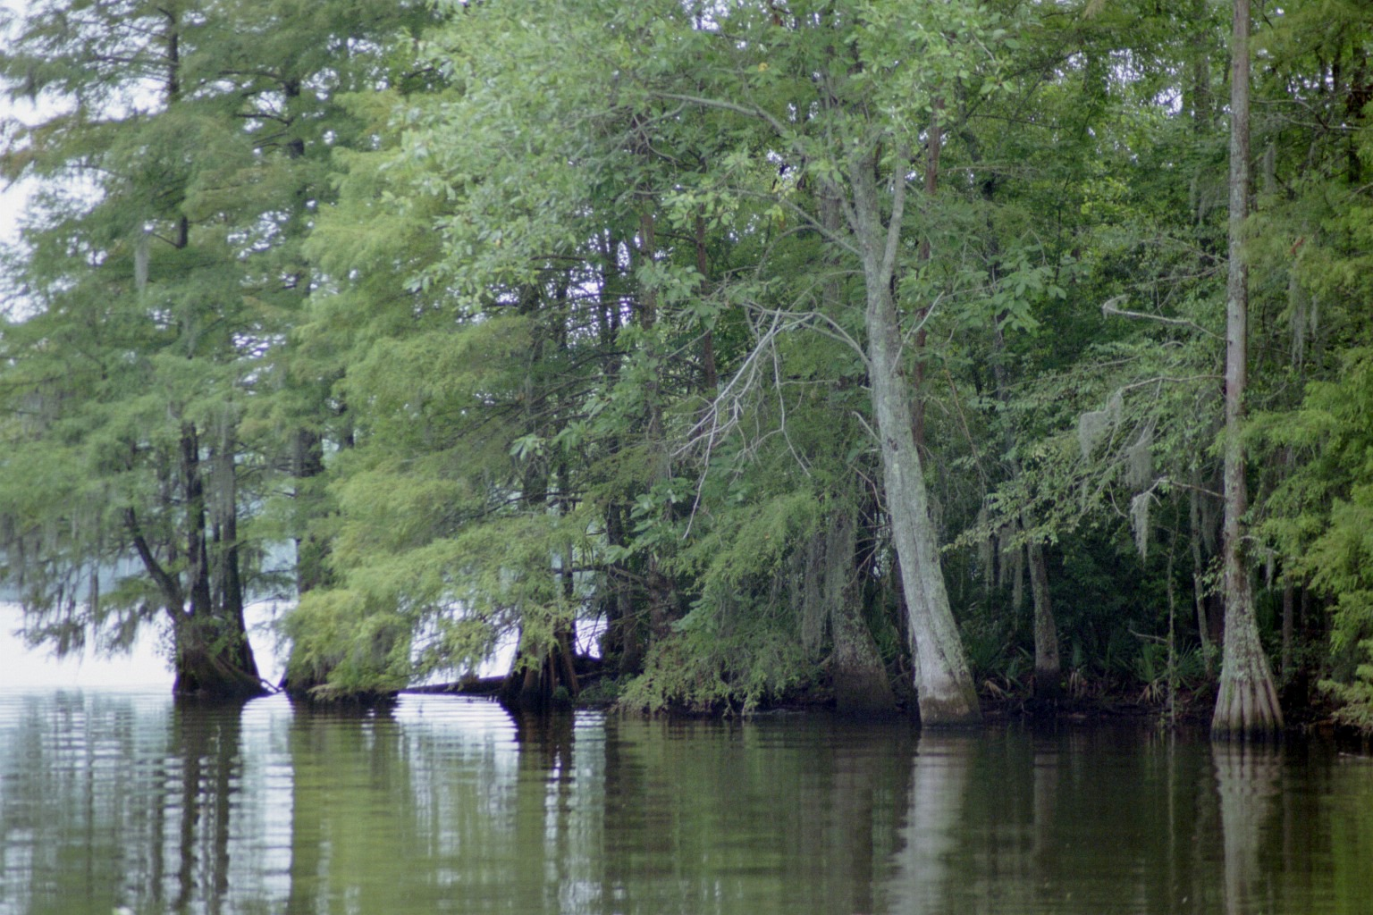 Swamp with Cypress Trees (Photo contributed by Eddie Lott)
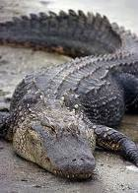
Alligator
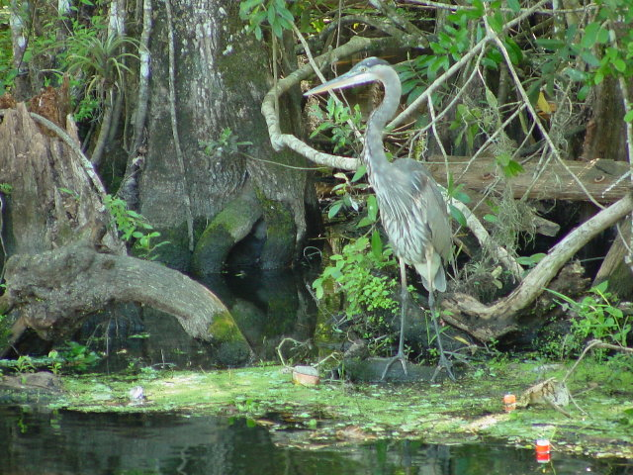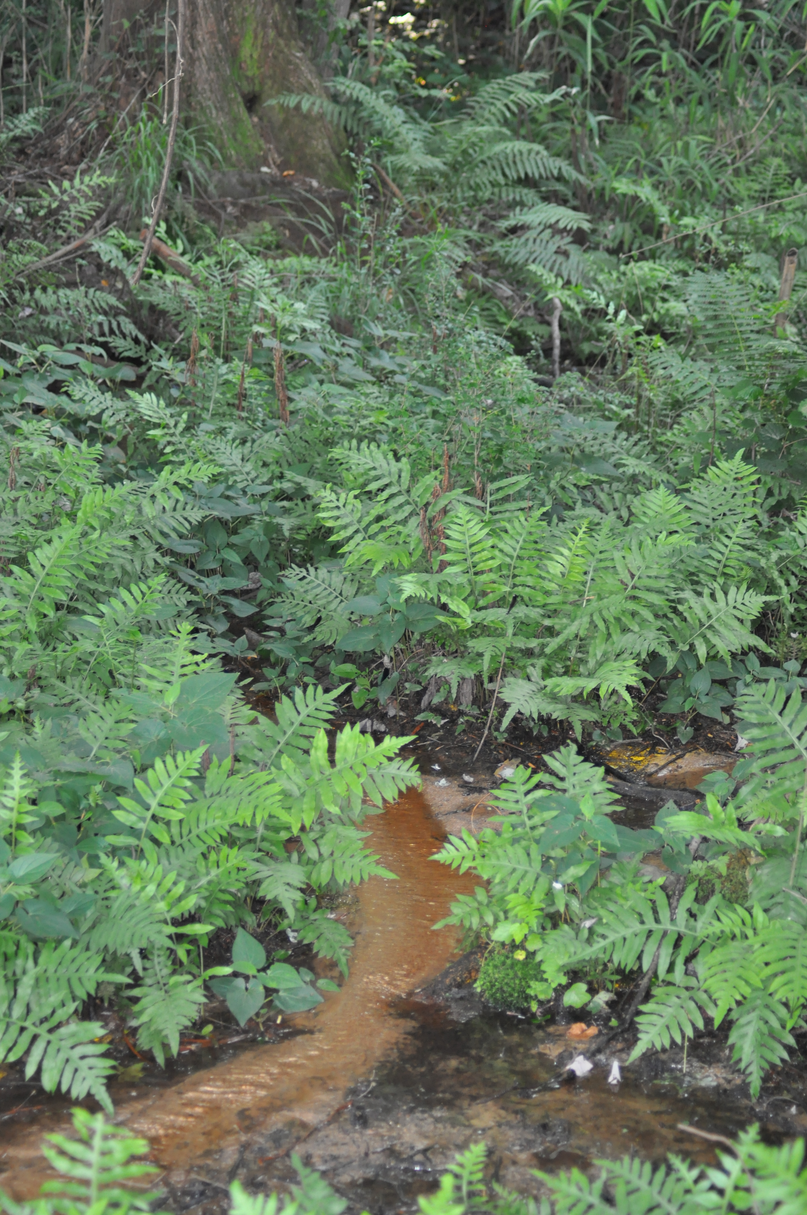
Blue Heron Ferns
(Photo Contributed by Eddie Lott)

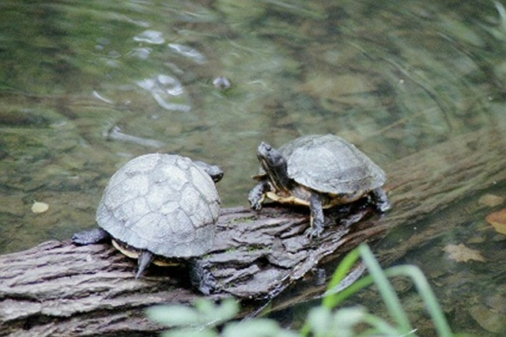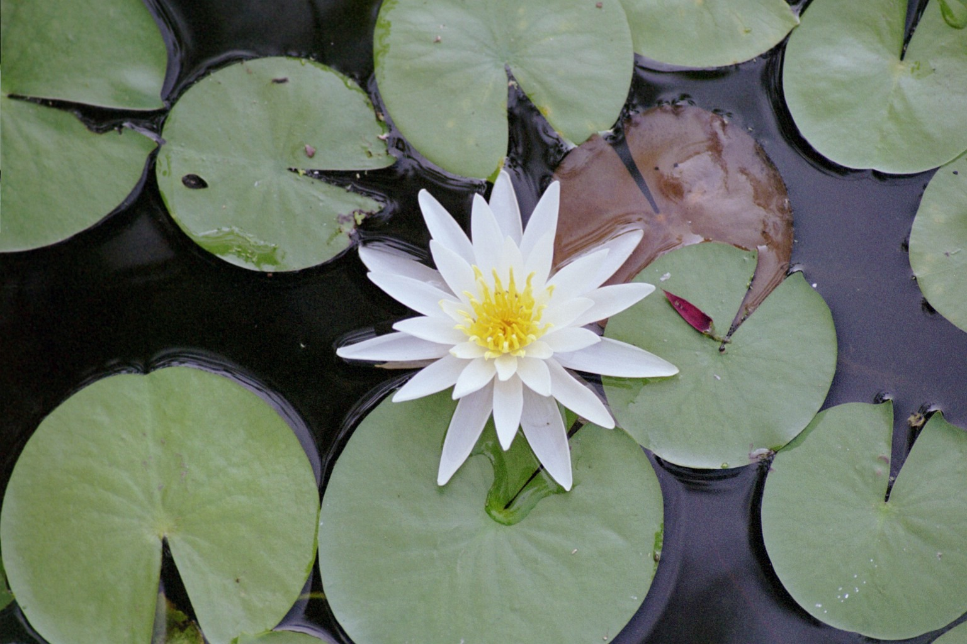

Turtles Water Lily
(Photos contributed by Eddie Lott)

