SOUTH CAROLINA SUPPORT SYSTEM INSTRUCTIONAL PLANNING GUIDE
Content Area | Sixth Grade Science
Recommended Days of Instruction: 6 |  |  |  | (one day equals 55 min)

Standard(s) addressed: 6-2
Students will demonstrate an understanding of structures, processes, and responses of plants that allow them to survive and reproduce.

Characteristics of Organisms
Indicator | Recommended Resources | Suggested Instructional Strategies |  | Assessment Guidelines
6-2.4 Summarize the basic functions of the structures of a flowering plant for defense, survival, and reproduction. | SC Science Standards Support Document  https://www.ed.sc.gov/apps/cso/standards/supdocs_k8.cfm  SC ETV Streamline  http://etv.streamlinesc.org  Adapting to the World  http://player.discoveryeducation.com/index.cfm?guidAssetId=E9539EBF-941F-4099-8D31-630387812FC8&blnFromSearch=1&productcode=US  Change is constant in the natural world. Four chapters demonstrate how adaptations have enabled various species to evolve and thrive. Through familiar examples, students gain better understanding of how adaptation works.  Plants  http://www.biology4kids.com/files/plants_main.html  This website offers an introduction to plants. Topics include basic structure, xylem-phloem, reproduction, angiosperm and gymnosperm.  Seed and Seed Pods  http://theseedsite.co.uk/seedpods.html  Parts of a Flower  http://www.botany.uwc.ac.za/ecotree/flowers/flowerparts.htm#top  This interactive website will allow students to learn the parts of a flower by playing a game. On successful completion, the diagram will be in color.  Parts of the flower lab  http://www.usask.ca/education/coursework/mcvittiej/resources/redlily/middleyears/pdf/worksheet.pdf | See Module 6-2.4 |  | From the Sc Science Support Document: The objective of this indicator is to summarize the basic functions of the structures of flowering plants; therefore, the primary focus of assessment should be to generalize points about the various structures needed for defense, survival, and reproduction.  However, appropriate assessments should also require student to identify the parts of a flower used for reproduction; identify structures in plants used for defense, survival, or reproduction; illustrate a flower or plant structures using words, pictures, or diagrams; or classify a structure based on its function for defense, survival, or reproduction.
6-2.4 Summarize the basic functions of the structures of a flowering plant for defense, survival, and reproduction. | Inside the flower  http://www.harcourtschool.com/activity/science_up_close/515/deploy/interface.html  Project Learning Tree Activity #43 “Have Seeds Will Travel”.

Sixth Grade

Science
Module
6-2.4

Structures, Processes and Responses of Plants

Lessons A-C

Standard 6-2: Students will demonstrate an understanding of structures, processes, and responses of plants that allow them to survive and reproduce.

Indicator 6-2.4: Summarize the basic functions of the structures of a flowering plant for defense, survival, and reproduction.

From the South Carolina Science Support Documents:

Indicator 6.2.4 Summarize the basic functions of the structures of a flowering plant for defense, survival, and reproduction.

Taxonomy level:
Understand Conceptual Knowledge (2.4-B)

Previous/Future knowledge: In 1st grade (1-2.4), students summarized the life cycle of plant, which included flowers and seeds. In 3rd grade (3-2.2), students explained how physical and behavioral adaptations (for example structures for defense) allowed organisms to survive.

It is essential for students to know that flowering plants have special structures that function for defense, survival, and reproduction.

Structures for Defense
Plants have structures for defense that protect them from threats and without these defenses the plant might die. Examples of natural defenses that plants have developed over time may be
- thorns that can defend the plant from being eaten by some animals
- fruits and leaves with poisons so that they are not eaten by animals
- the ability to close its leaves when touched (thigmotropism)

Structures for Survival
Plants have structures that allow them to survive in their habitats when the conditions are not suitable. Examples of parts of flowering plants that function for survival may be:
- Leaves function as the site of photosynthesis, respiration, and transpiration in plants.
- Stems support the plant and hold the leaves up to the light. Stems also function as food storage sites.
  - The xylem in the stems transports water from the roots to the leaves and other plant parts.
  - The phloem in the stems transport food made in the leaves to growing parts of the plant.
- Roots help anchor the plant in the ground.
- They also absorb water and nutrients from the soil and store extra food for the plants.
- The more surface area on the root that is available, the more water and nutrients it can absorb.
- Root hairs help to increase this surface area.
- There are two types of roots: fibrous roots and taproots.
- Fibrous roots consist of several main roots that branch off to form a mass of roots.
  - Examples are grass, corn, and some trees.
- Taproots consist of one large, main root with smaller roots branching off. Examples are carrots, dandelions, or cacti.
- Seeds have special structures that allow them to be dispersed by wind, water, or animals.
- The seeds coat helps protect the embryo from injury and also from drying out.

Structure for Reproduction
Parts of the flowering plant that function in reproduction include:
Flowers
- Flowers produce seeds.
- Many flowers contain both male and female parts needed to produce new flowers.
- Flower petals are often colorful or have a scent to attract insects and other animals.
Stamen
- The male part of a flower that has an anther on a stalk (filament).
- The anther produces the pollen that contains the sperm cells.
Pistil
- The female part of the flower that contains
- The ovary, which contains the ovules where the egg cells are produced,
- the stigma, which is the sticky top where pollen grains land, and
- the style, which is a stalk down which the pollen tube grows after pollination has taken place
Seed
- The ovule that contains the fertilized egg (embryo) from which new plants are formed.
- A fruit that is formed from the ovary often protects them.

It is not essential for students to know the cell layers of leaf structures or other structures of roots or stems.

Assessment Guidelines:
The objective of this indicator is to summarize the basic functions of the structures of flowering plants; therefore, the primary focus of assessment should be to generalize points about the various structures needed for defense, survival, and reproduction. However, appropriate assessments should also require student too identify the parts of a flower used for reproduction; identify structures in plants used for defense, survival, or reproduction; illustrate a flower or plant structures using words, pictures, or diagrams; or classify a structure based on its function for defense, survival, or reproduction.

Teaching Indicator 6-2.4: Lesson A-– Structures for Defense

Instructional Considerations:
This lesson is an example of how a teacher might address the intent of the indicator. Plants have different characteristics and structures, which help them to survive.

Preparation for the Lesson:
Secure pictures or plants that show structures used for defense. Plan for showing the Streamline video.

Misconceptions:
None noted

Safety Notes:
Caution: It is important to remember and let students know that some plants, trees or shrubs can cause death in humans. Some parts of the ornamental plants or flowers in yards may contain deadly poison.

Lesson time:
1 day (1 day equals 55 minutes)

Materials: (per group)
- SC Streamline Video “Adapting to the World”
- Pictures or plants to show structures used for defense
- Various resources or internet for research

Focus Question:
What are some of the structures plants use for defense?

Engage:
- Ask the students if they have ever picked blackberries or handled a rose? Ask them to describe the experience including what was difficult about the experience? Ask them if any of them have ever come in contact with poison ivy? If they have, have them explain the results of their encounter.
- Tell the students that the thorns of the rose bush or the blackberry bushes and the poisons in the poison ivy provide ways for the plants to defend themselves. Without these the plants may not survive.
- Ask them how they think the thorns protect the rose bushes or blackberries. (protects them from being eaten by some animals)
- Explain that you will be examining other structures plants use for defense during this lesson.
- Have student groups brainstorm structures that plants have to defend themselves. Ask students to share these structures. Compile a class list.

Explore:
- Show pictures or examples of some of the plants with poisonous fruit or leaves. Some fruits and leaves contain poisons that protect the plants from animals. Caution: Some plants, trees or shrubs are potential killers of man. Some part of the ornamental plants or flowers in your yard may contain deadly poison.
- Research plants and plant parts that are poisonous to humans. Some poisonous plants are yellow jasmine, daffodil, ivy, azalea, and lupines. Ask students to include the safety precautions that are needed when handling poisonous plants? (Provide various resources for students to use here.)
- Ask students to include this information in chart form in their notebooks.
- Use the SC Streamline Video “Adapting to the World” Segment “The Bloom of Plants” to further explore the structures plants have for survival, defense, and reproduction. Have the students used the interactive notebooking as described in Lesson A of Indicator 6-2.3.

Explain:
- Provide student groups with various pictures of plants. Ask them to sort them into two groups: those that have defensive structures and those that do not have defensive structures. Once they have sorted them, ask each group to be prepare to defend their decisions by indicating the defensive structure of each plant and to describe how it is used for defense. See support document for information on these structures.
- Ask students to make a list of ways plants defend themselves. Have them give an example of each of these structures.
- Ask students to describe ways plants can be poisonous to humans including safety measures they should remember.
- Explain to students that some plants have the ability to defend themselves by closing their leaves when touched. An example of this is the Mimosa (mimosa pudica). The students may know this plant by the name “touch me not”. If possible, show the students a mimosa or “touch me not”. If the actual plant is not available, show them a picture of a Mimosa. Ask them how this response helps the plant defend itself. Tropisms are the response of a plant to something in its natural environment. Thigmotropism is a general term used to describe a plant's response to physical contact. Some plants, like the Mimosa, have the ability to close their leaves when touched.
One other place you see this reaction is with vines like the Morning Glory or with tendrils that are found on vegetables such as beans or peas. When the plant tendrils curl around the string or other plant in response to “touch”, they are exhibiting thigmotropism.
- Plants like the Sundew and Venus Flytrap respond to touch by closing as well. For these plants, which are carnivorous, this response to stimulus allow the plant to “catch”/trap their food.
- Ask students to complete a Quick Write: What are some reasons plants might need to defend themselves? Ask them to cite examples of the plant and the defense.

Extend:
- Have students design and draw a plant with a defense structures. Have them name their plant and explain how the structures defend the plant.
- Provide an opportunity for students to design an investigation to find out which plants have characteristics that attract or deter insects or to determine which plants have a greater chance of being eaten by animals. Make sure the students have a testable question, independent and dependent variables and a plan for observing and collecting and recording data. This might be a group or individual assignment.

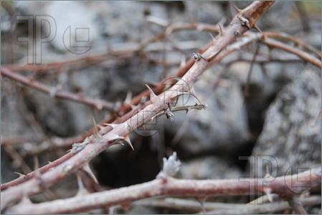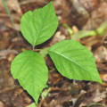
Blackberry Thorns Poison Ivy

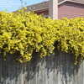

Rose with Thorns Yellow Jasmine

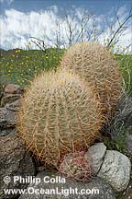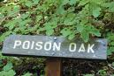

Cactus Poison Oak

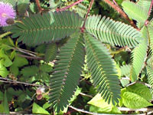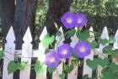

Mimosa Morning Glory

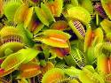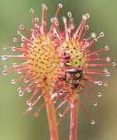
Venus Flytrap Sundew

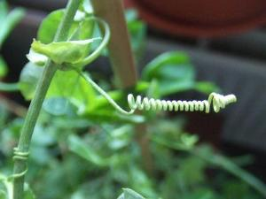

Tendril
Teaching Indicator 6-2.4: Lesson B-- Structures for Survival

Instructional Considerations:
This lesson is an example of how a teacher might address the intent of this indicator. The Science and Technology for Children (STCTM) Experiments with Plants kit provides an opportunity for conceptual development of the concepts within the standard. If this kit is available to you, the FAST plants that are included with it are ideal for illustrating seeds, leaves, stems and roots as well as illustrating a plant’s life cycle. Plants have different characteristics and structures, which help them to survive. This lesson will help students understand the different flowering plant structures such as: seeds, leaves, stem, and roots that help them survive in their habitat.

Preparation for this Lesson:
You will need to plan for and purchase vegetables and flowers (a florist might be a source for day old flowers) for this activity. If you don’t have the Experiments with Plants kit, it would be helpful to have a complete plant for the Engage activity. Pansies or petunias are generally available seasonally. One possible source for pictures of seeds is: the Project Learning Tree Activity #43 “Have Seeds Will Travel”.

Misconceptions: None noted

Safety Notes:
Students should follow all classroom safety procedures.

Lesson time:
4 days (1 day equals 55 minutes)

Materials Needed:
- Various market-fresh vegetables such as an uncut carrots, radishes, celery, broccoli, potatoes, sweet potatoes, spring onions, brussel sprouts, asparagus, beets, leeks, ginger, lettuce, parsley
- Flowering plant such as sunflower
- Pictures of different types of seed
- Magnifying glass

Focus Question:
In what ways are seeds, leaves, stems and roots important to a plant’s survival?

Engage:
1. Provide students with or show them a flowering plant that is currently flowering. Ask them to observe the plant, sketch it and label its parts. Ask them to describe the purpose for the plants roots, stems, leaves and seeds.
2. Pair students and have them share their drawings, labels and descriptions. As they share, allow students to add to their drawings and descriptions.
3. Tell the students that you will be exploring in more detail in this lesson these plant parts and that they will have an opportunity after this lesson to return to their drawings and add new learning.

Explore:
1. Give students different pictures of different types of seeds. If the time of the year is right, collect various seeds for students to use instead of pictures. Allow students to infer different ways each seed may disperse. Have students create a data chart like the one below to record their data and make inferences about the method of seed dispersement (travel). Seeds and/or pictures might include: maple, pine seeds; cockleburs, acorns, etc. They should indicate the interred primary method of travel of the seed, then provide evidence for that inference.

Name of Seed | Wind | Water | Animals | Evidence

2. The wind, water and animals are just some of the ways seeds travel. Ask students to record other ways seeds might travel in their notebooks.
3. Remind students that they dissected a monocot and dicot seed in Lesson 6-2.3 Ask them to Quick Write: From their work with seeds, describe why a seed is important to a plant’s survival.
4. Tell students that seeds are just one part of the plant that is important to its survival. Ask them to name other plant structures that are important to a plant’s survival. Explain that now they will look at other plant structures to determine how they are important to a plants survival as well. (leaves, stems, roots)
5. In cooperative groups, have students observe, classify, and dissect a number of examples of these plant structures (obtained from the supermarket). Students should observe each plant structure, describe both its external and internal structure in detail, determine what plant part the vegetable represents, and describe the function of that part of the plant (roots hold plant in ground, etc.)
6. Students should also observe some adaptations of plant structures (maple seeds with “wings”) and be able to explain how that adaptation serves the plant.
7. Assign cooperative groups a plant have them create projects using the data collected concerning plant structures or other available sources. Their presentation should include any unique characteristics or adaptations of the plant. Suggested projects are posters, flipbooks, and PowerPoint.
Presentations should include vegetable parts:
- Leaf description and functions
- Stem description, functions and classification (xylem or phloem)
- Roots description and functions
- Plant structures and survival
8. Develop and share a rubric with the students prior to their beginning the projects. Allow them to be a part of this development. The Anderson 5 District Curriculum has several rubrics that may be used for models.

Explain:

- Provide time for student groups to share their “presentations”. As they share allow time for classmates to ask for clarification or to ask questions of the presenting group. Use information in support document for resource.
- When presentations have been completed, select two plants and have the students compare and contrast the structure and function of the plant structures? (common functions of both plants, difference in structures, special structures or functions plant has to allow it to survive in its environment). Plants might include pine trees vs. cocklebur (both have structures that allow the seeds to be dispersed---pine seeds have “wings” so wind carries them to new site for germination; cocklebur—“spikes” that catch on to clothing and are dispersed this way. Dandelions have taproots that anchor them in the ground making it very difficult to “kill” this weed. Both of these structures allow for plant survival.)

Extend:
- Ask student groups to discuss how plants help society and the world. Allow them time to brainstorm and list in their notebook uses other than food for plant organs? Provide examples where needed (trees—wood, building; aloe—medicinal, burn relief).
- What plant structures do you think you eat the most? Is it a root, stem, leaf, or flower?
- Create a salad bar with an assortment of plant samples and have students identify the structures and functions of the different plant structures in the salad.
4. Share "The Tiny Seed” by Eric Carle (a picture book)

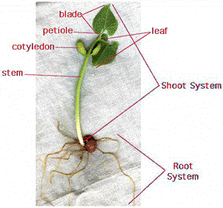

Different Types of Seed
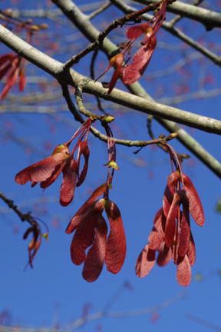 | 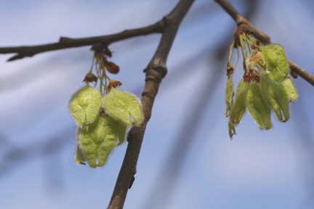
Red Maple Seed American Elm

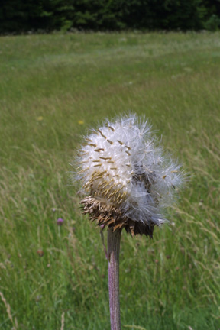  Thistle | Cattail
  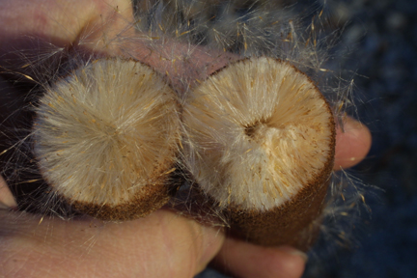

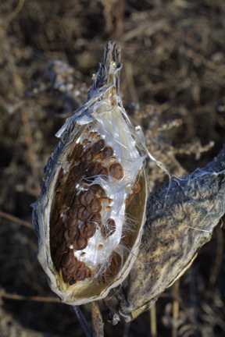 | 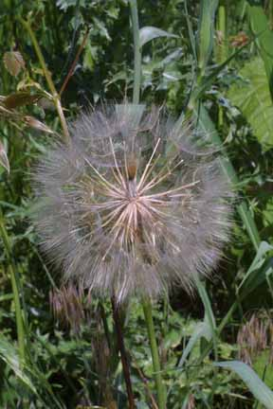

Milkweed Dandelion

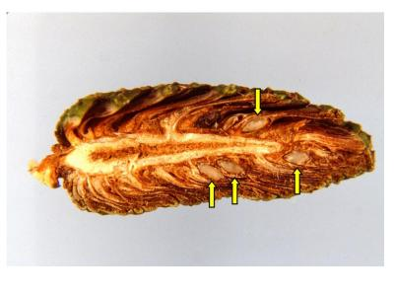
Pine Cone
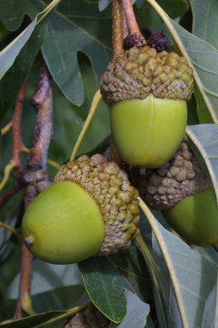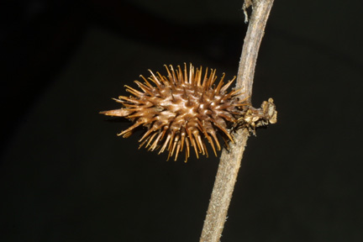
White Oak (acorns) Cockleburr

Monocots and Dicots

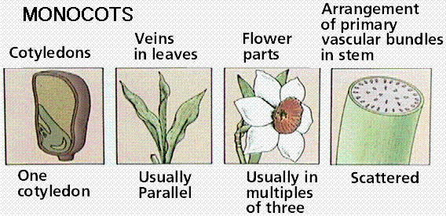

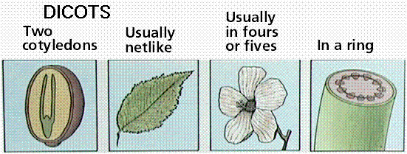
Different types of leaves

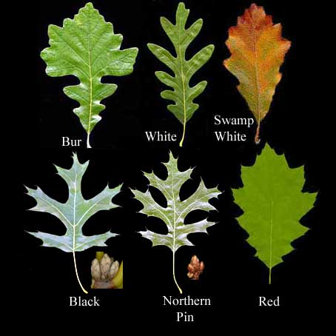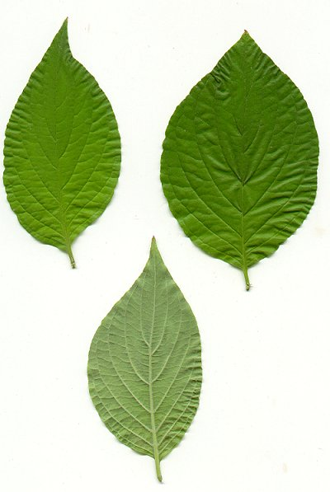

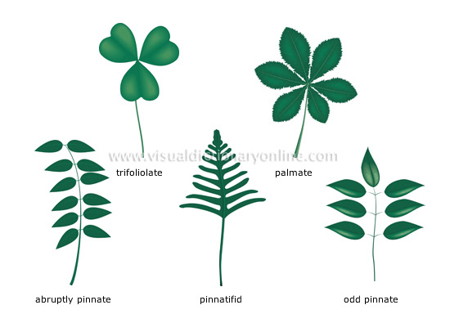

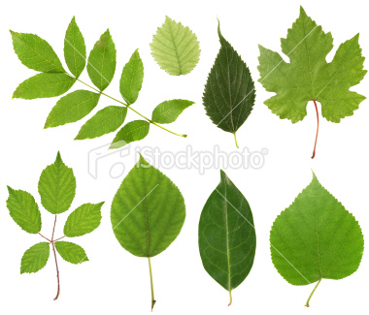

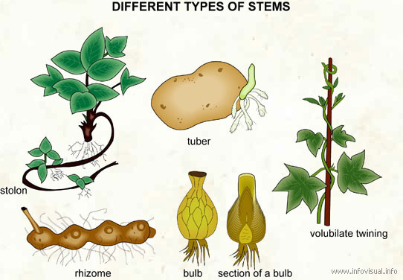

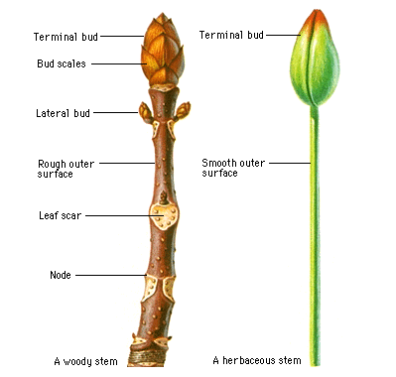

Different types of roots

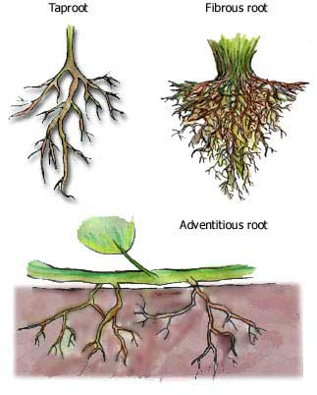

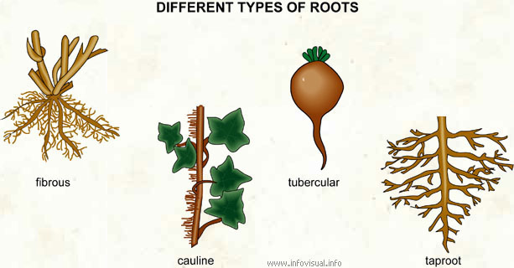

Xylem and Phloem
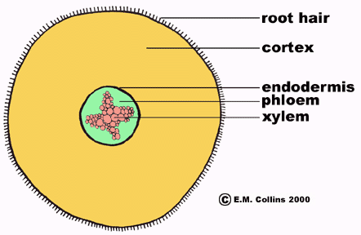
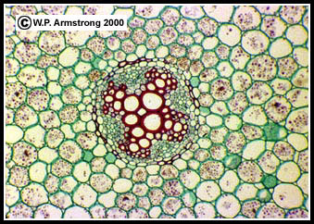
Microscopic view of the root of a buttercup (Ranunculus) showing the 4-pronged xylem. The large, water-conducting cells in the xylem are vessels. [Magnified Approximately 400X.]

Teaching Indicator 6-2.4: Lesson C - Structures for Reproduction

Additional Instructional Considerations :
This lesson is an example of how a teacher might address the intent of the indicator. The STC Experiments with Plants kit provides an opportunity for conceptual development of the concepts within this standard.
Plants have different structures, which help them to reproduce. In this lesson, students will explore those structures.

Preparation for the Lesson:
Obtain the flowers (1/student if possible) If it is spring time, Azalea flowers may be available. If not, then check with a local florist or flower provider for flowers that they may be discarding.

Misconceptions:
None noted

Safety Note
Daffodils are poisonous when ingested, allow the students to wear non-latex gloves or wash their hands if handling daffodils.

Lesson time:
1 day (1 day equals 55 minutes)

Materials Needed:
- 1 flower per student (daffodils or tulips) you can usually get these free from a florist. In season, azalea flowers work well also
- Hand lens
- Non-latex gloves

Focus Question:
What structures in a flowering plant are needed for reproduction?

Engage:
1. Ask students if any of them have ever received flowers for a special occasion? Let a few students share their thoughts.
2. Ask the students to brainstorm a list of flowers they are familiar with. As they share the flower’s name, scribe them on chart paper or the board.
3. Have students choose one of the flowers from the list or one they’re familiar with and draw and label a sketch of the flower in their notebooks.
4. Quick Write: (in student’s notebooks) The purpose of a plant’s flowers is _______________.
5. Show the students a picture of a flower. Ask them to talk to their elbow partner about the parts they know and the functions of those parts. Ask them to return to their notebook and add any new learning from talking with their partner.
6. Explain that you are going to give each person/group a flower to examine more closely.

Explore:
1. Provide each student or student group with a flower and have them set up their notebooks for recording observations.
- Title: Exploring the Reproductive Structures of a “Daffodil”
- Have them leave half of the page under the title blank, then move to c.
- Have them divide their page into two columns. On the left, students will sketch, label and describe the functions of the male reproductive structures (Stamen—anther and filament); on the right they should sketch, label and describe the functions of the female reproductive structures (Pistil—stigma, style and ovary).
- When they have their notebooks set up, provide them with the instructions below for observing their flower and recording their observations in their notebooks.

2. Student Instructions:
a. Examine and draw the outside parts of the flower in the space under the title. Note the outmost whorl of floral parts. They may be green or brown and leaf-like. These are called sepals. Label these on your drawing.
Inside the sepals you will usually find the large, colored part of the flower. These are called the petals. Label these on your drawing.
These parts of the flower are not directly involved in reproduction. What functions do you think they might have?

b. Carefully remove the sepals and petals to expose and examine the reproductive structures. Around a central stalk-like body are 5-10 delicate stalks, each ending in a small sac, or anther. These are the male reproductive structures or stamens. Draw and label the parts of the stamen (anther, filament) in your notebook. Thousands of pollen grains are produced in the anther. The number of stamens varies with the type of flower.

c. Answer the following questions about your flower
How many stamens are present in your flower? ___________
Therefore is your flower a monocot or dicot? ___________
How might pollen be carried from the anther to the female part of the flower?
d. As you return to your flower again and examine the center of it, you should notice a central stalk surrounded by the stamens. This is the female reproductive structure or pistil. It is composed of an enlarged bottom part, the ovary, above which is an elongated stalk, the style. The style ends in the stigma. You may want to remove the stamens for a better view.
e. Draw the pistol and label its parts. (stigma, style, ovary)
f. Examine the stigma carefully using the hand lens. How do you think it is adapted to trap the pollen grains and to provide a place for them to grow?
g. Carefully break open the ovary to uncover the ovules inside. The ovule is the female reproductive cell that will develop into a seed when fertilized by the pollen.
h. Sketch the ovary and the ovules inside.
i. Beside each of your labels write the function of that part of the flower.

Explain:
- Have students return to their original drawing of their flower and draw a line of learning, then add new learning to their drawing.
- Ask each student to turn to a new page in their notebooks and again divide the page into two columns. Explain that they will be using a strategy called “ I used to think… but now I know….” Have them label the left column: “I Used to Think…” and the right column: “But Now I Know”. Explain to them that they should describe how their ideas have changed or how they have become more specific due to the investigation with their flowers.
- Provide time for a quiet write
- After about 10 minutes, pair students and allow time for them to share their thoughts with each other. As they share, partners may change or add to their charts or learning in their notebooks. Again, they might want to draw another line of learning.
- Once they have had time to share with a partner, ask each partner to share one thing they now know. List these on chart paper.
- Using the support document information as background, make sure students have a good understanding of the reproductive structures of a flower. Ask questions as needed to ascertain their learning.

Extend
- If dissecting microscopes are available place the pistil under it for student viewing.
- Make a slide of pollen grains and place under a microscope for students to view. (Shake some of the pollen into a drop of water on a clean slide, add a cover slip and examine with a microscope.)
- Card Sort: Using terms from this indicator, make concept cards for students to sort.
  - Make sets of cards, placing one term on each card.
  - Divide students into cooperative groups and provide each group with a set of cards
  - Provide time for them to sort the cards into groups. You may want to give them the categories. Possible ones include: Defense, Survival, Reproduction. Or you might want them to determine the categories on their own. Tell them that they must be able to explain why they made the choices they did.
  - Share group sorts with other classmates and allow for questions.
- Use the cards you provided or provide them with a list of words that they use to make a concept map. Possible terms: (See support document) Structures, defense, survival, xylem, phloem, roots, stems, leaves, flowers, pistil, etc.
- http://www.usask.ca/education/coursework/mcvittiej/resources/redlily/middleyears/pdf/worksheet.pdf Parts of the flower lab
- http://www.harcourtschool.com/activity/science_up_close/515/deploy/interface.html
Inside the flower- identify parts of the flower and functions of each part.
7. Suggested Streamline Video: Adapting to the World
The Bloom of Plants
This video segment follows the processes of plant reproduction and survival.
ETV Streamline SC
6:13 to 11:31

