SOUTH CAROLINA SUPPORT SYSTEM INSTRUCTIONAL PLANNING GUIDE
Content Area | Sixth Grade Science
Recommended Days of Instruction: 2 |  |  | (one day equals 45 min)

Standard(s) addressed: 6-5
The student will demonstrate an understanding of the law of conservation of energy and the properties of energy and work. (Physical Science)
Energy Sources and Properties
Indicator | Recommended Resources | Suggested Instructional Strategies |  | Assessment Guidelines
6-5.1 Identify the sources and properties of heat, solar, chemical, mechanical, and electrical energy. | SC Science Standards Support Document  https://www.ed.sc.gov/apps/cso/standards/supdocs_k8.cfm  SC ETV Streamline  http://etv.streamlinesc.org  Getting to Know Energy  http://player.discoveryeducation.com/index.cfm?guidAssetId=FD5D90B6-3C2F-4651-A32E-495045ECC2BA&blnFromSearch=1&productcode=US  Energy is all around you. Learn about the many different types of energy and how energy can change form. Discover that energy never goes away, that it can only be transferred from one form into another.  California Energy Commission  http://www.energyquest.ca.gov/  This website provides numerous resources about types of energy and energy conservation. It  includes teacher and parent resources, puzzles, games and energy stories.  National Energy Education Development Project  http://www.eia.doe.gov/kids/energyfacts/science/formsofenergy.html  This site contains information about forms of energy, conservation of energy, and energy efficiency.  National Energy Education Development Project  http://www.eia.doe.gov/kids/energyfacts/science/formsofenergy.html  This site contains information about forms of energy, conservation of energy, and energy efficiency. | See Module 6-5.1 |  | From the SC Science Standards Support Document  The objective of this indicator is to identify the sources and properties of heat, solar, chemical, mechanical, and electrical energy; therefore, the primary focus of assessment should be to retrieve from memory sources and properties of the forms of energy listed.  However, appropriate assessments should also require students to recognize forms of energy by their sources.

Sixth Grade

Science Module
6-5.1

Conservation of Energy

Lesson A

Standard 6-5: The student will demonstrate an understanding of the law of conservation of energy and the properties of energy and work. (Physical Science)

Indicator 6-5.1: Identify the sources and properties of heat, solar, chemical, mechanical, and electrical energy.

Other indicators addressed:
6-1.1: Differentiate between observation and inference during the analysis and interpretation of data.

From the South Carolina Science Support Document:

Indicator 6-5.1: Identify the sources and properties of heat, solar, chemical, mechanical, and electrical energy.

Taxonomy level:
Remember Conceptual Knowledge (1.1-B)

Previous/Future Knowledge:
Students have been introduced to the concepts of sources of heat and how heat moves by conduction in 3rd grade (3-4.3 and 3-4.4). In 4th grade (4-5), students demonstrated an understanding of the properties of light and electricity. In 5th grade, students have been introduced the concept of matter being composed of very small particles (5-4.1) that can form new substances when they are mixed (5-4.7) and to the concepts of motion and position (5-5.2). Students will further develop the concept of energy traveling in waves in 8th grade (8-6.8).

It is essential for students to know that energy can be in many different forms. Students should know sources and properties of the following forms of energy:

Heat energy
- Heat energy is the transfer of thermal energy (energy that is associated with the motion of the particles of a substance).
- Remember that all matter is made up of particles too small to be seen (5th grade).
- As heat energy is added to a substance, the temperature goes up indicating that the particles are moving faster. The faster the particles move, the higher the temperature.
- Material (wood, candle wax) that is burning, the Sun, and electricity are sources of heat energy.

Solar energy
- Solar energy is the energy from the Sun, which provides heat and light energy for Earth.
- Solar cells can be used to convert solar energy to electrical energy.
- Green plants use solar energy during photosynthesis (6-2.7) to produce sugar, which contains stored chemical energy.
- Most of the energy that we use on Earth originally came from the Sun.

Chemical energy
- Chemical energy is energy stored in particles of matter.
- Chemical energy can be released, for example in batteries or sugar/food, when these particles react to form new substances.

Electrical energy
- Electrical energy is the energy flowing in an electric circuit.
- Sources of electrical energy include: stored chemical energy in batteries; solar energy in solar cells; fuels or hydroelectric energy in generators.

Mechanical energy
- Mechanical energy is the energy due to the motion (kinetic) and position (potential) of an object. When objects are set in motion or are in a position where they can be set in motion, they have mechanical energy.
  - Mechanical Potential energy: Potential energy is stored energy. Mechanical potential energy is related to the position of an object. A stretched rubber band has potential energy. Water behind a dam has potential energy because it can fall down the dam.
  - Mechanical Kinetic energy: Kinetic energy is the energy an object has due to its motion. Mechanical kinetic energy increases as an object moves faster. A moving car has kinetic energy. If the car moves faster, it has more kinetic energy.

NOTE TO TEACHER: Other types of energy can also be classified as potential and kinetic, but 6th grade students are only responsible for kinetic and potential mechanical energy.

It is not essential for students to know the terms chemical reactions or changes for chemical energy. They also do not need to know about electrons associated with electrical energy. The concept of nuclear energy will be addressed in high school.

Assessment Guidelines:
The objective of this indicator is to identify the sources and properties of heat, solar, chemical, mechanical, and electrical energy; therefore, the primary focus of assessment should be to retrieve from memory sources and properties of the forms of energy listed. However, appropriate assessments should also require students to recognize forms of energy by their sources.

Teaching Indicator 6-5.1: Lesson A - Energy Sources & Properties

Instructional Considerations:
This lesson is an example of how a teacher might address the intent of this indicator. Science and Technology Concepts for Middle SchoolsTM (STC/MSTM) kit Energy, Machines and Motion provides an opportunity for conceptual development of the concepts within the standard. Students have studied types of energy in grades 3-5 concentrating on the reflection, refraction and absorption of energy in 4-5.3. The sources and properties of energy will be reviewed in this lesson.

Preparation for the Lesson:
Gather pictures or items to represent the 5 types of energy reviewed in this lesson.
Obtain the materials needed for investigation

Misconceptions:
Students often think of energy as a thing. They think that energy is confined to a particular origin. We get it from food or from the electric company. This causes problems when they are asked to understand conservation of energy.

Safety Note:
Remind students of safety practices when working with hot/boiling water.

Lesson time: 2 Days (1 day equals 55 minutes)

Materials Needed: (per group)
- Hot beverage drinking cup with lid
- Metal spoon
- Battery
- Light bulb
- Wire
- Pictures or actual items that represent energy sources—sun, radio, microwave, battery, fruit or other food items, plant, light bulb, animal, rubber band, etc.
- ETV Streamline Video: Getting to Know Energy

Focus Question:
What are the sources and properties of heat, solar, chemical, mechanical, and electrical energy?

Engage:
- Write the words: solar, heat, chemical, mechanical and electrical on the board.
- Ask the students what they think about when they hear the word “Energy”. Ask
them to write their thoughts in their notebooks.
- Have them share some of their thoughts.
- If you’re using pictures, show them to the students and tell them that you asked a friend to send you some pictures you could use teaching a lesson on energy and that when you receive them they were just pictures on a page, there was no explanation as to why they were chosen or how you should use them.
- Tell them that as you examined them you decided that maybe they could represent different sources of energy, but you will need their help to categorize them for use.
- Explain that you have decided the sources you want to use are: solar, heat, chemical, mechanical, and electrical. Tell them that for their purposes in this activity each of the items represent the source or where that type of energy comes from. See pictures that follow. For example: the sun produces solar-- and heat energy, a fireplace is the source of heat and light energy.
- Give each group a set of the pictures and ask them to classify them based on the source of energy they represent.
- Explain that they will make decisions as a group and be asked to share them with the class providing evidence for why they placed each item in that specific group.
- Share groups classification decisions whole class.

Explore:
Provide students with the materials as needed and allow them to explore these 5 sources of energy.
- Heat Energy: Provide each group with a Styrofoam cup (hot drink cup), lid containing opening for straw. Pour very hot (almost boiling) water in the cup filling it to ¾ full. Close the cup by putting on the lid and then inserting a metal spoon or rod through the straw opening. Observe the changes in the spoon. What is the cause of the changes? Why does this change occur?
- Solar Energy: Show the picture of the solar panels on the house (used in the Engage phase). Ask students to talk about what is happening here. Where is the energy? What is the source of this energy?
  - Provide students with 4 plastic glasses, black and white construction paper, water and 4 thermometers. Have them cut a round circle from the black and white construction paper to fit the bottom of each glass. Cover two of the glasses with plastic wrap. Place all four cups in the sun for 20-30 minutes. Record the temperature every 10 minutes. What changes do you observe and measure. Why? What causes these changes? Where is the energy for this change coming from?
  - Talk about using solar energy for solar cookers.
- Chemical Energy: If students have already studied plants, ask them to think back to the process of photosynthesis. What do the plant’s need in order for this process to occur? What does the sun provide? What does the plant produce from this process? Where do humans get their energy?
  - Explain to the students that chemical energy is the energy stored in particles of matter. Batteries store and release chemical energy. Our bodies use chemical energy from the food we eat. The value for food energy is measured in calories. The average 9-12 year old needs about 1600-2200 calories per day for energy.
  - The graph below shows the amount of energy in calories for various foods.
  - Ask students to study the graph and respond to the following questions.
    - Which food (s) would supply you with the most energy?
    - Which food supplies the least amount of energy?
    - What fruit or vegetable would have the most energy?
    - Which foods would you eat to give you energy to ride our bike?

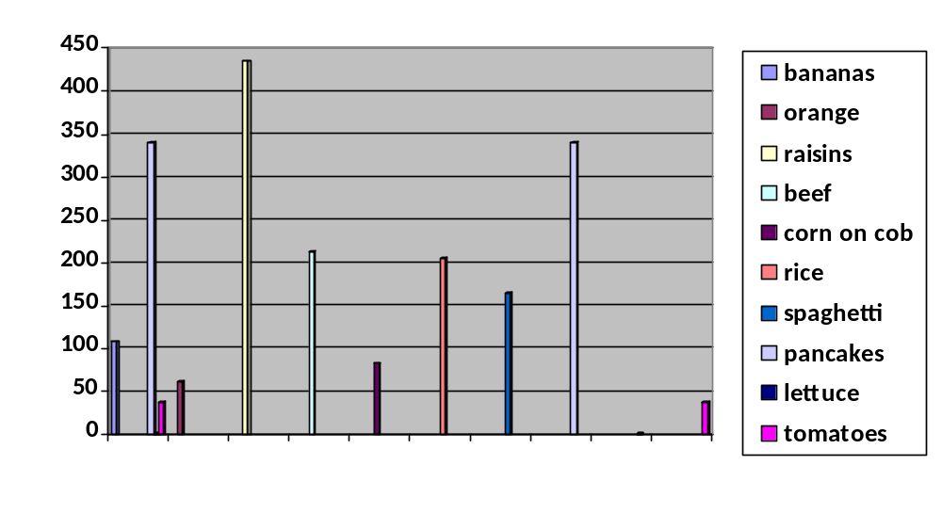
Foods

- Electrical Energy: Students studied electrical energy as 4th graders. Electrical energy flows through an electric circuit. Show students a battery, light bulb and wire and ask them to use their notebooks to illustrate an electric circuit and label the parts. Have them share their illustrations. As they share, use a battery, bulb and wire to demonstrate their descriptions. Remind them that although the battery is a part of the electric circuit and provides energy as electricity flows through the circuit, the energy in the battery is chemical energy.
- Mechanical Energy: Show students the pictures of the car and the dam once again. Tell them that these represent mechanical energy---energy due to motion (kinetic) and position (potential) of an object. As the water sits behind the dam, it has potential, once it begins to flow over the dam energy is due to its movement (kinetic energy),
a. Illustrate this with a rubber band. As it lays on a table/desk, it has potential energy. When you stretch it over the end of a ruler and then let it “fly”, it has kinetic energy. Ask them where the potential energy is with the race car? When does the potential energy become kinetic energy? Have them think of other examples.

Explain:
- Have students return to the pictures they sorted during the Engage phase
- Ask them to make a chart containing three columns. They should title Column 1, Source of Energy; Column 2, Properties; and Column 3, Examples/Illustrations.
- Using their pictures as examples and the information they’ve gained, have them complete their charts. Ask them to add other examples from prior knowledge of activities completed in class.
- Pair groups of students and have them share their charts.
- Post/write the 5 sources of energy on the board and have students place pictures of examples under the correct energy sources.
- Use: Getting to Know Energy, ETV Streamline SC, Segment 4: Forms of Energy: Examples of different types of energy and examples and explanations of types of energy, including, heat, solar, chemical, electrical, and mechanical energy.

Extend:
- Allow time for students to research and build a solar cooker. Use Inquiry 6-1.4 for guidance.
- From Anderson District 5 Curriculum: Have students keep a running list of the types of energy they come in contact with/use over a week. Have them make illustrations or take pictures to go with their list.



