SOUTH CAROLINA SUPPORT SYSTEM INSTRUCTIONAL PLANNING GUIDE
Content Area: | 6th Grade Science
Recommended Days of Instruction: 7 |  |  | (one day equals 45 min)

Standard(s) addressed: 6-5
The student will demonstrate an understanding of the law of conservation of energy and the properties of energy and work. (Physical Science)
Simple Machines
Indicator | Recommended Resources | Suggested Instructional Strategies |  | Assessment Guidelines
6-5.7  Explain how the design of simple machines (including levers, pulleys, and inclined planes) helps reduce the amount of force required to do work. | SC Science Standards Support Guide  https://www.ed.sc.gov/apps/cso/standards/supdocs_k8.cfm | See Module 6-5.7  Lesson 6-5.7A & B Simple Machines – “Levers”  Lesson 6-5.7 C Simple Machines – “Pulleys and Inclined Planes” |  | From the SC Science Support Document:  The objective of this indicator is to explain how the design of simple machines helps reduce the amount of force required to do work; therefore, the primary focus of assessment should be to construct a cause-and-effect model which shows how the design of simple machines (including levers, pulleys, and inclined planes) reduces the effort force or changes its direction.

Module 6-5.7 Continued
Indicator | Recommended Resources | Suggested Instructional Strategies | Assessment Guidelines
6-5.7  Explain how the design of simple machines (including levers, pulleys, and inclined planes) helps reduce the amount of force required to do work. | Intel  http://www97.intel.com/en/ProjectDesign/UnitPlanIndex/InventAMachine/  This an Intel Teach to the Future Unit in which students study the concepts of force, motion, and work as they analyze simple machines. They study the simple machines in complex machines, and track the transfer of force from input (effort) to output (work). In a design challenge, students become inventors and identify work they want to perform, and invent a laborsaving machine to do the job. The design steps of planning, drafting, construction,  troubleshooting, and reliability testing are followed before students unveil their wonderful inventions to an awed crowd. |  | However, appropriate assessments should also require students to recognize that simple machines can be designed to reduce the force needed to move an object; interpret a diagram showing different designs of the same simple machine to determine which would reduce the amount of force the most based on their designs; or summarize the relationship between the design of the simple machine and the reduction in force required to move an object.

Module 6-5.7 Continued
Indicator | Recommended Resources | Suggested Instructional Strategies | Assessment Guidelines
6-5.7  Explain how the design of simple machines (including levers, pulleys, and inclined planes) helps reduce the amount of force required to do work. | Work, Energy, and the Simple Machine: Inclined Plane, Wedge, Screw(6-5.7)  0:00 to 15:00  ETV Streamline SC  http://etv.streamlinesc.org  Students will see and learn how these three simple machines are closely related. Common  everyday situations are used to illustrate and demonstrate the widespread use of these machines.  Work, Energy, and the Simple Machine: Lever, Wheel and Axle, Pulley (6-5.7) 0:00 to 15:00  ETV Streamline SC  http://etv.streamlinesc.org  These three simple machines, as different as they may appear, are actually closely related. The  principles behind each of these simple machines are illustrated and demonstrated with common  situations and tools. |  | However, appropriate assessments should also require students to recognize that simple machines can be designed to reduce the force needed to move an object; interpret a diagram showing different designs of the same simple machine to determine which would reduce the amount of force the most based on their designs; or summarize the relationship between the design of the simple machine and the reduction in force required to move an object.

Sixth Grade

Science
Module
6-5.7

Conservation of Energy
Lessons A-C
Standard 6-5: The student will demonstrate an understanding of the law of conservation of energy and the properties of energy and work. (Physical Science)

Indicator 6-5.7: Explain how the design of simple machines (including levers, pulleys, and inclined planes) helps reduce the amount of force required to do work.

Other indicators addressed:
6-1.1 Use appropriate tools and instruments (including a spring scale, beam balance, barometer, and sling psychrometer) safely and accurately when conducting a controlled scientific investigation.
6-1.4 Use a technological design process to plan and produce a solution to a problem or a product (including identifying a problem, designing a solution or a product, implementing the design, and evaluating the solution or the product).
6-1.5 Use appropriate safety procedures when conducting investigations.

From the South Carolina Science Support Documents:

Indicator 6-5.7: Explain how the design of simple machines (including levers, pulleys, and inclined planes) helps reduce the amount of force required to do work

Taxonomy level of indicator:
Understand Conceptual Knowledge (2.7-B)

Previous/Future Knowledge:
In 3rd grade (3-5.3), students explained how the motion of an object is affected by the strength of a push or pull and the mass of an object. In 5th grade, students illustrated the affects of force on motion (5-5.1) and explained how a change of force or a change in mass affects the motion of an object (5-5.6). Students have not been introduced to the concept of simple machines in previous grades. Students will further develop the concept of force in 8th grade (8-5.4) and quantitative relationships of work in high school Physical Science (PS-6.4).

It is essential for students to know that a simple machine is a device that helps reduce the amount of force required to do work. Work is done when a force (effort force) is applied over a distance.
- A simple machine allows the user to apply a smaller force over a larger distance to move an object.
- Simple machines can also change the direction of the force applied.
- If the distance over which the effort force is exerted is increased, the same amount of work can be done with a smaller effort force.
- This is the principle that simple machines use to reduce the amount of effort force needed to do work.

The design of the simple machines can reduce the amount of force required to do work:

Lever
- A lever is a rigid bar or board that is free to move around a fixed point called a fulcrum.
- The fulcrum may be placed at different locations along the bar.
- A lever can be designed to reduce the amount of force required to lift a weight in two ways: (1) By increasing the distance from the fulcrum to the point where the effort force is applied, or (2) by decreasing the distance the weight is from the fulcrum.
- By increasing the distance the effort force moves relative to the distance the weight moves, a lever can reduce the effort force needed.

Pulley
- A pulley has a grooved wheel with a rope running along the groove.
- Pulleys can change the amount and/or the direction of the force applied (effort force).
- By arranging the pulleys in such a way as to increase the distance that the effort force moves relative to the distance the weight moves, a pulley can reduce the effort force needed.
- Movable pulleys are used to reduce the effort force.
- A single fixed pulley changes only the direction of the force (you pull down and the weight goes up.)

Inclined plane
- An inclined plane is a sloping surface, like a ramp, that reduces the amount of force required to lift an object.
- An inclined plane can be designed to reduce the force needed to lift a weight in two ways: (1) increase the length of the ramp or (2) decrease the height of the ramp.
- By increasing the distance the effort force moves (length of the ramp) relative to the distance the weight is lifted (height of the ramp), an inclined plane can reduce the effort force needed.

It is not essential for students to know the classes of levers or how to calculate the mechanical advantage of simple machines.

Assessment Guidelines:
The objective of this indicator is to explain how the design of simple machines helps reduce the amount of force required to do work; therefore, the primary focus of assessment should be to construct a cause-and-effect model which shows how the design of simple machines (including levers, pulleys, and inclined planes) reduces the effort force or changes its direction. However, appropriate assessments should also require students to recognize that simple machines can be designed to reduce the force needed to move an object; interpret a diagram showing different designs of the same simple machine to determine which would reduce the amount of force the most based on their designs; or summarize the relationship between the design of the simple machine and the reduction in force required to move an object.

Teaching Indicator 6-5.7: Lesson A – Conservation of Energy: Simple Machines – “Levers”

Instructional Considerations:
This lesson is an example of how a teacher might address the intent of this indicator. The FOSS Kit Levers and Pulleys provides an opportunity for conceptual development of the concepts within the standard. Students have not been introduced to the concept of simple machines in previous grades. Prior to the lesson students should know that energy is a property that enables something to move and work is done when a force (effort force) is applied over a distance. (6-5.6) Students should also be able to recognize levers, pulleys, and inclined planes.

Misconceptions:
Force, pushes or pulls putting matter into motion, is a difficult concept for students. Also, differentiating force and work or force and energy is difficult for students to conceptualize. Build upon students’ prior knowledge of simple machines, force, energy, and work by making students aware of ways that work is made easier. For example, pushing a heavy load on wheels is easier than pushing it across the floor without wheels, raising a heavy load is easier with a pulley than trying to lift it with human muscle only, or catapulting an object will send it further and faster than a human being can throw it. Simple machines make work (work = force x distance, W = fd) easier by decreasing the effort (EF) needed to move an object.

Safety Note:
Remind students of proper safety procedures, specifically when using rubber bands.

Lesson time:
1 day (1 day equals 55 minutes)

Materials Needed:
(per groups of 3-4 students)
- Meter stick
- Wooden block or a similar item to serve as a fulcrum
- Rubber bands
- 6 boxes of crayons (small boxes containing 8 crayons each)

Focus Question:
How can a lever be used to reduce the amount of force needed to do work?

Engage:
- Hold up a small can of paint. Try to open the can with your fingers. Ask students for ideas of how you might be able to open the can. Accept all ideas.
- Tell the students you will need a machine in order to open the can. What might be one machine you could use? Accept all answers.
- Use a flat head screwdriver to open the top of the can. Ask students for explanations of how the “work” was done. Explain that the screwdriver, in this case, was a simple machine called a lever. Levers are one of the basic tools that were probably used in prehistoric times. Levers were first described about 260 BC by the ancient Greek mathematician Archimedes (287-212 BC). A lever is a rigid bar that rests on a fulcrum (a fixed point.)
The screwdriver was the lever arm, the paint can lid was the load, the edge of the can served as the fulcrum, and the push on the screwdriver handle was the effort force.
- Ask students to share personal experiences of when they used a simple machine, such as a lever, to help them work.

Explore:
- Students will make a lever using a meter stick and a block of wood as the fulcrum.
- Have the students set up the levers on tables and show how it moves like a see-saw.
- Attach 2 boxes of crayons to each end of the meter stick by using rubber bands.
- Have the students make the lever balance. Draw a diagram of the lever in their science notebooks showing the position of the fulcrum (use the cm number) and the position of the boxes of crayons.
- Challenge the students to remove one box of crayons from one end of the stick. Use the lever to lift 2 boxes of crayons with 1 box of crayons. What changes were made? Draw a diagram showing your setup.
- Have students explore with different setups, such as lifting 3 boxes of crayons with just one box. Challenge the students to lift 3 boxes of crayons with 1 box, making necessary changes in the placement of the lever, drawing diagrams and recording the centimeter mark of the placement of the fulcrum.
- Circulate among the groups having students explain their procedures and results.

Explain:
- Ask students to explain what needed to be done to allow 1 box of crayons to lift 2 boxes. Why was this different than the first set up with 2 boxes on each end of the stick?
- Allow time for each group to share their results.
- Explain that when using a lever, something or someone must put force (push or pull) on a lever to make it work. The farther the force is from the fulcrum, the easier it is to work the lever. Levers may change the direction as well as the amount of force. A lever can reduce the amount of force needed to lift an object in 2 ways.
  - By increasing the distance from the fulcrum to the point where force is applied
  - By decreasing the distance the weight is from the fulcrum.
- Have students dialogue about where the most force was needed to lift the boxes of crayons in each trail, when the distance from the fulcrum had decreased or increased.

- Think-Pair-Share
  - Have students answer the focus question in their notebooks.
  - Students will share their answer with a partner.

Extend:
- Students may inquire further using rectangular blocks vs. triangular blocks for the fulcrum. Have students generate their own question to investigate, stating variables, collecting data, and
- Students may participate in a “lever” scavenger hunt around the school, their house, or the community, bringing back descriptions of the levers and how they made work easier.

Teaching Indicator 6-5.7: Lesson B-Conservation of Energy: “Catapults”

Instructional Considerations:
This lesson is an example of how a teacher might address the intent of this indicator. The FOSS Kit Levers and Pulleys provides an opportunity for conceptual development of the concepts within the standard. Students have not been introduced to the concept of simple machines in previous grades. Prior to the lesson students should know that energy is a property that enables something to move and work is done when a force (effort force) is applied over a distance. (6-5.6) Students should also be able to recognize levers, pulleys, and inclined planes.

Misconceptions:
See Lesson A

Safety Note:
Remind students of proper safety procedures, specifically with catapulted objects. Students should not place the cereal pieces in their mouths.

Materials:
(per two students)
- Small round cereal pieces (Cheerios, Fruit Loops, etc.) in a small cup
- Popsicle stick labeled in centimeters (use a marker and ruler to mark and label centimeters on the stick)
- Pencil
- Shortened height cup
- Goggles (one for each student)

Lesson time:
1 day (1 day equals 55 minutes)

Focus Question:
How can a lever be used to reduce the amount of force needed to do work?

Engage:
- Show a picture (or video clip) of a catapult. (see attached photos) Ask students what the purpose of a catapult might be. Answers should include to make the work (throwing a stone) easier.
- In the examples, have students tell which piece of the catapult is the lever and which piece of the catapult is the fulcrum. Where is the force applied? Refer to the previous lesson on levers, reminding students that levers are rigid bars that rest on a fulcrum (a fixed point.) Something or someone must put force (push or pull) on a lever to make it work. The farther the force is from the fulcrum, the easier it is to work the lever. Levers may change the direction as well as the amount of force.

Explore:
- In groups of 2, students will use a popsicle stick, marked in centimeters, as a lever and a pencil as the fulcrum to investigate the optimal fulcrum point needed to land a round cereal piece in a small cup.
- If popsicle stick is not marked in cm, have students do so using a cm ruler and marker.
- Lay the popsicle stick across the pencil.
- Ask students to place 1 cereal piece on the end of the popsicle stick and push down on the other end. Measure the distance of the cereal piece to the launch point. The launch point is the distance from the fulcrum to the point on the popsicle stick where the force (their finger) is applied. Change the location of the fulcrum and try again, measuring the distance.
- Students should create a data table for recording trials with the fulcrum at different centimeter marks. Make sure the cereal piece remains at the same point during each trial. The chart should show placement of the fulcrum and the distance the cereal piece traveled.
- As a class, determine the distance from the launch point they want to place a cup that will catch the cereal pieces that are launched. Place the cup in the agreed position and have each partner launch 5 cereal pieces.
- The partners with the most cereal pieces in their cup wins the catapult “tournament” (you may provide a small trinket or certificate as a prize)

Explain:
- Each student should record in their notebook a description and/or drawing of the best arrangement of lever, fulcrum, and force to achieve the greatest distance for the cereal piece.
- As a whole class, have student groups explain their procedures to each other.

Extend:
- Students can create a digital scrapbook of photos and or videos of simple machines describing how the machines make work easier.
- Invite a mechanical engineer to speak on the uses of simple and complex machines in their work.

Examples of Catapults

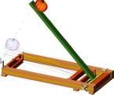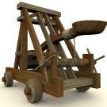

A simple catapult Medieval Catapult Replica
ineffingham.com westcentralcommunityeducation.com

Teaching Indicator 6-5.7: Lesson C-Conservation of Energy: Simple Machines – “Pulleys and Inclined Planes”

Instructional Considerations:
This lesson is an example of how a teacher might address the intent of this indicator. The FOSS Kit Levers and Pulleys provides an opportunity for conceptual development of the concepts within the standard. Students have not been introduced to the concept of simple machines in previous grades. Prior to the lesson students should know that energy is a property that enables something to move and work is done when a force (effort force) is applied over a distance. (6-5.6) Students should also be able to recognize levers, pulleys, and inclined planes.

Misconceptions:
See Lesson A

Safety Note:
Follow safety procedures when using tools such as a spring scale.

Lesson time:
2 -3 Days (1 day equals 55 minutes each)

Materials Needed:
(per group of 3 – 4 students)
- 5 pulleys
- Rope
- A load (small weight)
- Spring scale
- Book
- Plastic bag
- Board or Ramp (inclined plane)
- Levers (popsicle sticks, pencils, etc)
- Objects that can be used as a fulcrum

Focus Question:
How do pulleys and inclined planes reduce the amount of force needed to do work?

NOTE: If students have not previously used a spring scale, instruction will be necessary prior to the pulley investigation. A spring scale is a tool used to measure the weight of an object or the force on an object. Some spring scales have a slider that moves in response to the weight/force of an object. The measurement is read on one of two scales located on either side of the slider. Some spring scales have a spring that is visible through a clear plastic tube with two scales labeled on either side of the tube. Before an object is attached to the spring scale, make sure the marker is on the zero (0) by adjusting the slider or knob usually found on the top of the scale. A spring scale measures weight or force in newtons (N).

Engage:
- Show a picture (see example attached) or a video clip (ETV Streamline SC) of pulleys and inclined planes in action.
- Demonstrate the operation of a single pulley. A pulley has a grooved wheel with a rope running along the groove. They can be used to change the amount of force and/or the direction of the force.

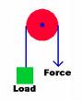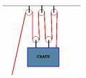
A single pulley like the one in the first diagram changes the direction of the force. As one pulls down the load goes up.
- If simple machines are used to reduce the amount of force required to do work, ask students how can we measure (or quantify) the force needed to do work? (A spring scale can be used to measure the force needed to move an object)
- Demonstrate the use of a spring scale and a single pulley. The single fixed pulley does not change the force needed to lift the load. Use a spring scale to lift the load without using the pulley and then using the pulley. There will be no difference. Have students generate questions as to how they might decrease the force needed to lift a load. Questions can be charted for future reference.
- Using a spring scale, demonstrate the force required to pull a load (a book in a plastic bag) up an inclined plane. An inclined plane is a sloping surface, like a ramp, that reduces the amount of force needed to lift a weight or load. It can be designed to lift in 2 ways:
  - Increase the length of the ramp
  - Decrease the height of the ramp

Explore:
- Hand out the materials to each group.
- Ask students, with the materials they have available and in the amount of time available (one class period to plan and design and one class period to communicate their findings to the class) to design a system that will take the least amount of force to lift or move a load. Students should investigate the actions of a single pulley vs. a multiple pulley system. They may use levers, pulleys, and/or an inclined plane.
- Students should use the steps in the technological design process (6-1.4)

Explain:
- In addition to using the technological design process, students should draw a diagram of the system they designed. They should be able to provide evidence, as in a data table, that their design required the least amount of force to lift or move a load. Each group member should have all information recorded in their science notebooks.
- If time allows, each group can create posters or charts with their design process detailed, and with the evidence or results of their implementation and evaluation of their design. Class presentations can be made.

Extend:
- Have students research and then design a “Rube Goldberg” device only using simple machines, such as levers, pulleys, inclined planes, (There are several videos available on Google videos or Teacher Tube www.teachertube.com showing such devices. )

Pulleys and Inclined Planes at Work

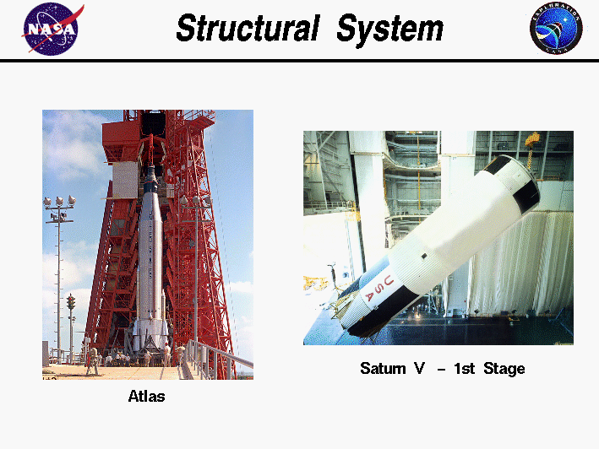

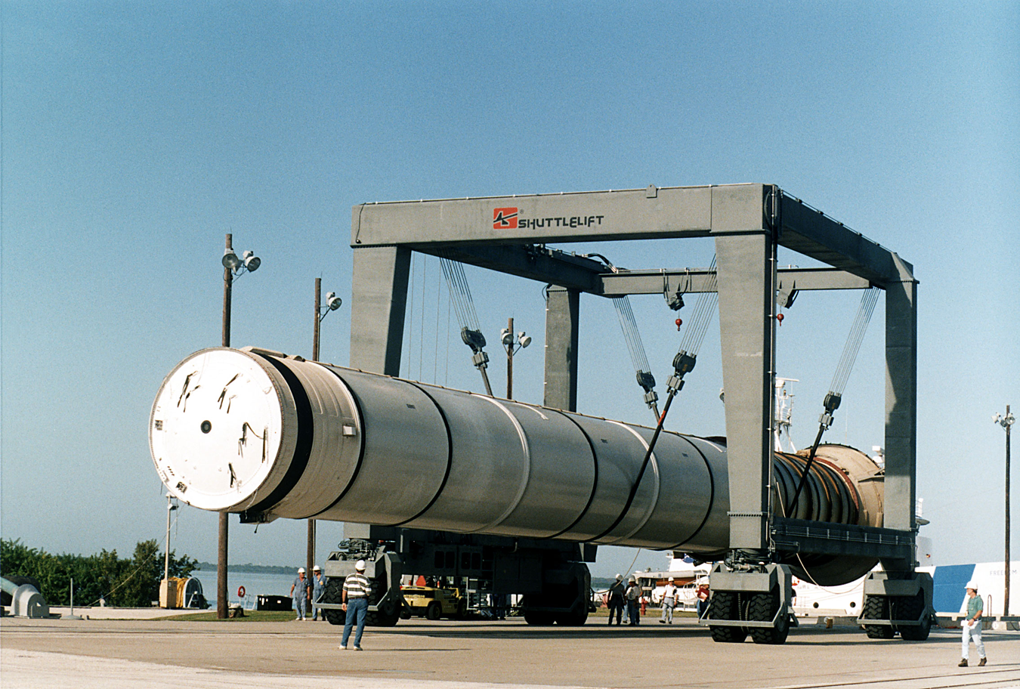

NASA PowerPoint
http://exploration.grc.nasa.gov/education/rocket/Talks/SimpleMacSpace.ppt



