SOUTH CAROLINA SUPPORT SYSTEM INSTRUCTIONAL PLANNING GUIDE
Content Area: | Science 7th Grade
Recommended Days of Instruction: 3 |  |  | (one day equals 55 min)

Standard(s) addressed: 7-2
The student will demonstrate an understanding of the structure and function of the cells, cellular respiration and heredity. (Life Science)

Heredity
Indicator | Recommended Resources | Suggested Instructional Strategies |  | Assessment Guidelines
7-2.5 Summarize how genetic information is passed from parent to offspring by using the terms genes, chromosomes, inherited traits, genotype, phenotype, dominant traits, and recessive traits. | SC Science Standards Support Document  https://www.ed.sc.gov/apps/cso/standards/supdocs_k8.cfm  University of Utah’s Genetic Science Learning Center  http://learn.genetics.utah.edu  A resource which addresses cells, DNA, Heredity and Traits.  “Genotype versus Phenotype”  http://evolution.berkeley.edu/evosite/evo101/IIIA1Genotypevsphenotype.shtml  This site explains the difference between phenotype and genotype and uses pictures to illustrate this.  “Basic Principles of Genetics”  http://anthro.palomar.edu/mendel/  This site provides information about Mendel, probability, Punnett Squares, (does not address  exceptions) and has links, and a puzzle. | See Module 7-2.5.  Teaching the Lesson 7-2.5A  Heredity – “Inherited Traits”  Teaching the Lesson 7-2.5B  Heredity – “Pasta Genetics”  Teaching the Lesson 7-2.5C  Heredity – “Paper Pollywogs” |  | From the SC Science Standards Support Document  The objective of this indicator is to summarize how genetic information is passed from parent to offspring; therefore, the primary focus of assessment should be to generalize the major points about inheritance using the terms genes, chromosomes, inherited traits, genotype, phenotype, dominant traits, and recessive traits.

Module 7-2.5 Continued
Indicator | Recommended Resources | Suggested Instructional Strategies |  | Assessment Guidelines
7-2.5 Summarize how genetic information is passed from parent to offspring by using the terms genes, chromosomes, inherited traits, genotype, phenotype, dominant traits, and recessive traits. | www.middleschoolscience.com  A variety of hands on lessons, especially Plastic Egg Genetics  Good Gizmos on www.explorelearning.com -- Mouse Genetics (one trait) – Chicken Genetics –  Suggested Streamline Videos:  http://etv.streamlinesc.org  “Introducing the Cell”  This includes information on single celled organisms, basic cell parts, and the differences between plant and animal cells.  21:00  “Greatest Discoveries with Bill Nye: Genetics”  “The Basics of Genes”  This introduces inheritance through information about Mendel’s experiments. It, also, describes genes and chromosomes. -10:30 |  |  | However, appropriate assessments should also require students to identify the main components of genetic information; explain how genetic information passed from parents to offspring determines inheritance; or compare genotype and phenotype or dominant and recessive traits.

Seventh Grade

Science
Module
7-2.5

Cells and Heredity

Lessons
A-C

Standard 7-2: The student will demonstrate an understanding of the structure and function of the cells, cellular respiration and heredity. (Life Science)

Indicator 7-2.5: Summarize how genetic information is passed from parent to offspring by using the terms genes, chromosomes, inherited traits, genotype, phenotype, dominant traits, and recessive traits.

Other indicators addressed:

From the South Carolina Science Support Document:
Indicator 7-2.5: Summarize how genetic information is passed from parent to offspring by using the terms genes, chromosomes, inherited traits, genotype, phenotype, dominant traits, and recessive traits.

Taxonomy level of indicator:
Understand Conceptual Knowledge (2.4-B)

Previous/Future Knowledge:
Students have had no previous instruction in genetics, but they were introduced to inherited characteristics in fourth grade (4-2.4). In sixth grade (6-3.7), students compared learned to inherited behaviors in animals. Students will study in greater detail DNA and RNA and how these substances function and are replicated as part of high school biology.

It is essential for students to know that offspring may have the same physical characteristics, or traits, as their parents because genetic information (DNA) is passed from parent to offspring during sexual reproduction.
- Each sex cell (egg or sperm) of the parent organism (plant or animal) contains one-half of the genetic material needed to create a new organism.
- Heredity is the passing of traits from one generation to another, or inheritance.

Chromosomes
- A structure found in the nucleus of a cell that contains the genetic information (DNA).

Genes
- A segment of DNA found on a chromosome that determines the inheritance of a particular trait.
- Genes are responsible for the inherited characteristics that distinguish one individual from another.
- Genes for a specific trait generally come in pairs.
- One gene from the pair is called an allele.
- Genes may be expressed in two different forms.
  - Genotype—the set of genes carried by the organism.
  - Phenotype—the physical expression of the genes.

Inherited traits
- Characteristics that are passed from parent to offspring. Examples of inherited traits may be eye color, eye shape, hair type, or face shape.
- Some inherited traits are dominant and some are recessive.
  - Dominant trait—A trait that will always be expressed in the phenotype. Alleles for dominant traits are represented by capital letters.
  - Recessive trait—A trait that will only be expressed in the phenotype if two recessive alleles are present. In the presence of a dominant trait, the recessive trait will not be expressed. Alleles for recessive traits are represented by lowercase letters.

It is not essential for students to know the stages of meiosis, or the structure of DNA and RNA. Sex-linked traits, mutations, incomplete dominance, codominance, polygenic inheritance, and genetic engineering are also not essential concepts for this indicator.
Assessment Guidelines:
The objective of this indicator is to summarize how genetic information is passed from parent to offspring; therefore, the primary focus of assessment should be to generalize the major points about inheritance using the terms genes, chromosomes, inherited traits, genotype, phenotype, dominant traits, and recessive traits. However, appropriate assessments should also require students to identify the main components of genetic information; explain how genetic information passed from parents to offspring determines inheritance; or compare genotype and phenotype or dominant and recessive traits.

Teaching Lesson 7-2.5 A Heredity – “Inherited Traits”

Instructional Considerations:
This lesson requires a pdf download from http://learn.genetics.utah.edu/content/begin/traits/activities/pdfs/Inherited%20Human%20Traits%20Quick%20Reference_Public.pdf

Students have had no previous instruction in genetics, but they were introduced to inherited characteristics in fourth grade (4-2.4). In sixth grade (6-3.7), students compared learned to inherited behaviors in animals.

- Inherited traits are Characteristics that are passed from parent to offspring. Examples of inherited traits may be eye color, eye shape, hair type, or face shape.

An excellent resource is the University of Utah’s Genetic Science Learning Center’s Education Outreach http://learn.genetics.utah.edu/ including an animated tour of “What is Heredity?” and an image slideshow of “Observable Traits’

Misconceptions:
According to Benchmarks, when asked to explain how physical traits are passed from parents to offspring, elementary-, middle-, and some high-school students express various misconceptions. For example, some students believe that traits are inherited from only one of the parents (e.g., the traits are inherited from the mother, because she gives birth or has most contact as children grow up; or the same-sex parent will be the determiner). Other students believe that certain characteristics are always inherited from the mother and others come from the father. Additionally, some students believe in a "blending of characteristics."
Early middle-school students explain inheritance only in observable features, but upper middle-school and high-school students have some understanding that characteristics are determined by a particular genetic entity that carries information to be translated by the cell. (Benchmarks for Science Literacy, p. 341.)
Some students may also think that because they look similar to an aunt or uncle that they received those traits from them.
Safety Note:
Students should follow all classroom safety procedures.

Lesson Time:
1 Day (55 minutes)

Materials:
- “Inherited Human Traits: A Quick Reference” download this pdf document at the University of Utah’s Genetic Science Learning Center: http://learn.genetics.utah.edu/content/begin/traits/activities/pdfs/Inherited%20Human%20Traits%20Quick%20Reference_Public.pdf
Have enough copies so that each student can have their own to place in their notebooks.
- Photos of Inherited Traits (Attached)
- Highlighters for each student.
- Text-to-Self Connections Sheet (attached)

Focus Question:
What are inherited traits?

Engage:
- Show ETV Streamline SC video clip Genes, Genetics, and DNA segments 1 and 2. STOP at 4:03 (after the ducks and before the butterfly)
- Show a few photos of genetic traits such as detached earlobes, rolling of tongue, freckles, dimples. Have students try rolling their tongue.
- Tell students to clasp their hands together by folding their hands with their fingers interlocking. Which thumb is on top – your left or your right?
One study found that 55% of people place their left thumb on top, 45% place their right thumb on top and 1% have no preference.

(A study of identical twins concluded that hand clasping has at least some genetic component. However, other scientists have not found evidence that genetics plays a significant role in determining this trait.)

- Pass out the “Inherited Human Traits: A Quick Reference” document. Make sure all students have a highlighter.

Explore:
- In groups of 4 have students, have all students read the Background Information on page 1 of the Quick Reference Guide. As they read, they should highlight or mark sentences that connect to their own life through past experience or prior knowledge.
- Have students divide the 12 traits in the Quick Reference evenly. Each person should have 3 traits to read about.
- Allow time for students to read silently.

Explain:
- When the group members have finished reading, each person should share their new knowledge with the group.
- Once again, students can highlight sentences that they connect with.
- Once all group members have shared, they should fill out the Text-to-Self Connections sheet.

Extend:
- Allow time for students to share something new they have learned.
- Ask them to answer the Focus Question in their notebooks.
- Have students turn in the Text-to Self Connections sheet as an Exit Slip. (Return to students the following day to be placed in their notebooks.
- Other activities can be found at The University of Utah’s Genetic Science Learning Center http://learn.genetics.utah.edu/ including an animated tour of “What is Heredity?” and an image slideshow of “observable Traits’

Inherited Traits Photos

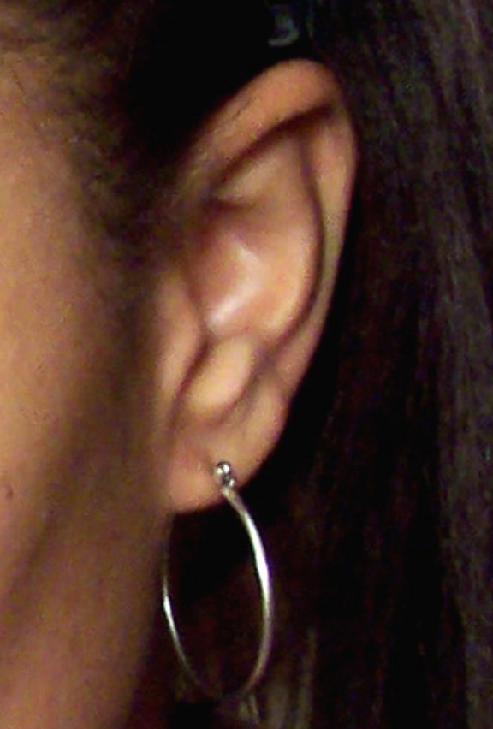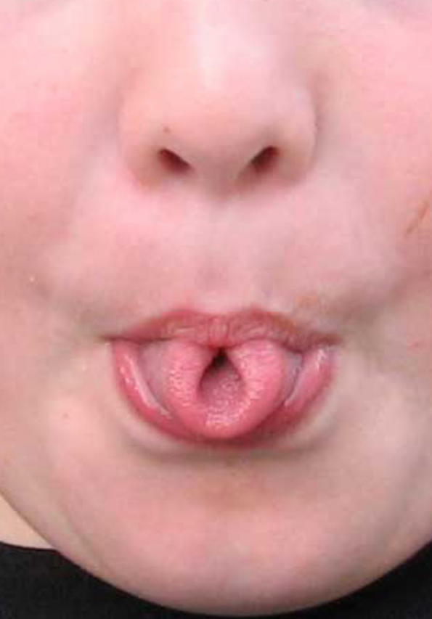
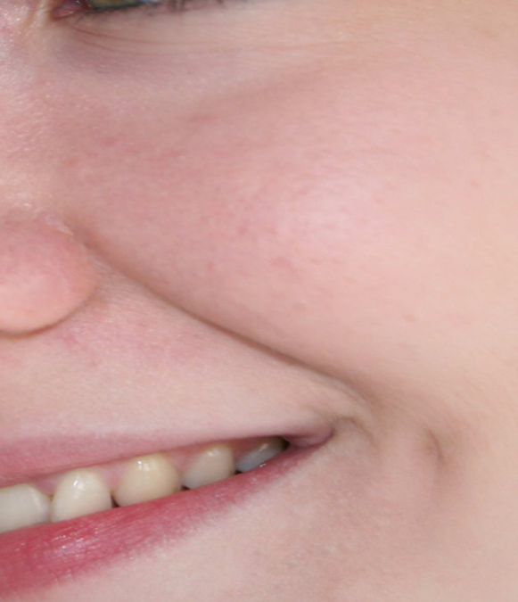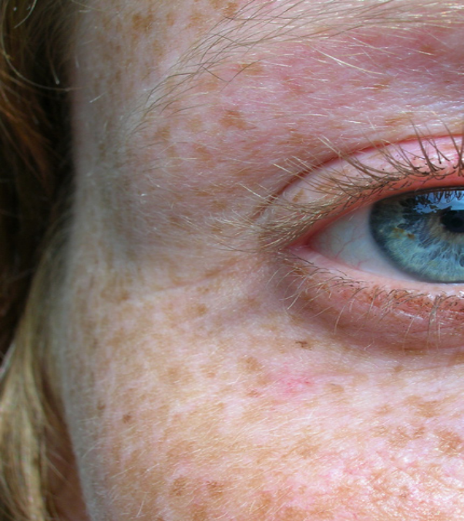

Text-to-Self Connections
While reading, highlight or mark sentences where you connect your own life through past experiences or prior knowledge. When finished reading choose two sentences, paragraphs, or pictures to place in the first box. Continue making your connections in the other boxes.
Quote or Picture from the text:

This reminds me of…..

Quote or Picture from the text:

This reminds me of…

Adapted from: Strategies That Work:Teaching Comprehension to Enhance Understanding by Stephanie Harvey and Anne Goudvis. 2000. Stenhouse Publishers, York, Maine.

Teaching Lesson 7-2.5 B Heredity – “Pasta Genetics”

Instructional Considerations:
This activity was based on the "Genes and Generations" activity in You, Me, and Others (1995), an elementary school genetics curriculum developed by BSCS and March of Dimes. There are new terms introduced in this session. Relate these terms to the ones found in 7-2.5 B. It is important that students understand the relationship among and between these terms. Monitoring of student understanding is needed, addressing misconceptions when they arise. It is suggested that this lesson be taught after 7-2.5 A.
Misconceptions:
According to Benchmarks, when asked to explain how physical traits are passed from parents to offspring, elementary, middle, and some high school students express various misconceptions. For example, some students believe that traits are inherited from only one of the parents (e.g., the traits are inherited from the mother, because she gives birth or has most contact as children grow up; or the same-sex parent will be the determiner). Other students believe that certain characteristics are always inherited from the mother and others come from the father. Additionally, some students believe in a "blending of characteristics."
Early middle school students explain inheritance only in observable features, but upper middle school and high school students have some understanding that characteristics are determined by a particular genetic entity that carries information to be translated by the cell. (Benchmarks for Science Literacy, p. 341)
Some students may also think that because they look similar to an aunt or uncle that they received those traits from them.
Safety Note:
Students should follow all classroom safety procedures, specifically when handling food products. No food products should ever be tasted or eaten without permission from the teacher.

Lesson time:
One day (55 minutes)

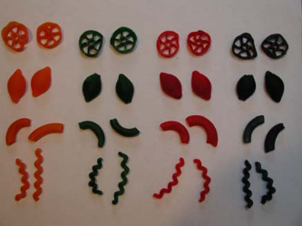
Materials Needed:
- 4 bags pasta of different shapes (if you can find different shapes in 4 different colors then you will not need to dye the pasta)

Example

- Paper muffin cups or small petri dishes, enough for 7 per group of 2 students.
- Enlarged template (use attached and enlarge on an 11x17 piece of paper. An alternative is to have students draw the shapes on the 11x17 paper.)
- Crayons or colored pencils
- “Student Procedure” Sheet (attached)
- “Student Data Table and Questions” Sheet (attached)

If you need to dye the pasta, follow these directions:
You will need
- 4 small vials food coloring: red, blue, green, and yellow
- 2 gallons white vinegar (inexpensive brand)

Place one half gallon vinegar and one small vial food coloring in a large bowl. Stir to mix. Place one quarter of each of the 4 bags of pasta in each bowl. Stir well. Let pasta sit in dye-vinegar mixture for one hour, stirring occasionally. Drain pasta and rinse briefly in cold water. Note: if you do not rinse the pasta, it will remain very aromatic. If you rinse too vigorously or for too long, some of the color may leach out. Cover cookie sheet with foil and place dyed pasta on top in single layer. Bake in 250° oven for 10 minutes to dry the pasta.

Focus Question:
How do organisms get their inherited traits?

Engage:
- Remind students that they have just learned about Inherited Traits.
- Ask students where do we get the “directions” from to make us who we are? (Student answers may vary. If the answer “From our parents” does not arise, then share the answer with students.)
- The “directions” to make us come from our biological parents, biological grandparents, great-grandparents, and so on.
- Show a model or photo of a DNA double helix.

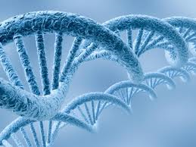

Those “directions” are genetic information called DNA (Deoxyribonucleic acid) which is a nucleic acid that contains the genetic instructions used in the development and functioning of all known living organisms.

- Write these following words on the board or on sentence strips DNA, Chromosomes, Genes, Heredity.
- Ask students where is DNA found in our bodies?
- Have the following definitions written on separate sentence strips.
- Genetic information genetic information passed from parent to offspring during sexual reproduction.
- A structure found in the nucleus of a cell that contains the genetic information (DNA).
- A segment of DNA found on a chromosome that determines the inheritance of a particular trait.
- The passing of traits from one generation to another
- Ask students where each definition belongs on the board. (Answers: Bullet 1 is DNA, Bullet 2 is chromosomes, Bullet 3 is genes, Bullet 4 is heredity)
- Ask for students’ comments or questions. (NOTE: One question may be how do scientists know what DNA looks like? You may want to share the history of who first found DNA. An Example source can be found at eZine @rticles: http://ezinearticles.com/?Who-Discovered-DNA,-Lifes-Building-Block?&id=1478447)

- Tell students that genes are responsible for the inherited characteristics that distinguish one individual from another and that genes for a specific trait generally come in pairs. (Show a model or image of a gene.)

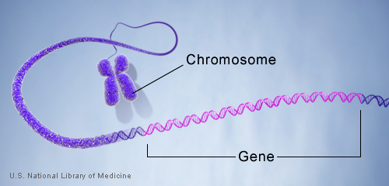

Genes are made up of DNA. Each chromosome contains many genes.
http://ghr.nlm.nih.gov/handbook/basics/gene

- Next, they will be exploring how genes, the directions for building a person, are passed from grandparents to parents to children and why each of us is unique.
- Hand out materials to pairs of students. Review the procedure, asking for questions from students before beginning the exploration.

Explore:
- Students will need to color the placeholders for both sets of grandparents, parents and child according to the procedure.
- Students should follow the procedure sheet, recording each trial on the “Student Data Table”

Explain:
- Have students answer the questions on the Procedure sheet.
- Students should write the definitions on the board into their notebooks (or have the definitions on half sheets to glue or tape into notebooks.)
- In groups of 4, have students compare the results from their trials.
- As an Exit Slip, have students write one interesting new learning and one question they have.

Extend:
- Let students share any questions regarding genetics and heredity. Chart the questions and hang as an anchor chart. This will provide a source for future research.
- A source of reference is The National Library of Medicine, Genetics Home Reference, http://ghr.nlm.nih.gov/
- Additional Lesson plans on genetics can be found at: The GENETICS Project , University of Washington Department of Genome Sciences Education Outreach, http://chroma.gs.washington.edu/outreach/genetics
Pasta Genetics
Student Procedure Sheet

- Label the muffin cups and arrange them on the diagram.

- Place eight pieces of pasta, two of each shape, into each cup, using the following color code:

Grandfather 1: red
Grandfather 2: yellow
Grandmother 1: green
Grandmother 2: blue

Using this code, color the space for each grandparent on your diagram.

- The pasta pieces stand for genes, and each pasta shape is a different gene. There are two of each pasta shape because we have two copies of each of our genes. In this example, Grandfather 1 has four pairs of genes, all colored red, and Grandmother 1 has four pairs of genes colored green.
- Now you are going to choose the genes for the daughter of Grandfather 1 and Grandmother 1. To do this, select four genes from the Grandfather 1 cup, making sure that you take one of each shape, and take four genes from the Grandmother 1 cup, one of each shape. Close your eyes as you select the genes. Place these pasta pieces in the cup labeled “Mother.” The eight pasta pieces in the “Mother” cup are Mother’s genes, half from her father and half from her mother. Color your diagram.
- Without looking, take four different genes from Grandfather 2 and four different genes from Grandmother 2 and place in the cup called “Father.” Color the diagram.
- Mother and Father are going to have four children. Each child gets half of his or her genes from Mother and half from Father. For the first child, select four genes, one of each shape, from Mother’s cup and four genes, one of each shape, from Father’s cup, and place in the cup labeled “Child.” Be sure to close your eyes when you select the genes! Color the diagram to show which genes Child 1 has. What is your child’s name?
- Return the child’s genes to the Mother and Father cups. (Mother’s genes are red and green, and Father’s genes are yellow and blue.) Select genes for Child 2 as you did for the first child, and record your results on the diagram. Repeat this step for Child 3 and Child 4. Remember to color the diagram after each child and return all of Mother’s and Father’s genes to the correct cups before choosing genes for the next child. Don’t forget to name your children!
- Fill in the data table and answer the questions in your notebooks.

Lesson adapted from: The GENETICS Project http://chroma.gs.washington.edu/outreach/genetics
University of Washington Department of Genome Sciences Education Outreach
Pasta Genetics
Diagram

Gf

1
Gm

1
Gf

2
Gm

2

Mother
Father

Child

Data Table

Data Table: Pasta Genes Number of genes from: |  | Child 1  _________ | Child 2  _________ | Child 3  _________ | Child 4  _________
Grandfather 1 (red)
Grandmother 1 (green)
Grandfather 2 (yellow)
Grandmother 2 (blue)
Total # of genes | 8
Total # of gene pairs | 4

Questions

- How many genes did each child inherit from Mother? From Father?

- How many of each gene (pasta type) does each child receive?

- Did any of the four children have exactly the same combination of genes?

- Did every child get at least one of his/her genes from each grandparent?

5. Would it be possible for a child in this activity to have the following combinations of genes:
• eight yellow genes?
• four yellow genes and four red genes?
• three blue genes, two green genes, and three red genes?

Teaching Lesson 7-2.5 C Heredity – “Paper Pollywogs”

Instructional Considerations:
In this lesson students will become familiar with genotype, phenotype, dominant and recessive traits. There are new terms introduced in this session. Relate these terms to the ones found in 7-2.5 B. It is important that students understand the relationship among and between these terms. Monitoring of student understanding is needed, addressing misconceptions when they arise. It is suggested that this lesson be taught after 7-2.5 A and 7-2.5 B.
Misconceptions:
According to Benchmarks, when asked to explain how physical traits are passed from parents to offspring, elementary, middle, and some high school students express various misconceptions. For example, some students believe that traits are inherited from only one of the parents (e.g., the traits are inherited from the mother, because she gives birth or has most contact as children grow up; or the same-sex parent will be the determiner). Other students believe that certain characteristics are always inherited from the mother and others come from the father. Additionally, some students believe in a "blending of characteristics."
Early middle-school students explain inheritance only in observable features, but upper middle-school and high-school students have some understanding that characteristics are determined by a particular genetic entity that carries information to be translated by the cell. (Benchmarks for Science Literacy, p. 341.)
Some students may also think that because they look similar to an aunt or uncle that they received those traits from them.
A dominant trait does not mean "more potent," and recessive does not mean "weaker." The terms simply refer to the visible trait, the phenotype.
Safety Note:
Students should follow all classroom safety procedures.

Lesson time:
One day (55 minutes)

Materials Needed:
- Blue and yellow copy paper
- An outline of the paper pollywog copied onto the copy paper, enough for one per student. Each sheet of copy paper will hold two pollywogs.
- Copy the “Genotype/Phenotype” chart on the back of each pollywog.
- “Pollywog” trait chart
- “Genotype Selection” directions (attached)
- “Mating Data Table and Directions/Questions” sheet (attached)
- One die per student
- Image/drawing of a chromosome (attached)
Focus Question:
How are traits passed from parent organisms to their offspring?

Engage:
- Show the images of chromosomes.
- Ask how many chromosomes are found here in a human cell (46 or 23 pairs). One chromosome of each pair came from the mother, and the other chromosome from each pair came from the father during a special cell division called meiosis. (Students learned of mitosis in Lesson 7-2.4 but have not learned of meiosis. It is not essential for students to know the stages of meiosis. Meiosis can be explained as a special type of cell division essential for sexual reproduction in which the number of chromosomes per cell is cut in half.)

- Refer back to the definition for gene from Lesson 7-2.5 B. Explain that genes for a specific trait generally come in pairs. One gene from the pair is called an allele and genes may be expressed in two different forms.

- Introduce three more terms on sentence strips: Genotype , Phenotype, Allele
Have the definitions written on two other sentence strips.
  - (Genotype) the set of genes carried by the organism.
  - (Phenotype) the physical expression of the genes.
  - (Allele) one gene from the gene pair for a specific trait is called an allele
- Explain that the physical expression of genes may not show other inherited traits that the person has a gene for. Ask students, if they have brothers or sisters do all of them have the same eye color? Do some of them have curly hair while others have straight hair?
- Introduce two more terms: recessive trait and dominant trait
  - Dominant trait—A trait that will always be expressed in the phenotype. Alleles for dominant traits are represented by capital letters.
  - Recessive trait—A trait that will only be expressed in the phenotype if two recessive alleles are present. In the presence of a dominant trait, the recessive trait will not be expressed. Alleles for recessive traits are represented by lowercase letters.
A dominant trait does not mean "more potent," and recessive does not mean "weaker." The terms simply refer to the visible trait, the phenotype.
- Referring to the definitions on the board for dominant and recessive traits, ask students if they remember from Lesson 7-2.5 A which traits were dominant (tongue rolling, dimples, freckles, etc.) Provide an example of dominant and recessive traits using freckles. Draw the following on the board:

Mom Dad
Ff Ff

Child
ff

- Explain that in genetics a dominant trait is written with a capital letter, a recessive trait is written with a lower case letter. In this example, both Mom and Dad have freckles (phenotype) because they have the dominant allele for freckles. However, they both carry a recessive allele. Their child receives one allele from both parents (random) so it is possible for the child to have received both recessive alleles. Therefore the child will not have freckles in his phenotype (appearance.) The tricky part of genetics that this child’s brother or sisters could have freckles. (Draw another child with Ff and another with FF.)
- Ask for any clarifying questions monitoring for misconceptions. Refer back to Lesson 7-2.5 B.
- Explain that everyone in the class is now a licensed breeder of pollywogs (tadpoles.) Using the Traits Chart, each student will create a pollywog with six traits.
  - Color (blue/yellow)
  - Gender (male/female)
  - Eyes (large/small)
  - Nose (round/pointy)
  - Tail (long/short)
  - Toes (webbed round/webbed pointy)

- Allow students to choose either yellow or blue paper with an outline on it. Using the pollywog outline side, have the students create the features of their pollywog using the information on the “Pollywog Traits” chart. (NOTE: Make sure that there is an even number of male and female pollywogs. It would be a good idea to have a few extra males and females on hand prior to mating day.)
- On the back, have them fill out the phenotype.
- Explain that their pollywogs received their traits from their parents. It was a random selection. Now, pass out the “Genotype Selection” directions. Have students fill in the letter of the alleles they chose. (genotype) They will need a die.
- Once students have their genotypes filled out, ask students to share any patterns they are seeing? Which traits do they think are the dominant traits? What is the evidence for that claim? (Students should be seeing the pattern of traits that are dominant. They may have questions regarding the recessive alleles. Refer back to the freckles demonstration.) Ask for any questions students might have before proceeding.

Explore:
- Explain to students that it is now mating season. They should find a pollywog of the opposite sex. (Based on the classroom culture, students can be assigned partners or self select partners.)
- Using the “Trial Data Table and Directions” students will follow the directions for mating. It is suggested that one round be modeled by the teacher. If an even number is rolled, the first allele on the student’s pollywog genotype will be written in the genotype box under Child 1. If an odd number is rolled, the second allele will be written. Remind students that Genotypes are normally written with the capital letter (dominant allele) first, however this can be addressed after all rolls have been completed.

Explain:
- Have students fill in the data table and answer the questions.
- Have students join another pair of students to share their mating results. Are they seeing patterns? What phenotypes are the most prevalent?
- Allow students to share in whole class dialogue their new learning, questions, or surprises.

Extend:
- Assign groups of 4 students to create a Frayer Model for one of the vocabulary words on sentence strips posted on the board. The vocabulary words can be assigned to groups. Have students complete the Frayer Model using a large index card. These can be posted below each sentence strip. See the example of a Frayer Model below.

Definition  Vocabulary Word | Characteristics
Examples | Non-examples

- Students may wish to continue mating pollywog children from a different pair of pollywogs to determine if new patterns appear over time.

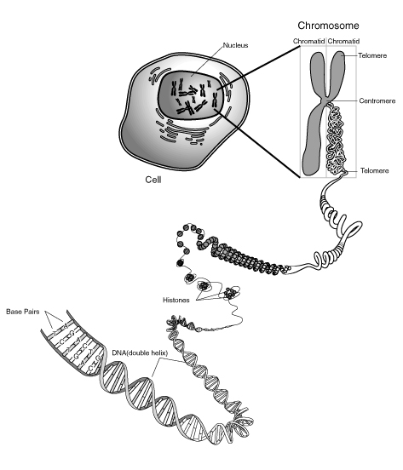
http://www.ams.org/samplings/feature-column/fcarc-primer1

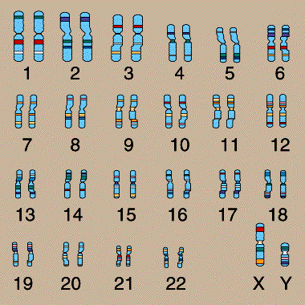
http://www.accessexcellence.org/AE/AEPC/NIH/gene03.php

Each human cell contains 23 pairs of chromosomes, which can be distinguished by size and by unique banding patterns. For all 23 pairs of chromosomes, one chromosome of each pair came from the mother and the other chromosome from each pair came from the father. This set is from a male, since it contains a Y chromosome. Females have two X chromosomes.

Pollywog outline

Back of Pollywogs

Pollywog name

PhenotypeGenotypeColor
Gender
Eyes
Nose
Tail
Toes
(Genotype) the set of genes carried by the organism.
(Phenotype) the physical expression of the genes.

Pollywog Trait Chart

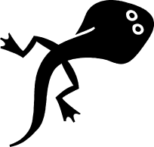

Color: Blue or Yellow

Gender: Male or Female

Eyes:

Small Large

Nose:

Round Pointy

Tail: (Pick 2, can be different)

Long Flat Short flat
Toes: (Pick 2, can be different)

Webbed Webbed
Pointy Round

Genotype selection
Fill in the Genotype boxes on the back of your pollywog using the guidelines below.

Color:
- If your color is blue, its Genotype can be BB or Bb
  - Roll the die. If the number is even your genotype will be BB
  - If the number is odd, your genotype will be Bb
- If your color is yellow, then your genotype will be bb

Gender:
- If you are a male, your genotype will be XY
- If you are a female, your genotype will be XX

Eyes:
- If you have large eyes, your genotype can be LL or Ll
  - Roll the die. If the number is even, your genotype will be LL
  - If the number is odd, your genotype will be Ll
- If you have small eyes, your genotype will be ll

Nose:
- If you have a round nose, your genotype can be RR or Rr
  - Roll the die. Even number, RR. Odd number, Rr
- If you have a pointy nose, your genotype will be rr

Tail:
- If you have a long tail, your genotype can be TT or Tt
  - Roll the die. Even number, TT. Odd number, Tt.
- If you have a short tail, your genotype will be tt

Toes:
- If you have webbed round toes, your genotype can be WW or Ww
  - Roll the die. Even number, WW. Odd number, Ww.
- If you have webbed pointy toes, your genotype will be ww.

Mating Results Data Table and Directions

Trait | Child 1 | Child 2 | Child 3

 | Genotype | Phenotype | Genotype | Phenotype | Genotype | Phenotype
Color

Gender

Eyes

Nose

Tail

Toes

Mating Directions:

- Choose one person to roll the die first.
- If an even number is rolled, write down the first allele from your pollywog’s genotype in the genotype box under Child 1 above.
- If an odd number is rolled, write the second allele from your pollywog’s genotype in the genotype box above.
  - Example: Student A rolls a 2. In her pollywog’s genotype for Color (blue) she will write the first allele from the genotype which would be B.
- The next person should now roll the die. If an even number is rolled, write down the first allele. If an odd number, the second allele.
  - Example: Student B rolls a 3. In his pollywog’s genotype the second allele is a b. He will write b beside the allele from Student A. Now, in the genotype box of Child 1 above, there is a Bb, which means the pollywog Child 1 has both a dominant allele for the color blue and a recessive allele for the color yellow. Child 1’s phenotype will be Blue, because blue is dominant.
- Continue having each person roll the die, selecting an allele for each trait. Be sure to complete the phenotypes of Children 1, 2, and 3.
NOTE: Genotypes are normally written with the capital letter (dominant allele) first.

Questions:
- What patterns are you seeing?

- What are the dominant traits? Recessive traits? Which phenotypes were the most common?

- Did any of the offspring have the exact combination of genes (all traits)? Explain why or why not?

- How is it possible for two blue parents to have a yellow child? Is it possible for two yellow parents to have a blue child? Explain why or why not.

Possible Answers:
- The patterns students are seeing will vary, but there should be a pattern where the dominant traits are evident in the phenotypes. There should be more blue pollywog children with large eyes, round noses, long tails, and webbed round toes.
- Dominant: Blue, large eyes, round noses, long tails, webbed round toes
Recessive: Yellow, small eyes, pointy noses, short tails, webbed pointy toes
The most common phenotypes are the dominant traits.
- If so, they would be identical twins. Twins make up 1.9% of the world population, with identical twins making up 0.2% of the total - and 8% of all twins.
- Two blue parents could be carrying the recessive allele for yellow. If both recessive alleles combine, then the offspring is yellow. Two yellow parents could not have a blue offspring because there is no dominant allele for blue present.

