SOUTH CAROLINA SUPPORT SYSTEM INSTRUCTIONAL PLANNING GUIDE
Content Area: | Eighth Grade Science
Recommended Days of Instruction: 2  (for this lesson only; NOT for this indicator) |  |  | (one day equals 55 min)

Standard(s) addressed: 8-4
The student will demonstrate an understanding of the characteristics, structure, and predictable motions of celestial bodies. (Earth Science)
Earth’s Structure and Processes
Indicator | Recommended Resources | Suggested Instructional Strategies |  | Assessment Guidelines
8-4.9: Recall the Sun’s position in the universe, the shapes and composition of galaxies, and the distance measurement unit (light year) needed to identify star and galaxy locations. | SC Science Standards Support Guide Resource List  https://www.ed.sc.gov/apps/cso/standards/supdocs_k8.cfm  SC ETV Streamline  http://etv.streamlinesc.org  Exploring Space: The Universe  http://player.discoveryeducation.com/index.cfm?guidAssetId=B81EE2CC-1AC4-49C3-92FC-EB4E84FFC409  Additional Resources  “Solar System Bead Distance” http://www.jpl.nasa.gov/education/index.cfm?page=101  Atlas of the Universe http://www.atlasoftheuniverse.com/  “Group the Galaxies” http://amazing-space.stsci.edu/resources/print/classroom_activities/group_the_galaxies.pdf  “Find the Right Circle” http://amazing-space.stsci.edu/resources/print/classroom_activities/find_the_right_circle.pdf  HubbleSite http://hubblesite.org/  NASA Jet Propulsion Laboratory: Welcome to the Planets http://pds.jpl.nasa.gov/planets/welcome.htm  Amazing Space  http://amazing-space.stsci.edu/  Earth Science World http://www.earthscienceworld.org/index.html  Views of the Solar System http://solarviews.com/  The Planetary Society http://www.planetary.org/  San Francisco Exploratorium Space Weather Research Explorer http://www.exploratorium.edu/spaceweather/index.html  National Aeronautic and Space Administration (NASA) Earth Observatory http://Earthobservatory.nasa.gov/  Measuring the Universe http://www.nasa.gov/audience/foreducators/topnav/materials/listbytype/Taking_the_Measure_of_the_Universe.html  Studying the Pleiades star cluster http://www.nasa.gov/audience/foreducators/topnav/materials/listbytype/SMII_Problem12.html  Calculating star distances  http://www.nasa.gov/audience/foreducators/topnav/materials/listbytype/SMII_Problem5.html  Just how big is this place by StarChild  http://starchild.gsfc.nasa.gov/docs/StarChild/teachers/how_big.html  Galaxies to be Classified http://btc.montana.edu/CERES/html/Galaxy/galunknsheet.html)  “Drawing a scale model of the  Solar System”  http://spaceplace.jpl.nasa.gov/en/educators/comet_orbits_cnsr.pdf  Amazing Space trading cards http://amazing-space.stsci.edu/resources/print/activities/galaxytradecards.pdf  Amazing Space  http://amazing-space.stsci.edu/resources/organizers/docs/tchr_tchart_galaxytypes.pdf  Diverse Galaxies lithograph and informational article http://amazing-space.stsci.edu/resources/print/lithos/diverse-galaxies_litho.pdf | See Science Module 8-4.9 |  | From the South Carolina Science Support Document:  The objective of this indicator is to recall the Sun’s position in the universe, the shapes and composition of galaxies, and the measurement unit light year; therefore, the primary focus of assessment should be to remember what is needed to identify star and galaxy locations.  However, appropriate assessments should also require students to identify the name of Earth’s galaxy or the meaning of light year.

Eighth Grade

Science Module
8-4.9

Astronomy: Earth and Space Systems

Lessons A

Standard 8-4: The student will demonstrate an understanding of the characteristics, structure, and predictable motions of celestial bodies. (Earth Science)

Indicator 8-4.9: Recall the Sun’s position in the universe, the shapes and composition of galaxies, and the distance measurement unit (light year) needed to identify star and galaxy locations.

From the South Carolina Science Support Documents:

Indicator 8.4.9: Recall the Sun’s position in the universe, the shapes and composition of galaxies, and the distance measurement unit (light year) needed to identify star and galaxy locations.

Taxonomy level:
Remember Factual Knowledge (1.2-A)

Previous/Future knowledge: This indicator contains new conceptual material. Students will expand on this knowledge in high school Earth Science as they then develop understanding of the classifications of stars (ES-2.5), the life cycle of stars (ES-2.7), and how gravity and motion affect the formation and shapes of galaxies (ES-2.8).

It is essential for students to know that:
- The Sun is a star in the Milky Way galaxy located in a spiral arm about two-thirds of the way from the center of the galaxy.
- Galaxies are made up of gas, dust, and billions of stars and have different shapes –
  - elliptical – spherical or flattened disks,
  - spiral – a nucleus of bright stars and two or more spiral arms, or
  - irregular – no definite shape
- Because distances in space are so great that conventional numbers are too large to work with, astronomers use a unit of measurement called light year to measure the distance to stars and galaxies in space. The distance in one light year is equal to the distance light travel in one year.

NOTE TO TEACHER: Students may come with a misconception that the Milky Way galaxy is in the solar system because they may have seen the band of stars in the night sky. The relationship between objects within the solar system and those out in the universe is an important concept to form accurately at this time.

It is not essential for students to know other characteristics of the Milky Way galaxy, or how galaxies came to have their shapes, or the characteristics of the stars in the various galaxies. The study of stars, their magnitudes, classifications and life cycle, is not included with this indicator. Using the measurement, astronomical unit, and parallax to determine distances in space is also not necessary.

Assessment Guidelines:
The objective of this indicator is to recall the Sun’s position in the universe, the shapes and composition of galaxies, and the measurement unit light year; therefore, the primary focus of assessment should be to remember what is needed to identify star and galaxy locations.

However, appropriate assessments should also require students to identify the name of Earth’s galaxy or the meaning of light year.
Teaching Indicator 8-4.9: Lesson A –“Celestial Bodies”

Instructional Considerations:
This lesson is an example of how a teacher might address the intent of this indicator. The STC kit Earth in Space provides an opportunity for conceptual development of the concepts within the standard. NOTE: This lesson does NOT adequately address the entire content included within this standard.

Misconceptions:
Some incorrect believes children often hold include but are not limited to:
- The planets are relatively similar in size to the Sun and are relatively close in distance to one another. (The diameters of the planets are vastly different. The distances between the last five planets are much greater than the distances between the first four planets.)
- The planets are always lined up with each other in the solar system. (Although nearly all of the planets orbit the Sun along the same plane of the ecliptic, they are not normally in alignment with each other because their orbital velocities and orbital periods vary.)
- Planets cannot be seen with the naked eye.
- The earth is the center of the solar system. (The planets, sun and moon revolve around the earth.)
- The solar system contains only the sun, planets and the moon.
- Stars and constellations appear in the same place in the sky every night.
- All the stars in a constellation are near each other, and form patterns clearly resembling people, animals or objects.
- All stars are the same size, and the same distance from the earth.
- The galaxy is very crowded.
- Stars are evenly distributed throughout the universe.
- The brightness of a star depends only on its distance from the earth.
- The North Star is the brightest star in the night sky. (Sirius is the brightest star in the sky, after the Sun.)
- Most galaxies are easily viewed with the naked eye. (Most galaxies are so far away that people can view them only with the help of telescopes. Only three galaxies can be seen with the unaided eye: the Andromeda Galaxy and the Large and Small Magellanic Clouds. These galaxies appear as cloudy patches in the sky. Other galaxies appear as fuzzy spots in the sky when viewed with small telescopes.)
- All galaxies are the same. (The shapes of galaxies vary – some are elliptical, others are spiral, and still others have no definite shape. Galaxies differ in color, composition, orientation, age, size, the number of stars within them, and their distance from Earth.)
- Galaxies are composed of stuff that is different from stars. (Galaxies are large collections of stars, gas, and dust held together by their gravitational attraction.)
- Galaxies are static, remaining unchanged with time. (In fact, galaxies are dynamic and change over millions of years. Stars are born and die in galaxies. A galaxy also can interact with another galaxy, which alters both galaxies' shapes.
- You can judge the distance of a galaxy based on its size. (The size a galaxy appears to be to an observer depends on how many stars are in it and how far away it is. Two galaxies may appear to be the same size. One of them, however, may be a small galaxy close to Earth and the other a large galaxy that is much farther away.)
- Children often have trouble making the connection to real world from simulations or models; be explicit in asking clarifying questions to ensure lifelong misconceptions are not created.

Safety Note(s):
Students should know and practice the procedures for fire, glass and chemical safety. Students should use care when performing this experiment, and be wearing the proper safety equipment including aprons and goggles. Students should know and practice safe disposal of materials in a laboratory setting.

Lesson time:
2 days (1 day equals 55 minutes)

Materials Needed: (per groups of 2)
- Planet beads (large craft pony beads in 11 colors) roughly approximating the appearance of the planets and the sun
- Five meters of string for each student
- Small piece of cardboard to wrap solar system string around (10 cm x 10 cm)
- Meter sticks or rulers with centimeter markings for each student or group to share
- Student calculations table, one for each student
- Piece of corrugated cardboard at least 25 centimeters
- (10 inches) square
- String
- Ruler (metric or English units)
- Pencil
- 2 straight pins or push pins
- Clean, dry area of pavement outside at least 8 meters (27 ft) long and 6 meters (20 ft) wide
- Sidewalk chalk, several large pieces, two colors
- Two broom or mop handles (rubber tips are helpful)
- String
- Meter (or yard) stick or tape measure
- Small pieces of paper (for string labels)
- Stapler
- Student activity sheet for “Group the Galaxies” (see attached)
- Galaxy trading cards set (see attached)
- Student Activity Sheet A “Find the Right Circle: Compare/Contrast Chart” – (see attached)
- Venn Diagram: Comparison of Spiral and Elliptical Galaxies (see attached)
- Sheet of different galaxies (see attached)
- Lithograph and article “Diverse Galaxies” (see attached)

Focus Question:
What are some characteristics of celestial bodies?

Engage:
NOTE: This has been extracted from the activity “Solar System Bead Distance” originally published by NASA and can be downloaded in the original format at: http://www.jpl.nasa.gov/education/index.cfm?page=101
- Our solar system is immense in size. We think of the planets as revolving around the sun but rarely consider how far each planet is from the sun or from each other. Furthermore, we fail to appreciate the even greater distances to the other stars. Astronomers refer to the distance from the sun to the Earth as one "astronomical unit" or AU. This unit provides an easy way to calculate the distances of the other planets from the sun and build a scale model with the correct relative distances.
- NOTE:
Astronomical Unit - 1AU = approximately 150 million kilometers (93 million miles)
(149,597,870,700 kilometers or 92,955,807,238 miles to be exact!)
- We will construct a distance model of the solar system to scale, using colored beads as planets. The chart below shows the planets and asteroid belt in order along with their distance from the sun in astronomical units. First, complete the chart by multiplying each AU distance by our scale factor of 10 centimeters per astronomical unit. Next, use the new distance to construct a scale model of our solar system. Start your model by cutting a 4.5 meter piece of string (5.0 meters if you are doing the Pluto extension). Use the distances in centimeters that you have calculated in the chart below to measure the distance from the sun on the string to the appropriate planet and tie the colored bead in place. When you are finished, wrap your string solar system around the cardboard holder. Note that the bead colors are rough approximations of the colors of the planets and the sun.
- Keep two important solar system facts in mind. The first is that the planets never ever align in a straight line. Occasionally sky watchers are treated to the sight of two bright planets apparently close together as viewed from our planet.
- The second fact is that your string solar system is a radius of the orbits of the planets. To see how large the solar system is hold the sun in one location and swing the planets in a circle around it. If you move counter-clockwise you will be moving the planets in the direction they move as viewed from above their plane. The whole circumference of the solar system probably will not fit into your classroom.

Planet | AU | Scale Value (cm) | Color
Sun | 0.0AU | 0 cm | yellow
Mercury | 0.4AU | __ cm | solid red
Venus | 0.7AU | __ cm | cream
Earth | 1.0AU | 10 cm | clear blue
Mars | 1.5AU | __ cm | clear red
Asteroid belt | 2.8AU | __ cm | black
Jupiter | 5.2AU | __ cm | orange
Saturn | 9.6AU | __ cm | clear gold
Uranus | 19.2AU | __ cm | dark blue
Neptune | 30.0AU | __ cm | light blue
* Pluto (closest) | 29.7AU | __ cm | brown
Pluto (average) | 39.5AU | __ cm | brown
Pluto (most distant) | 49.3AU | __ cm | brown
- You can add "dwarf planet" Pluto’s nearest and most distant points to illustrate that Pluto’s orbit is much different than the eight major planets. This was one element of the decision to describe Pluto as a dwarf planet. When Pluto is closest to the sun it is inside the orbit of Neptune. If a bead is to be added for Pluto at this point it needs to be on the string before the Neptune bead is tied off. So the order will be: Uranus, Pluto, Neptune, Pluto, Pluto.
- Consider that if you were traveling at the speed of light, it would take 8 minutes and 19 seconds (or about 8.3 minutes) to travel from the sun to the Earth (1 AU). Using this measure, students can calculate the light-time from the sun to each planet. It would take 4.3 years (traveling at the speed of light – 300,000 kilometers per second) to reach the next nearest star system, Alpha Centauri!
- The Voyager spacecraft are the most distant human-made objects. Launched in 1977, the mission flew by all four of the "Jovian" planets -- Jupiter, Saturn, Uranus and Neptune (only Voyager 2 flew past Uranus and Neptune) -- and kept on going. At the start of 2010 Voyager 1 was 111.4AU from the sun, almost four times as distant as Neptune! Each year it moves another 3.5AU farther. Add Voyager 1 by tying additional string on to the end of your solar system.
- Convert the various astronomical unit distances to centimeters and complete the chart on the student calculations table.
- Measure and cut a piece of string 4.5 meters long.
- Using the calculated centimeter distance, tie the bead onto the string using a double knot.
- When finished with the activity wrap the solar system string (with beads) around the cardboard holder.
Distance Answer Key:
Planet | AU | Scale Value (cm) | Color
Sun | 0.0AU | 0 cm | yellow
Mercury | 0.4AU | 4 cm | solid red
Venus | 0.7AU | 7 cm | cream
Earth | 1.0AU | 10 cm | clear blue
Mars | 1.5AU | 15 cm | clear red
Asteroid belt | 2.8AU | 28 cm | black
Jupiter | 5.2AU | 52 cm | orange
Saturn | 9.6AU | 96 cm | clear gold
Uranus | 19.2AU | 192 cm | dark blue
Neptune | 30.0AU | 300 cm | light blue
* Pluto (closest) | 29.7AU | 297 cm | brown
Pluto (average) | 39.5AU | 395 cm | brown
Pluto (most distant) | 49.3AU | 493 cm | brown
Voyager 1 | 111.4AU | 1,114 cm | any color
Credits: Tom Gates – NASA Educator, NASA Ames Research Center. Adapted by Steve Klug, Fees Middle School, Tempe, AZ, Sheri Klug, ASU Mars K-12 Education Program, Tempe, AZ, David Seidel, Jet Propulsion Laboratory, Pasadena, CA.
Student Calculations Table:
Planet | AU | Scale Value (cm) | Color
Sun | 0.0AU | 0 cm | yellow
Mercury | 0.4AU | __ cm | solid red
Venus | 0.7AU | __ cm | cream
Earth | 1.0AU | 10 cm | clear blue
Mars | 1.5AU | __ cm | clear red
Asteroid belt | 2.8AU | __ cm | black
Jupiter | 5.2AU | __ cm | orange
Saturn | 9.6AU | __ cm | clear gold
Uranus | 19.2AU | __ cm | dark blue
Neptune | 30.0AU | __ cm | light blue
* Pluto (closest) | 29.7AU | __ cm | brown
Pluto (average) | 39.5AU | __ cm | brown
Pluto (most distant) | 49.3AU | __ cm | brown

Explore:
NOTE: This has been extracted from the lesson “Group the Galaxies” published by Amazing Space and can be downloaded directly from their website at: http://amazing-space.stsci.edu/resources/print/classroom_activities/group_the_galaxies.pdf
- Start the activity by asking students if they have ever heard of the Milky Way galaxy.
- Ask them to share what they know about it.
- Make sure they are aware that a galaxy is a very large collection of stars, dust, and gas held together by the force of gravity. They should also be aware that not all galaxies look the same.
- Provide students with copies of the activity sheet and the trading cards. Tell them the cards have images of galaxies on one side and information about the galaxies and the constellations in which they reside on the other side. Explain that some of these galaxies are very similar to the Milky Way galaxy and others are not. All galaxies, however, are composed of stars, dust, and gas. Tell students that they are going to sort or order the cards based on some trait or characteristic the cards have in common. They can sort their cards into groups based on similarities in the shapes or color of the galaxies, or even by the shape of the pictures. Information on the backs of the cards can be used for sorting as well.
- Once students have placed their cards in piles, ask them to fill out the worksheet by writing “shapes of galaxies” on the line that says “Galaxies sorted by:” Underneath “Groups,” they should write “round or oval,” “pinwheel,” and “other” in a column.
- Then have the students turn their pile of round galaxies over and find the NGC or ESO numbers near the top of the cards. Astronomers use these numbers to catalog and identify galaxies.
- Under the heading “Members of the group,” students should record the NGC or ESO numbers to the right of the words “round or oval.” Students should do the same thing with their “pinwheel” and “other” piles. (NOTE: NGC: These letters, when followed by numbers, refer to specific entries in The New General Catalogue of Nebulae and Clusters of Stars, which was compiled by John L.E. Dreyer in the nineteenth century. This comprehensive list remains the standard reference guide used by the world’s astronomers. ESO: These letters, when followed by numbers, refer to the specific entries in an archive of observations made by the European Southern Observatory telescopes. Since the Hubble Space Telescope (HST) is a joint venture between NASA and the European Space Agency, ESO numbers are used to designate HST discoveries. Galaxies with ESO numbers are generally not included in earlier catalogs, such as those with numbers starting with “NGC” (designating John Dreyer’s New General Catalogue of Nebulae and Clusters of Stars) or “M” (designating Charles Messier’s Catalog of Nebulae and Star Clusters).
- Now ask students to think of other sorting methods and record them on their worksheet.
- Once they have done so, ask them to follow the same procedure for sorting and recording the results.
- Encourage students to read and use the information found on the backs of the cards.
- Monitor their work, and if they appear to be running out of ideas, conduct a brainstorming session in which they share possible groupings with each other.
- When students have finished the worksheet, ask them to explain their various groupings.
- Students may come up with a variety of different groupings, all of which may be valid. Some of them are discussed in the answer key to the activity sheet (see below).

Possible ways to group the galaxies:
By shape of the galaxies (based on looking only at the images on the card fronts):
•Elliptical (oval or round): NGC 3377 and NGC 4881 (Students could include
ESO 350-G040, an irregular galaxy, and NGC 72 17, a spiral galaxy.)
•Spiral (pinwheel): NGC 4321 and NGC 4156
•Irregular (lumpy): NGC 4038 and 4039, and NGC 5253
By the labels at the top, on the backs of the cards:
•Barred Spirals: NGC 4156
•Spirals: NGC 4321 and NGC 7217
•Irregular: NGC 5253
•Colliding: NGC 4038 and 4039, and ESO 350-G040
•Elliptical: NGC 3377 and NGC 4881
By the symbols at the top, on the backs of the cards:
•Oval-shaped: NGC 3377 and NGC 4881
•Pinwheel-shaped: NGC 4321, NGC 7217, and NGC 4156
•Irregularly-shaped (scattered blob): NGC 5253, ESO 350-G040, and NGC 4038 and 4039
By the shape of the pictures:
•Pictures with the chevron shape: NGC 4881 and NGC 4038 and 4039
•Pictures without the chevron shape: All the rest
By galaxies with young/new stars versus those with only old stars:
•Only old stars: NGC 4881 and NGC 3377
•Young/new stars: All the rest
By galaxy color:
•Red/yellow: NGC 4881 and NGC 3377
•Blue: NGC 4321, NGC 7217, and NGC 4156
•Red/yellow and blue: NGC 5253, ESO 350-G040, and NGC 4038 and 4039
By how the galaxy is identified:
•ESO plus number: ESO 350-G040
•NGC and M plus number: NGC 4321 (M100)
•NGC plus number: All the rest (Students could single out the galaxies NGC 4038 and 4039— the Antennae — as being a separate class because they have two NGC numbers.)

By constellation:
•Animal: NGC 4038 and 4039, NGC 7217, NGC 3377, and NGC 4156
•Person: NGC 4881 and NGC 4321
•Neither or both: NGC 5253 and ESO 350-G040
By putting the constellations in alphabetical order:
1) Canes Venatici (NGC 4156)
2) Centaurus (NGC 5253)
3) Coma Berenices (NGC 4881)
4) Corvus (NGC 4038 and 4039)
5) Leo (NGC 3377)
6) Pegasus (NGC 7217)
7) Sculptor’s Workshop (ESO 350-G040)
8) Virgo (NGC 4321)
By amount of gas (and dust):
•Large amount of gas (and dust): NGC 4321, NGC 7217, NGC 5253, and NGC 4156
•Small amount of gas (and dust): NGC 3377 and NGC 4881
•No information on card: ESO 350-G040 and NGC 4038 and 4039

Explain:
- Read the article “A universe of diverse galaxies” (2 pages – see attached).
- Have a class discussion about the shape, composition and distances of different galaxies.
- How have scientists come to these conclusions?
- NOTE: This has been extracted from the lesson “Find the Right Circle” published by Amazing Space and can be downloaded directly from their website at: http://amazing-space.stsci.edu/resources/print/classroom_activities/find_the_right_circle.pdf
- Completing Activity Sheet A: “Compare/ Contrast Chart: Comparison of Galaxies”: Provide students with several pictures from the Galaxy Trading Cards. Some of the pictures should be spiral galaxies (such as NGC 4321, NGC 4156 and NGC 7217) and some of elliptical galaxies (such as NGC 4881 and NGC 3377). Be sure that students understand they have two classes of galaxies.
- Ask students to examine the galaxy cards and look for differences and similarities between the spiral and the elliptical galaxies. Students should record the characteristics of these two classes of galaxies in the appropriate column on the “Comparison of Galaxies” chart. If students are just beginning their study of galaxies, then provide them with the information about galaxies found in the student reading to help them complete the chart.
- Once students have finished this section of their charts, provide them with another image of a spiral and an elliptical galaxy. Don’t tell them which galaxy is which type. Then ask them to decide whether the galaxies fit into the spiral or elliptical column on their compare/contrast charts.
- Next, introduce the idea of irregular galaxies by giving them images of irregular galaxies from the Galaxy Trading Cards (such as: NGC 5253, NGC 4038 and 4039, and ESO 350-G040). Ask them, as a class, to try to classify these galaxies. Students should realize that these new galaxies are neither spiral, nor elliptical and belong to the third column, called irregulars. Ask students to write down the characteristics of irregular galaxies in the third column.
- Once students have completed the whole chart, give them other galaxies to classify based on the information on their compare/ contrast charts.
- If students have been working independently or in small groups, teachers may want to check their charts to make sure they have included all the characteristics in the correct column before proceeding.
- Completing Activity Sheet B: “Venn Diagram: Comparison of Spiral and Elliptical Galaxies”: To emphasize the similarities as well as the differences between the three classes of galaxies, provide students with Activity Sheet B, which contains a two-circle Venn diagram and questions about irregular galaxies. A Venn diagram consists of two or more overlapping circles. It is often used in mathematics to show relationships between sets. In other applications, Venn diagrams are useful for examining similarities and differences in the characteristics of objects or ideas. In this application, the circles represent elliptical and spiral galaxy types. Each circle contains information on a particular galaxy type. Where the two circles overlap, the characteristics are common to both types.
- Tell students to fill in the Venn diagram with the aid of their comparison chart (Activity Sheet A). A characteristic that is common to both elliptical and spiral galaxies belongs in the central region where the two circles overlap. Otherwise, characteristics common to spiral galaxies belong in the spiral circle and those common to elliptical galaxies belong in the elliptical circle.
- Once the Venn diagram is complete, have a whole class discussion on the following questions:
  - Explain why irregular galaxies are not part of this comparison. (Answer: Irregular galaxies don’t have a predictable shape or structure.)
  - What features of irregular galaxies are also common to both spiral and elliptical galaxies? (Answer: Like spirals and ellipticals, irregular galaxies are huge. They contain stars, gas, and dust — all held together by gravity. They have a halo (but don’t always have a bulge).
  - What features of irregular galaxies are common to either spiral galaxies or elliptical galaxies (but not both)? (In each case, identify the feature and the type of galaxy that irregulars resemble.) (Answer: Irregular galaxies are similar to spiral galaxies in two respects: they are usually rich in gas and dust and they have both young and old stars.)
- After the discussion, explain the three main groups of galaxies: elliptical, spiral, and irregular:
  - Elliptical Galaxy: A galaxy having an elliptical shape. Some elliptical galaxies are nearly spherical, while others are more oblate, resembling footballs. An elliptical galaxy is essentially a big bulge composed mostly of old stars and containing little interstellar matter (the gas and dust often found in the space between stars).
  - Spiral Galaxy: A galaxy made up of a disk, spiral arms, and a bulge at its center. The size of the disk and the bulge vary. The galaxy is composed of a mixture of old and young stars, as well as loose interstellar matter (the gas and dust found in the space between stars).
- Irregular Galaxy: A galaxy whose shape is neither elliptical nor spiral. It is often rich in interstellar matter (gas and dust).

Extend:
- Students should look at the sheet of galaxies provided (see attached) and create a classification system with identifiable characteristics. Sort the galaxies based on the system designed and defend placement.
- Compare your classification system with three other groups in the class.
- How might scientists create a classification system for galaxies?

Additional Resources:
- Atlas of the Universe - http://www.atlasoftheuniverse.com/
- HubbleSite - http://hubblesite.org/
- NASA Jet Propulsion Laboratory: Welcome to the Planets - http://pds.jpl.nasa.gov/planets/welcome.htm
- Amazing Space - http://amazing-space.stsci.edu/
- Earth Science World - http://www.earthscienceworld.org/index.html
- Views of the Solar System - http://solarviews.com/
- San Francisco Exploratorium: Space Weather Research Explorer - http://www.exploratorium.edu/spaceweather/index.html
- National Aeronautic and Space Administration (NASA) Earth Observatory - http://Earthobservatory.nasa.gov/
- The Planetary Society: http://www.planetary.org/
- Measuring the Universe: http://www.nasa.gov/audience/foreducators/topnav/materials/listbytype/Taking_the_Measure_of_the_Universe.html
- Studying the Pleiades star cluster - http://www.nasa.gov/audience/foreducators/topnav/materials/listbytype/SMII_Problem12.html
- Calculating star distances: http://www.nasa.gov/audience/foreducators/topnav/materials/listbytype/SMII_Problem5.html
- Just how big is this place by StarChild: http://starchild.gsfc.nasa.gov/docs/StarChild/teachers/how_big.html

Amazing Space activity sheet for “Group the Galaxies” can be downloaded directly from their website at: http://amazing-space.stsci.edu/resources/print/classroom_activities/group_the_galaxies.pdf

Student Activity Sheet - Group the Galaxies
Directions:
Scientists sort galaxies into different groups to study how galaxies work. Your teacher will give you a set of cards with pictures of galaxies on the front and information about the galaxies on the back. You can use the pictures and the information to create your own galaxy categories. Examine the cards, both front and back. How do the galaxies look different? How do they look the same? Think of some groups, based on the differences and similarities between the cards. Once you have decided on the groups to use, decide which cards fit into which groups. Record the groupings on the activity sheet, using the NGC or ESO numbers. Don’t let the scientists’ groupings keep you from thinking of your own groups.

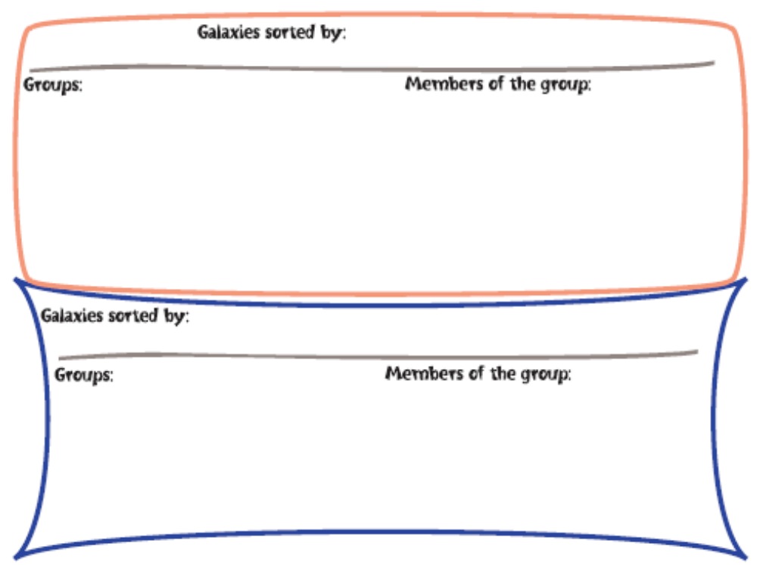

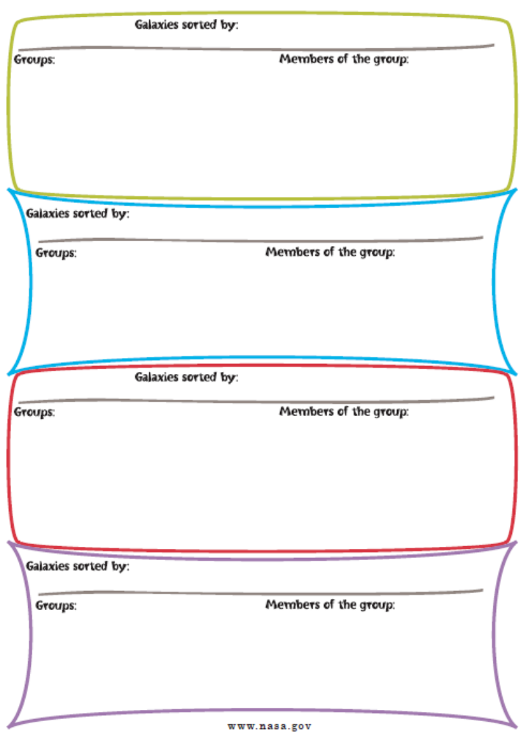
Amazing Space trading cards can be downloaded directly from their website at: http://amazing-space.stsci.edu/resources/print/activities/galaxytradecards.pdf

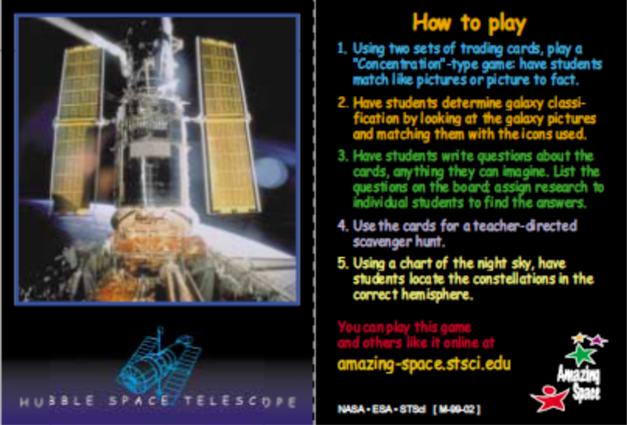

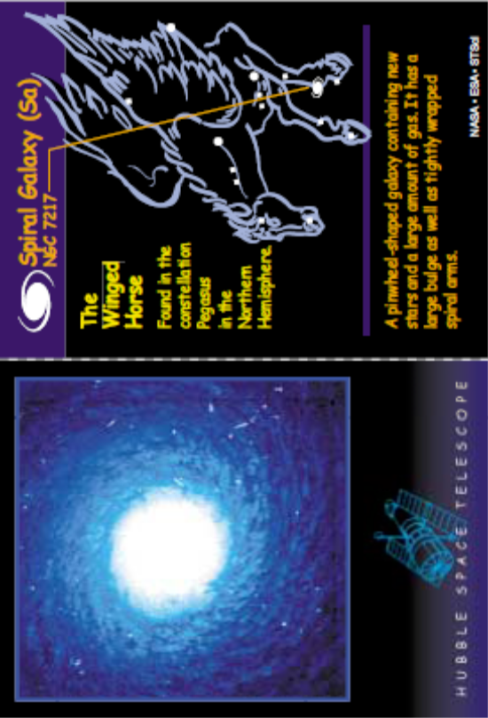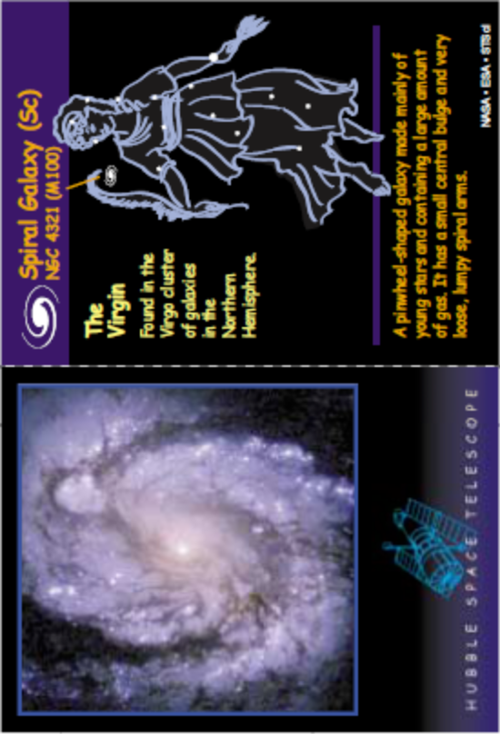

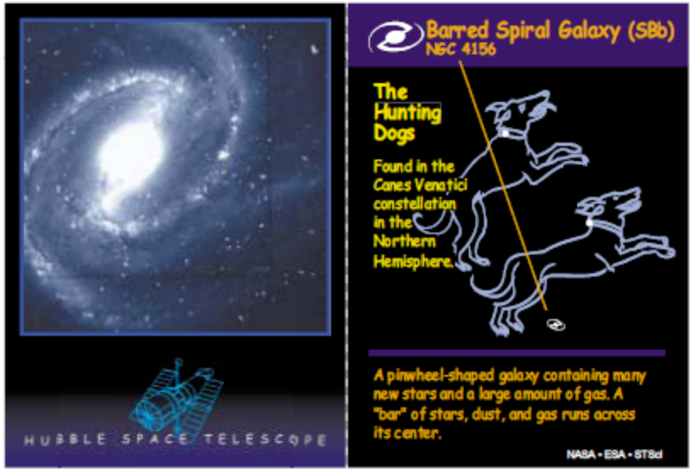

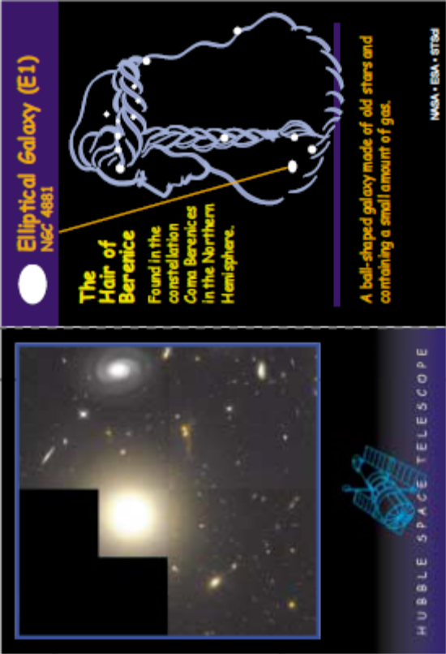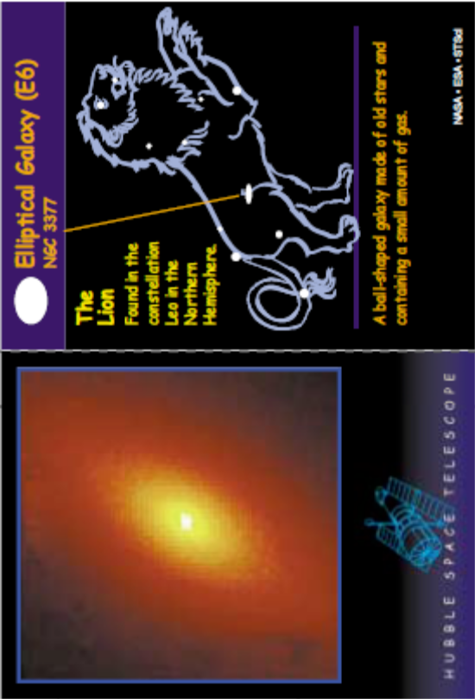

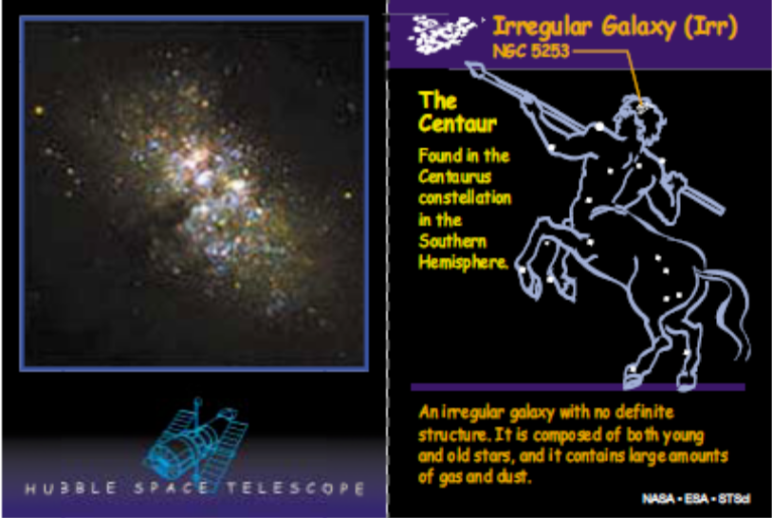

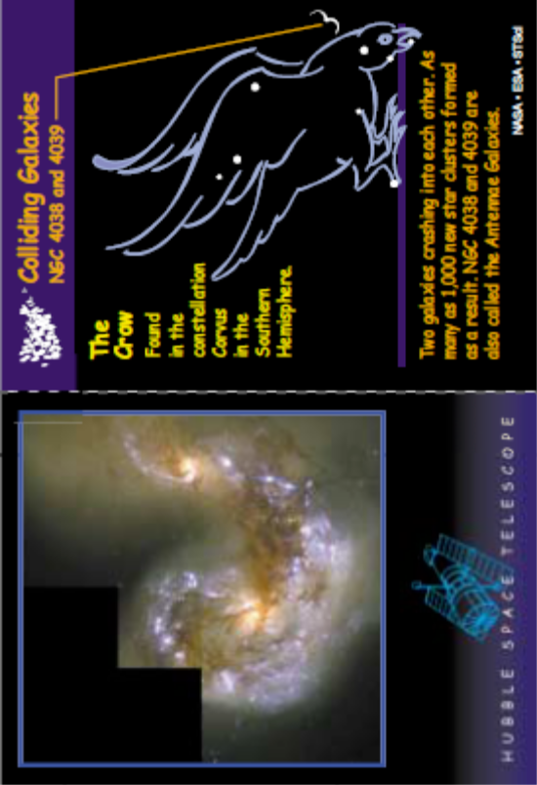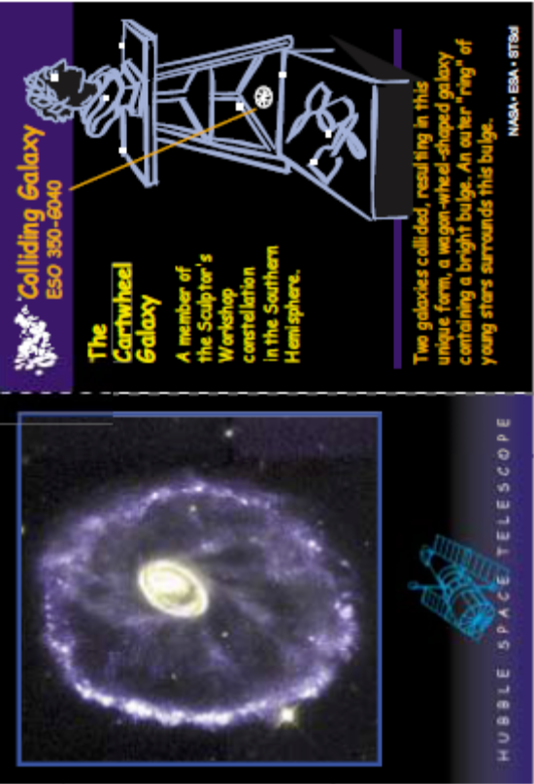
Student Activity Sheet A - Find the Right Circle: Compare/Contrast Chart

Directions:
Using the Galaxy Trading Cards and other material provided by your teacher, compare the properties of spiral and elliptical galaxies by listing the characteristics of each in the appropriate column. Once you have finished, look at some examples of irregular galaxies and list their properties in the third column.

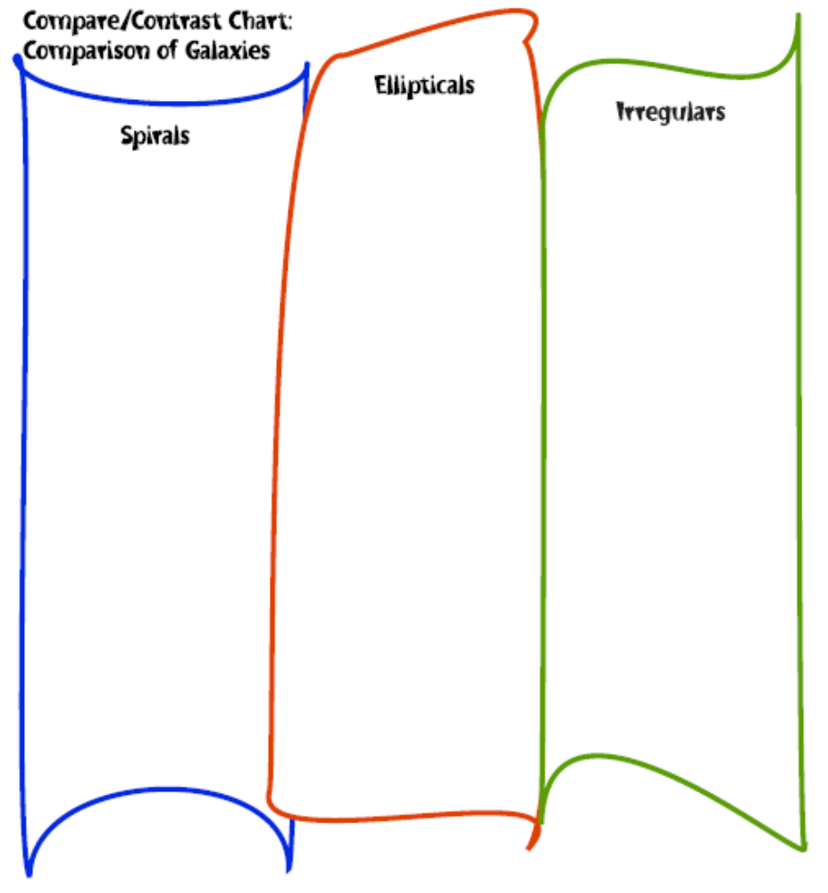

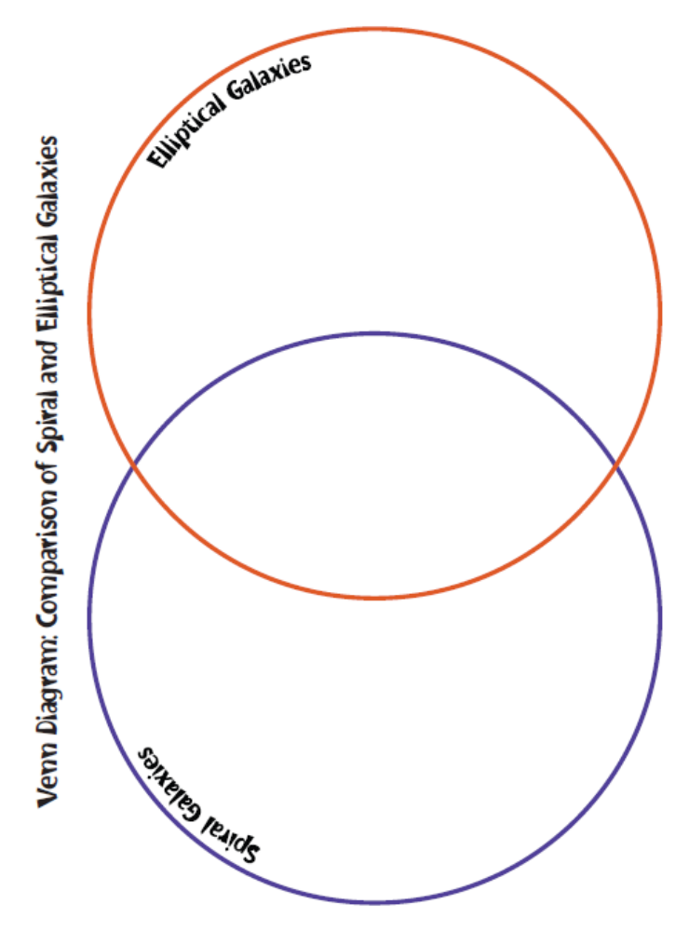
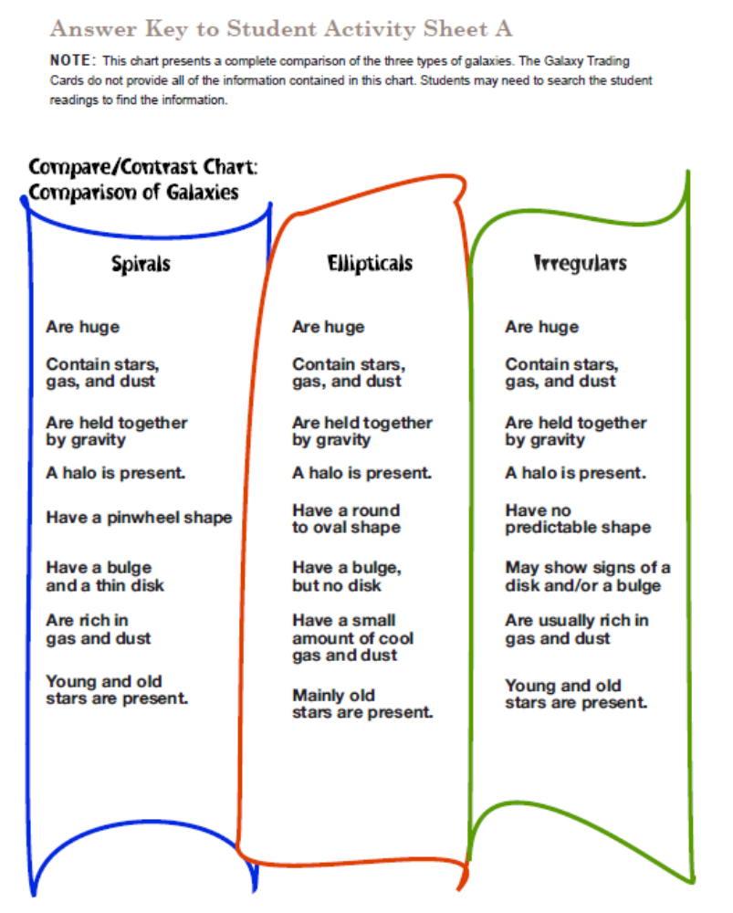

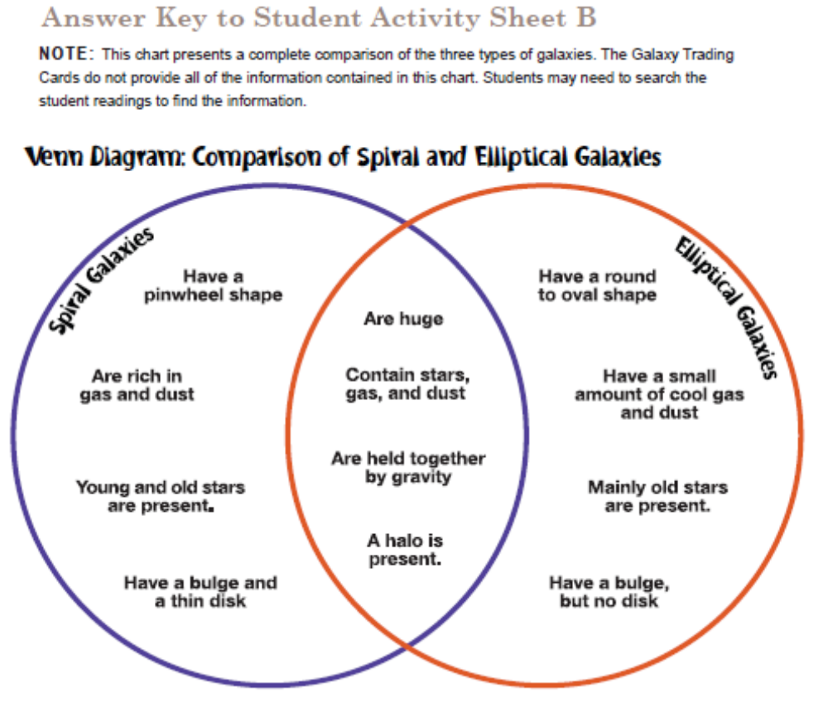
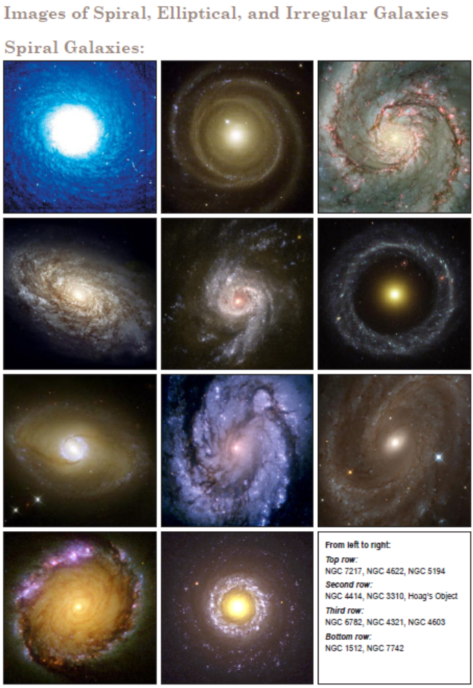
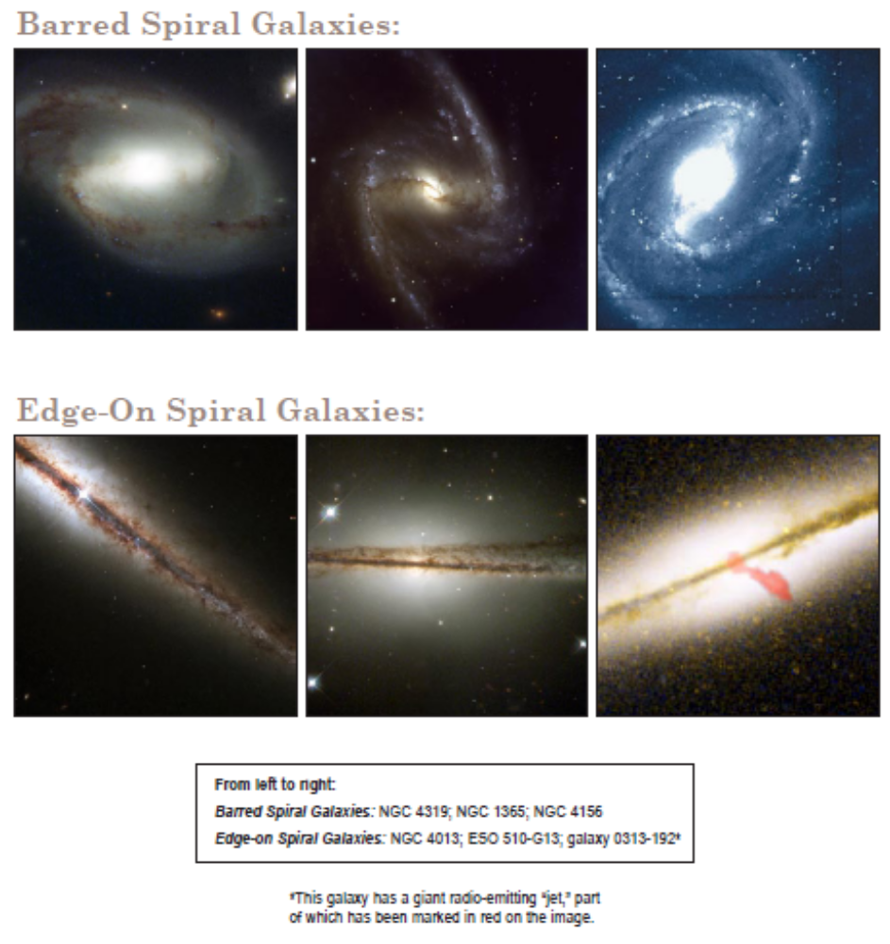

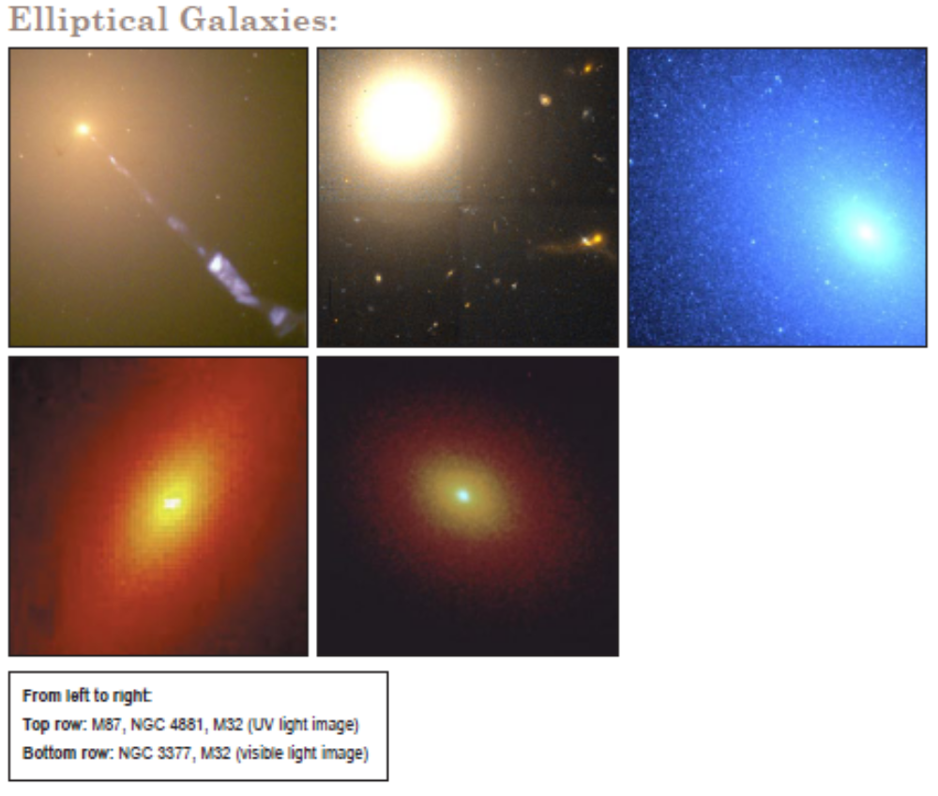

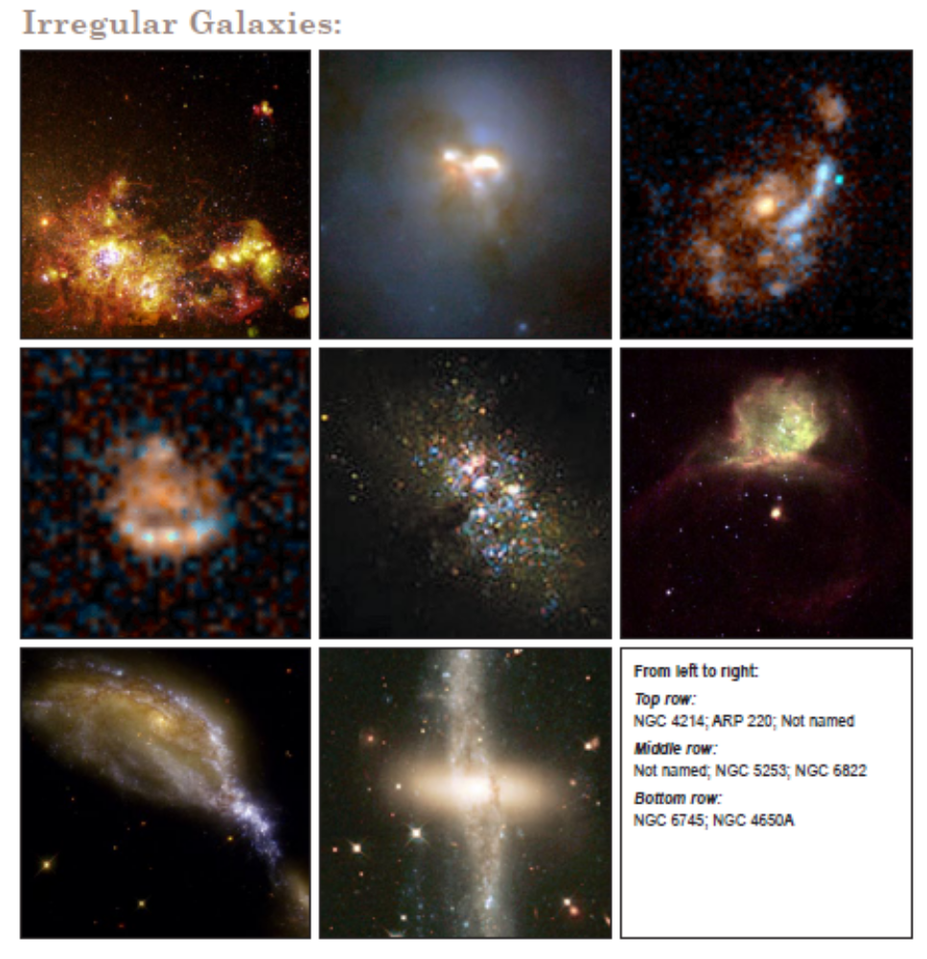

Galaxies to be Classified (from: http://btc.montana.edu/CERES/html/Galaxy/galunknsheet.html)
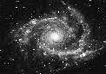  1. ___________ | 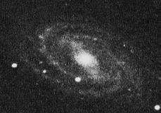  2. ___________ | 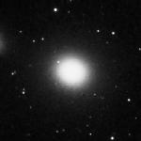  3. ___________
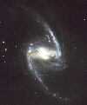  4. ___________ | 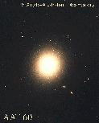  5. ___________ | 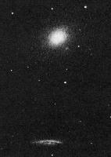  6. ___________
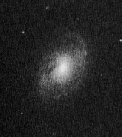  7. ___________ | 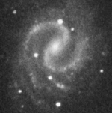  8. ___________ | 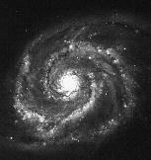  9. ___________
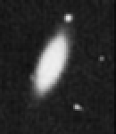  10. ___________ | 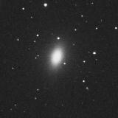  11. ___________ | 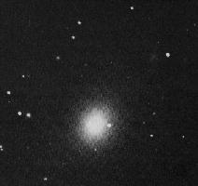  12. ___________
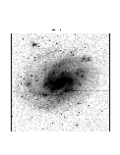  13.___________ | 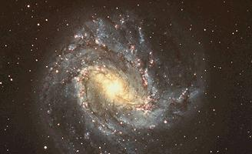 14.___________ | 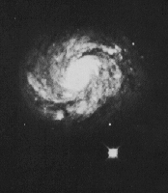  15. ___________

Downloaded from:
http://amazing-space.stsci.edu/resources/organizers/docs/tchr_tchart_galaxytypes.pdf

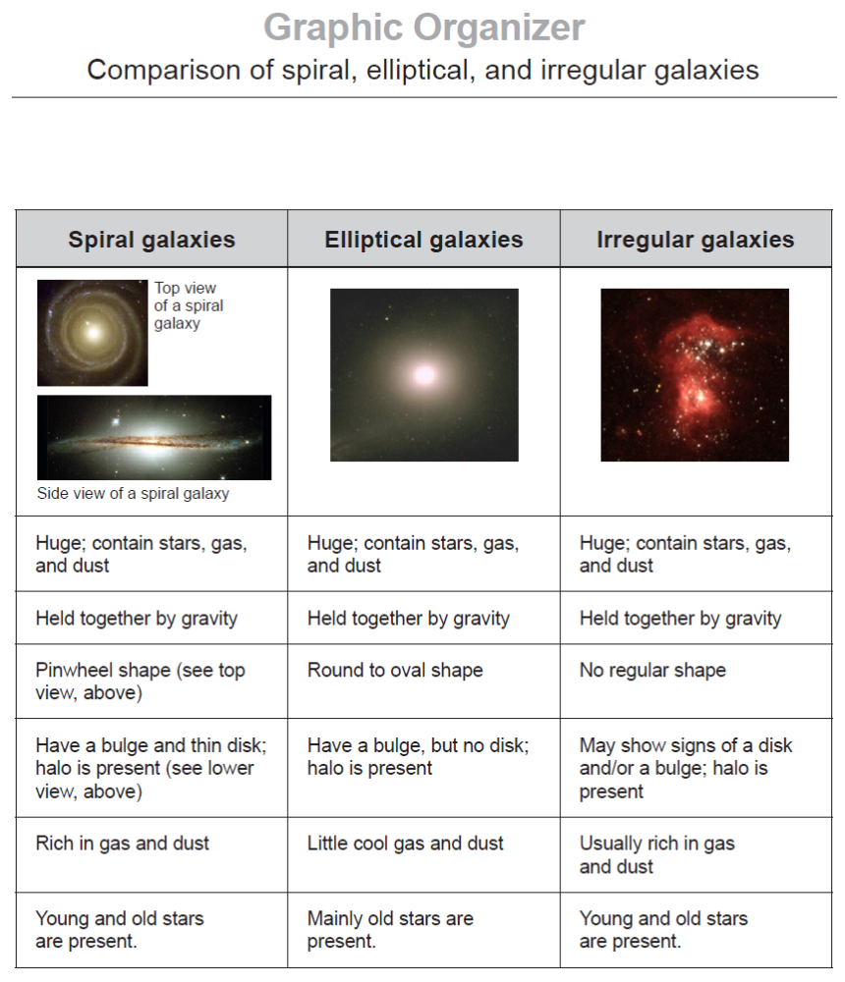

Diverse Galaxies lithograph and informational article can be downloaded directly from the website at: http://amazing-space.stsci.edu/resources/print/lithos/diverse-galaxies_litho.pdf

Diverse Galaxies
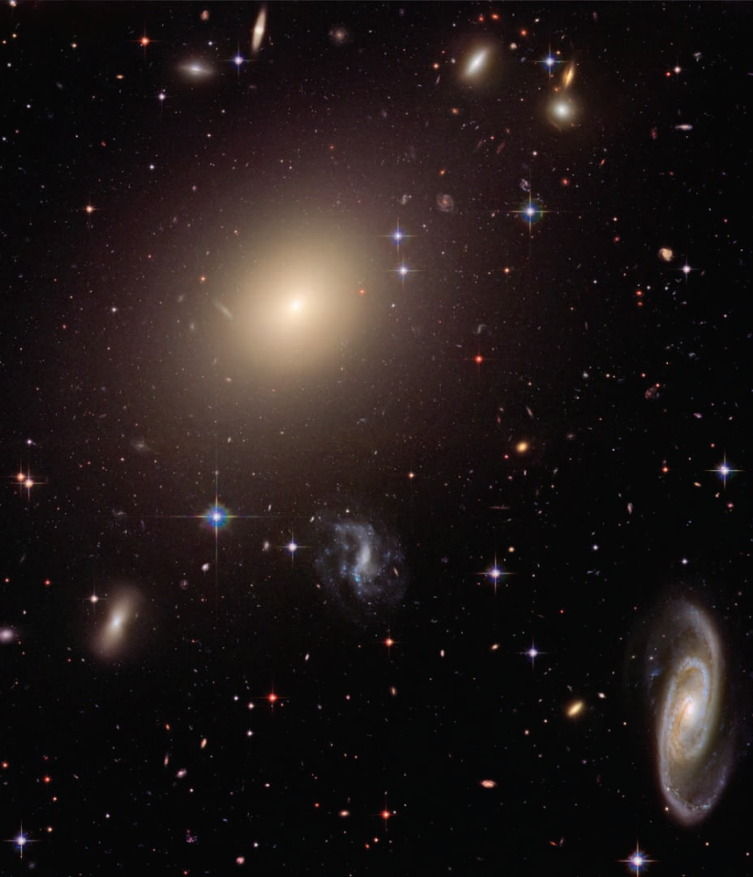
A Universe of Diverse Galaxies
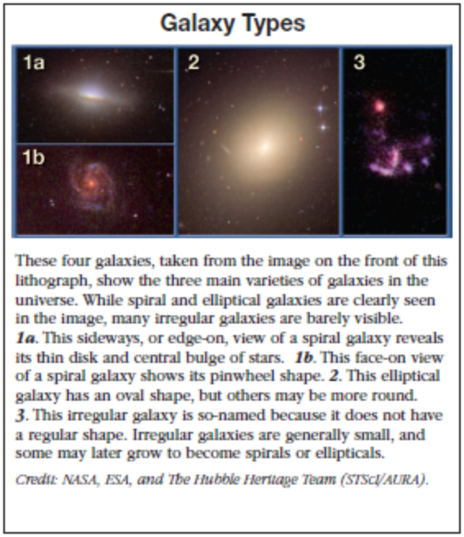
Galaxies come in an assortment of shapes, sizes, ages and
colors. The galactic hodgepodge seen in the image on the
front from NASA’s Hubble Space Telescope highlights the
diversity of our universe. The image contains thousands of
galaxies. Some of the largest galaxies are members of a small
cluster of galaxies called Abell S0740.
The golden ball of light, to the left and slightly above center, that dominates the image is an elliptical galaxy. Elliptical galaxies are stellar retirement homes. They mainly contain aging
stars, and are no longer giving birth to new generations of
stars. This oval galaxy, named ESO 325-G004, is packed with
a few hundred billion stars. Stars are clumped tightly in the
center of the galaxy and are sprinkled sparingly on the edges.
They are spread out so much in the outskirts of the galaxy that
it is transparent — the light of distant galaxies shines through.
The glittering whirlpool in the bottom, right corner of the
image is a spiral galaxy. Sweeping arms speckled with young
blue stars coil out from the galaxy’s bulging middle. Spiral galaxies
are rich in dust and gas, the two important ingredients
for making new stars.
Our own Milky Way Galaxy is a spiral galaxy. We view the
Milky Way from inside it, and cannot get a bird’s-eye view of
the whole structure. Observing distant spiral galaxies, like this
one, gives us the chance to better understand what our home
VOCABULARY
Galaxy cluster: A collection of dozens to thousands of galaxies bound together by gravity.

FAST FACTS
Constellation: Centaurus.
You can get images and other information about the Hubble Space Telescope on the World Wide Web. Visit our website, http://www.stsci.edu/outreach/ and follow the links.

You can find the corresponding Classroom Activity for this lithograph at http://amazing-space.stsci.edu/ or by contacting the Ofﬁce of Public Outreach at the Space Telescope Science Institute, 3700 San
Martin Drive, Baltimore, MD 21218.
galaxy looks like.
Many more elliptical and spiral galaxies are sprinkled
throughout the background. Some of the spiral galaxies are
slanted — their flat spiral disks are seen edge-on with their
centers protruding like eggs cooked sunny-side up. Others appear
face-on from our viewpoint and look like pinwheels.
In the image on the front, a number of stars within the
Milky Way appear in the foreground. Individual stars can be
distinguished from galaxies because they appear to have narrow
crosses of light protruding from them. The cross pattern is
not real but is produced by the telescope’s optics. The foreground
blue stars are young and hot. The red stars are older
and cooler.
Galaxies far outnumber the individual stars seen in the image.
The section of sky in this view is no wider than a pencil
tip, but extends 450 million light-years into outer space. In this
narrow slice of sky, astronomers see a wide variety of galaxies.
They are typical of the rich diversity of galaxies in our universe.

Alternative Engage (if students are having trouble conceptualizing the distance between planets):

NOTE: This has been extracted from the activity “Drawing a scale model of the solar system” originally published by NASA and can be downloaded in the original format at:
http://spaceplace.jpl.nasa.gov/en/educators/comet_orbits_cnsr.pdf
In this activity, we will see how the orbits of comets compare to the orbits of the planets. We will use a loop of string to learn the difference between an ellipse in general and a circle in particular (a circle is a special kind of ellipse). We will then go outside to make a true-scale chalk drawing of the orbits of the planets in our solar system, including a few comets.
First, let’s draw some ellipses.
1. Tie a 20-centimeter (8-inch) length of string into a loop. Push a pin into a piece of cardboard. Place the loop of string around the pin. Use a pencil inside the loop to trace out a shape as you pull the loop tight.
What shape is made with one pin at the center?
2. Place a second pin 5 cm (2 in) from the first pin. With the loop of string enclosing both pins, trace another shape with the pencil. This shape is called an ellipse. How is this shape different from the first shape?
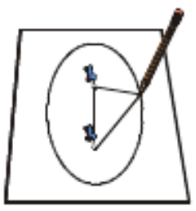
A circle has a single center, but an ellipse has two centers, called foci (FO-sigh). The pins represent the foci of the ellipse you have drawn.

3. Move one of the foci so it is 8 cm (3 in) from the other one. Trace a loop with the pencil. How did the shape of the ellipse change?

The amount of flattening of the ellipse is called its eccentricity. A circle is a special kind of ellipse with no flattening, so we say it has an eccentricity of 0 (zero). An ellipse that is so flat it looks almost like a straight line has an eccentricity of almost 1.
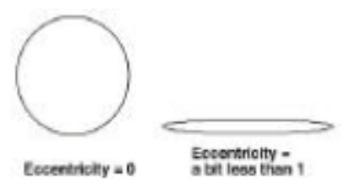

The orbit of anything that orbits the Sun has two foci, with the Sun at one and empty space at the other. As a comet comes near the Sun, the Sun’s gravitational pull speeds it up until it is going fastest when closest to the Sun. The comet’s path is bent by the increasing pull of the Sun’s gravity until it swings around the Sun and heads back into deep space. The comet’s momentum sends it far into space, although it slows down because of the Sun’s gravitational pull. Sometimes, comets come so close to the Sun, they just crash into it, instead of swinging around it. Well, they don’t really “crash,” because all the ice has evaporated long before they actually hit the Sun. Nearby planets, especially the larger planets like Jupiter and Saturn, can disturb comets’ orbits. These giant bodies have enough gravitational pull to change a comet’s orbit dramatically, flinging it in toward the Sun, into a planet, or out farther into deep space never to return. Comet Shoemaker-Levy 9 was captured and broken up by the huge gravitational forces of Jupiter, and ended up crashing into the planet in 1994. Scientists now believe that Jupiter’s gravity has helped deflect many comets away from Earth since its formation, helping protect our fragile environment enough to allow life to evolve and flourish over a long period. Comets’ orbits differ from those of planets not only in their shape (eccentricity), but also in their orientation. All planets’ orbits lie very close to an imaginary flat plane called the ecliptic. In fact, all planets even orbit the Sun in the same direction. The orbits of comets, on the other hand, are tilted at random angles to the ecliptic.
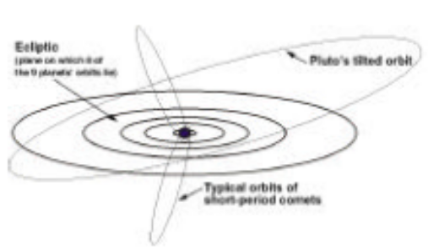

Let’s draw the orbits of the solar system.
We will include the planets and a few comets. Except for Pluto, the planets’ orbits have such a small eccentricity, we will draw their orbits as circles. We can draw Pluto’s more eccentric orbit as similar to the orbits of comets using the two foci method we used before. We will need lots of room for this drawing if the orbits are to be to scale. Let’s go outside and draw with chalk on some pavement, so we can really get a feel for some distances.

First, draw the orbits of the first eight planets:
1. Cut pieces of string for each orbit with the lengths (either in centimeters or inches) given in the first table on the next page. (These measurements already include an extra 15 cm [6 in] for tying a knot and looping the string around the broom handle.)
2. Tie each length of string into a loop. Write the planet name on a small piece of paper and staple it to the string.
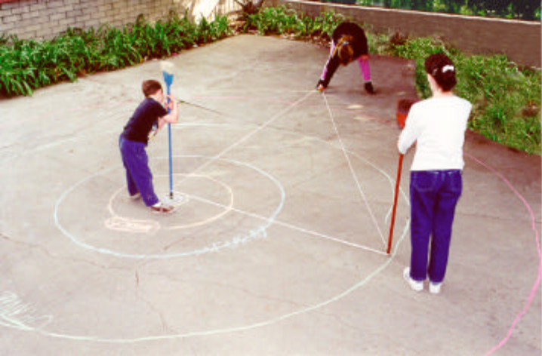

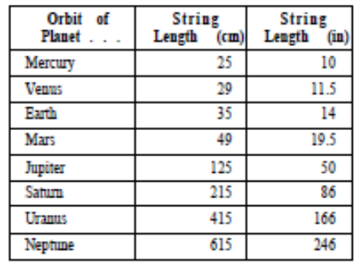
3. Mark a spot on the pavement to represent the position of the Sun. Have one person stand the end of the broom handle on this spot.
4. Anchor the loop at the pin or broom handle. Use one color of chalk for all the planets’ orbits. With the chalk inside the loop, stretch it all the way out and draw a circle. If the Mercury and Venus loops seem too small to work with, first draw the Earth orbit, then free-hand sketch in the two smaller orbits, using the lengths of their loops as an eyeball guide. Draw the rest of the planets’ orbits through Neptune. For the outer orbits, be sure to keep that string stretched tight! These orbits are big!

Now, draw orbits for Pluto and some short-period comets:
1. Make loops of string with lengths given in the “string length” columns of the chart in the next column. Label them as you did for the planets’ orbits.
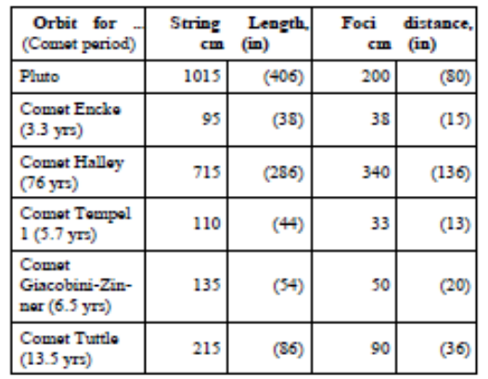

2. For each orbit, in addition to a broom handle placed at the Sun position, place a second broom handle at the foci distance stated in the chart.
3. Using the second color of chalk for the comet orbits, draw the elliptical orbits using the loops with the two broom handles as foci. What is unique about Pluto’s orbit compared to Neptune’s, the next planet in toward the Sun? How are the orbits of short-period comets different from those of the planets? Long-period comets, like Hyakutake, which recently passed Earth, have orbits that stretch far beyond Pluto’s orbit and can take over 10,000 years to travel just once around the Sun. Their orbits are much too large and elongated to fit on your pavement, even if it covered the entire school yard!

